

**Faculty of Commerce**

**Information Systems and Computers Department**

**English Section**

**Graduation Project**

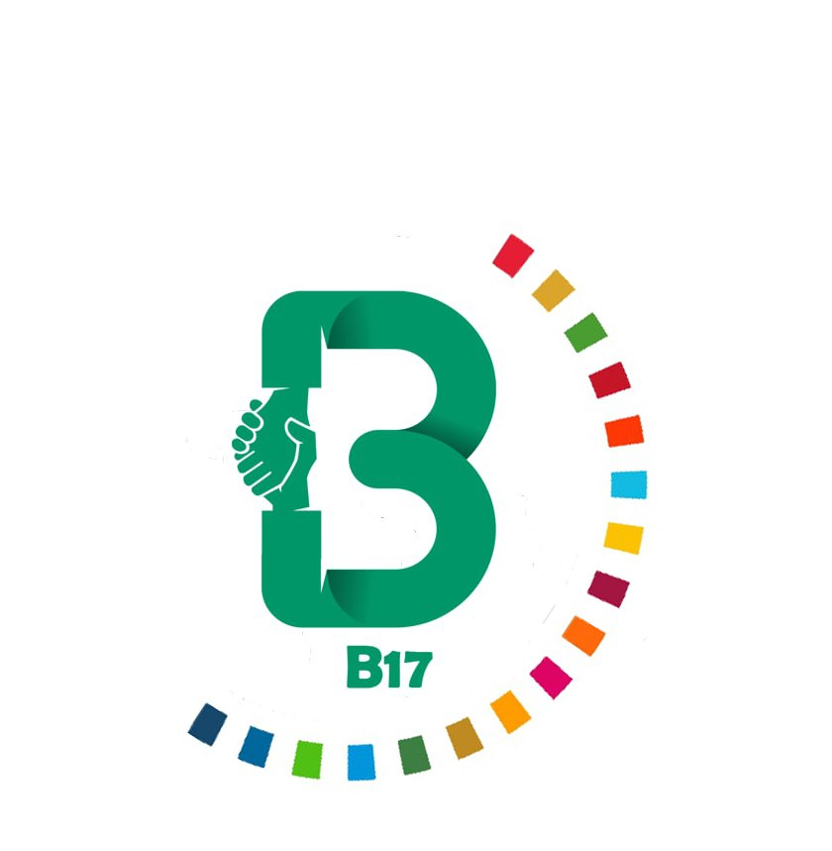

**Supervised by:**

**Dr. Ghada El Khayat**

**Submitted by:**

|  |  |
| --- | --- |
| Aml Ahmed ElGebaly | Mahmoud Mohamed Ibrahim |
| Aya Samy Ali | Mennatullah Magdy ElZalabani |
| Bassem Ahmed Ahmed Ali | Nada Saeed Abdel Hafez |
| Doaa Sherif Abdelsalam | Nisreen Mohamed Abdel Ader |
| Hadeer Mahmoud Mohamed | Ola Adel Ayad |
| Khaled Mohamed Mohamed | Rana Ashraf Mohamed |
| Madonna George Antoun |  |

**July 2022**

Acknowledgment

We would like to thank Dr. Ghada El Khayat for being the best mentor, professor, and teacher one could ever wish to have, thank you for your supervision and guidance and thank you for making our college experience much better.

We also want to thank Mr. Yousef Yassin, Safe organization, and our fellow students for cooperating with us and responding to our inquiries.

Table of Figures

**Figure 1: Project Roadmap 7**

**Figure 2: Survey questions no.1 9**

**Figure 3: Survey questions no.2 9**

**Figure 4: Survey questions no.3 10**

**Figure 5: Survey questions no.4 11**

**Figure 6: Survey questions no.5 11**

**Figure 7: Survey questions no.6 12**

**Figure 8: Survey questions no.7 13**

**Figure 9: Survey questions no.8 13**

**Figure 10: Survey questions no.9 14**

**Figure 11: Box plot in Data analysis 20**

**Figure 12: DFD - Context level 25**

**Figure 13: DFD - Level 0 26**

**Figure 14: DFD - Level 1 Process 1 27**

**Figure 15: DFD - Level 2 Process 3.5 28**

**Figure 16: DFD - Level 1 Process 3 28**

**Figure 17: DFD - Level 2 Process 4.1 29**

**Figure 18: DFD - Level 1 Process 4 29**

**Figure 19: DFD - Level 1 Process 6 30**

**Figure 20: Use Case Diagram 32**

**Figure 21: Events Activity Diagram 33**

**Figure 22: Post- Events Activity Diagram 34**

**Figure 23: Sequence Diagram - User POV 35**

**Figure 24: Sequence Diagram - Student POV 36**

**Figure 25: Sequence Diagram - Organization POV 37**

**Figure 26: Entity Relationship Diagram 39**

**Figure 27: Business Model Canvas 40**

**Figure 28: Competitors’ Analysis 41**

**Figure 29: Application's backend overview 70**

**Figure 30: Application's Redux connection 71**

Table of Contents

**Chapter (1): Introduction** 5

**1.1 The Problem** 5

**1.2 The Idea** 5

**1.3 Our Mission and Vision** 6

**Chapter (2): Background and Literature Survey** 7

**2.1 B17’s Roadmap** 7

**2.2 Information gathering** 8

**Chapter (3): Analysis and Design** 25

**3.1 Data Flow diagram** 25

**3.2 UML** 31

**3.3 Entity Relationship diagram** 38

**Chapter (4): Feasibility and (lean) Business Model Canvas** 40

**4.1 Business Model Canvas** 40

**4.2 Competitor’s analysis** 41

**4.3 Revenue stream analysis** 41

**4.4 Initial marketing plan** 42

**Chapter (5): Implementation and Testing** 45

**5.1 Tools used:** 45

**5.2 User Interface design** 50

**5.3 Application development** 67

**5.4 Website development** 78

**Chapter (6): Conclusion, results, and future work** 85

**Appendix A:** 86

**Appendix B:** 109

**References:** 110

Abstract

The main idea of the project is to create a mobile application that facilitates contributing to achieving a sustainable future on the students-level,

through linking the students acts, skills and services to some organizations CSR programs.

So that the organizations could benefit from the specialized students’ skills in contributing to one or more of the SDG goals while offering their program and budget both of which would help the student learn and practice more and create a material return system tailored for the students’ interest found on the app.

On the other hand, this offers a safe and encouraging space for the students to put their knowledge into action and experience more in their fields on interest.

# **Chapter (1): Introduction**

## **1.1 The Problem**

**Problem One:**

A lot of students are struggling to practice their knowledge and gain more experience in the fields they’re studying or interested in and, in fact it is true that the opportunities for freshers are extremely limited.

**Problem Two:**

Organizations investing in programs to contribute to sustainability or to any of the SDGs do not have it that easy, it costs a lot, even if they do depend on volunteers for example the recruiting process for the volunteers itself is costly and it’s almost impossible to find volunteers whose interest align with the task at hand.

**Problem Three:**

The general ignorance of the sustainability movement, Sustainable Development Goals and 2030 VISION among the students and hence the lack of initiative to apply them.

## **1.2 The Idea**

While trying to generate solutions for the problems mentioned above, we came up with this idea and it is to create a mobile Application that basically acts as a mediator between students and sustainability-oriented organizations.

The Application’s job is to connect the students with certain skills and interests with the organizations in need of these skills to carry out a task or an activity in their CSR or sustainability programs, where both parties would benefit of each other’s needs.

In the bigger picture this Application will facilitate contributing to the SDGs both on the student and institutional level.

## **1.3 Our Mission and Vision**

**B17’s Mission statement:**

We aim to be the greatest sustainability-oriented volunteering/ youth empowering platform in Egypt and hopefully in the whole world.

**B17’s Vision statement:**

We are doing this to accelerate the sustainable development and ensure a better future for our youth through our youth.

# **Chapter (2): Background and Literature Survey**

## **2.1 B17’s Roadmap**

Our project went through many phases to develop and still has more phases to go thought to reach the state we planned on having, but nevertheless we would say that the good news is we managed to stay on plan.

Below you will find a Gantt chart representing our roadmap and project development stages with respect to our timeline.

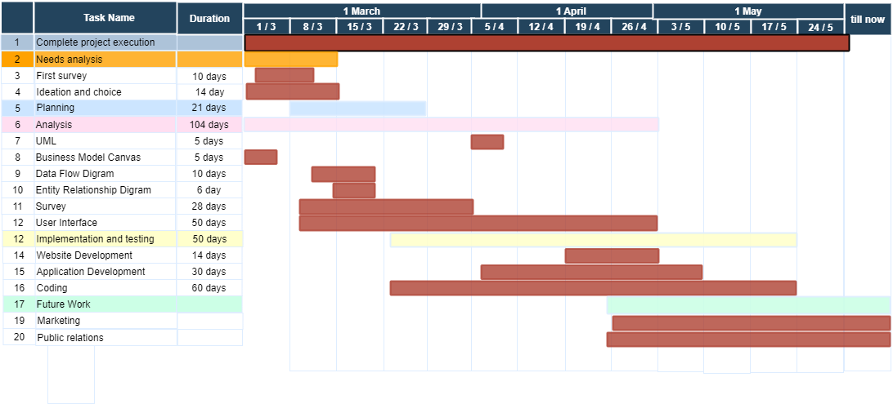

Figure : Project Roadmap

First off, we started with our market’s needs analysis obviously as our first stage while working in parallel on a related survey and initiating the planning process which took about three weeks and was done in parallel with other process because we believe that planning generally is a never-ending process, because a lot of struggles and issues pop up which requires plan adjustment often.

Our next process, Ideation and Choice, were mainly about generating idea to cover the needs found in the prior stages and choosing the best idea among them, which you know by now.

After that we finally started our analysis process which included UML designing, creating a business model canvas to analyze our costs, revenue streams and competitors and highlight our value added, Data flow diagrams, Entity relationship diagram and yet another survey but this time to analyze our potential users needs within the scope of our idea.

Next, we started working on our UI/UX design to visualize the user flow through the application and creating a visual plan to use as a reference while coding.

Then we started with our most awaited stage but also the most exhausting one, Implementation and Testing, in this stage we started working on the code both the front-end and back-end simultaneously while also working on the website development in sync with the App, taking into consideration that the website development is not as complicated or rather tricky as the App development.

Finally, after being done with about 70% of the development we began formulating a marketing and a public relations strategy to put into action instantly when deciding to publish our work in the market.

## **2.2 Information gathering**

Before we jump directly into implementing our idea it is only reasonable to analyze the idea, our potential users and all the relevant information we could get. So, we began with surveying some of our fellow university students and friends considering they do classify as potential users.

**Survey**

Let’s walk you through the survey, we started off with some background assessment questions like their age group, gender, and university.

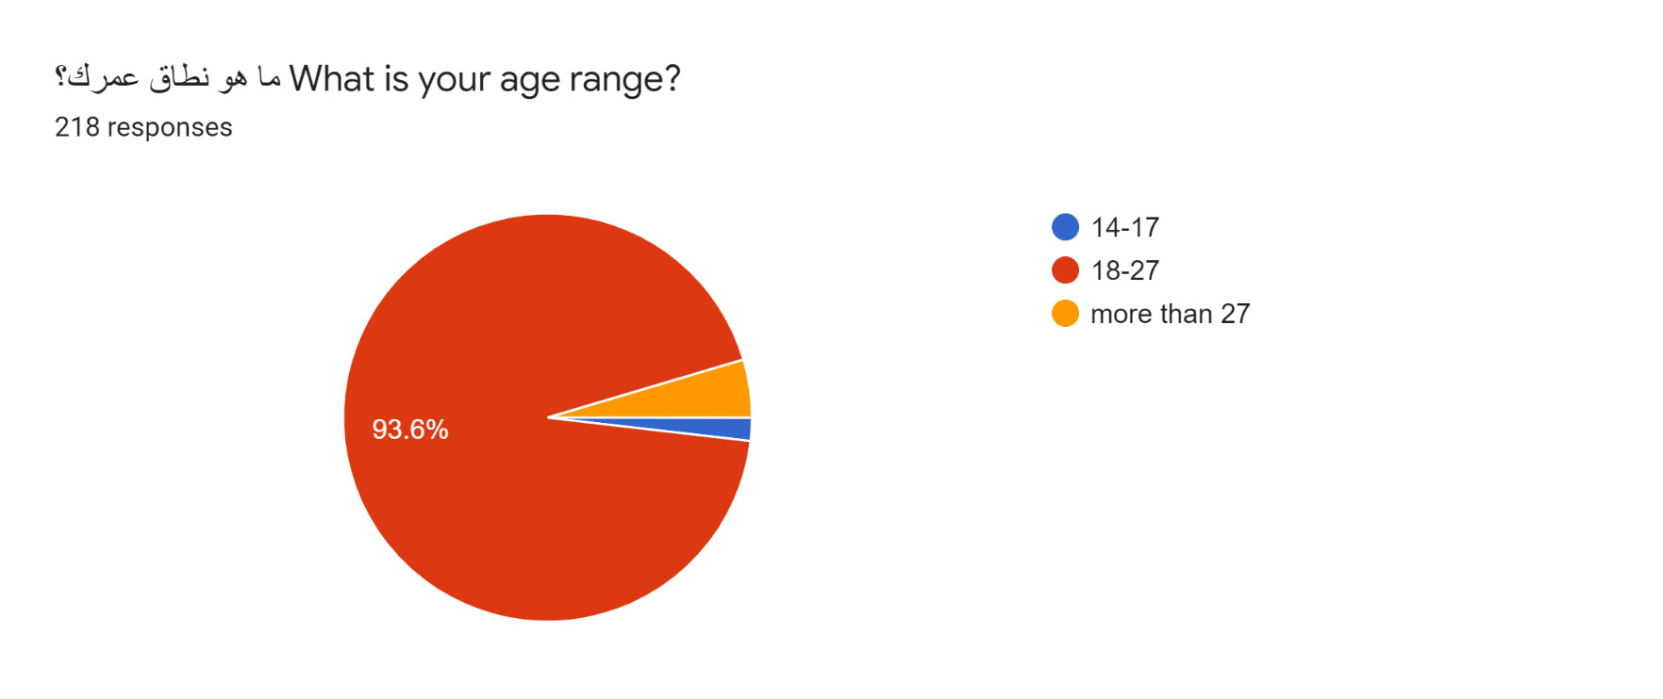

Figure : Survey questions no.1

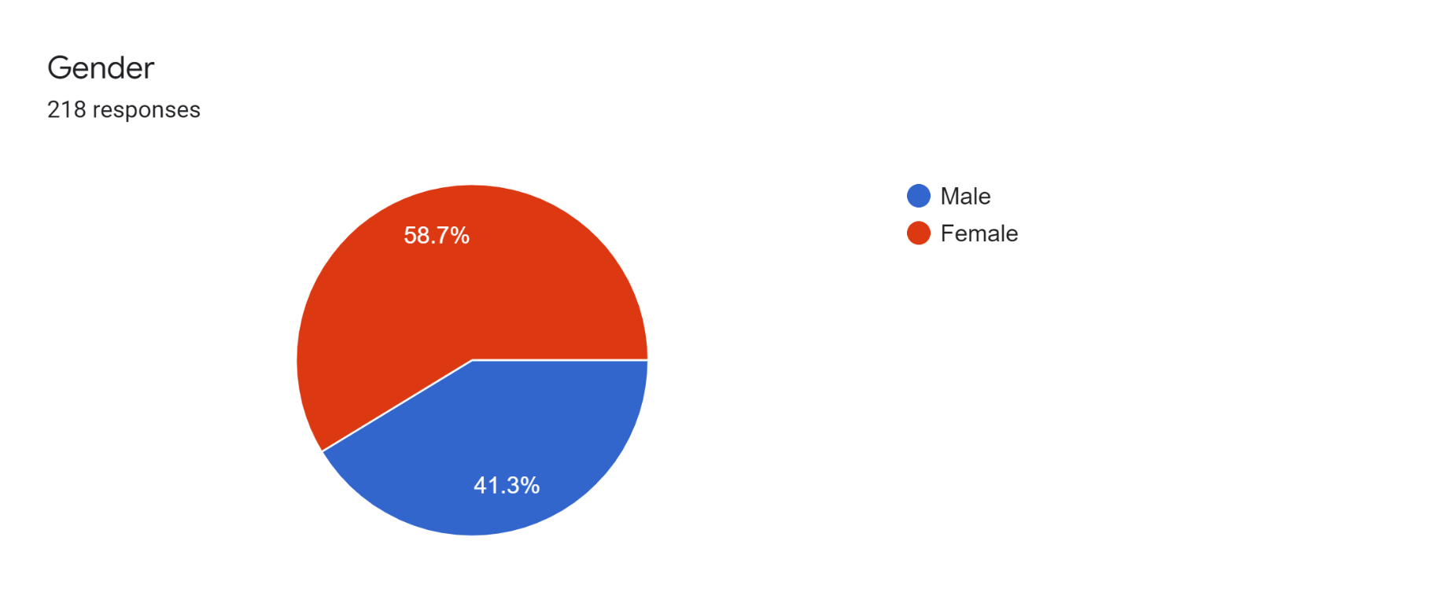

Figure : Survey questions no.2

From the responses it is obvious that most of the responders are university students and specifically in Alexandria university which is expected because this is our target student segment and our most accessible circle.

For the gender, it didn’t really mean anything on its own but even when assessing the gender with other factors in the survey, like the prior knowledge of SDGs or preferring experience over material return the percentages were exactly the same (28% and 84% respectively).

Next, we addressed their prior knowledge of SDGs and their preferences in the goals or movements as in which goal would they like to contribute to more than the other, we also added some questions to help us formulate the return or reward system according to what the students are actually expecting to gain.

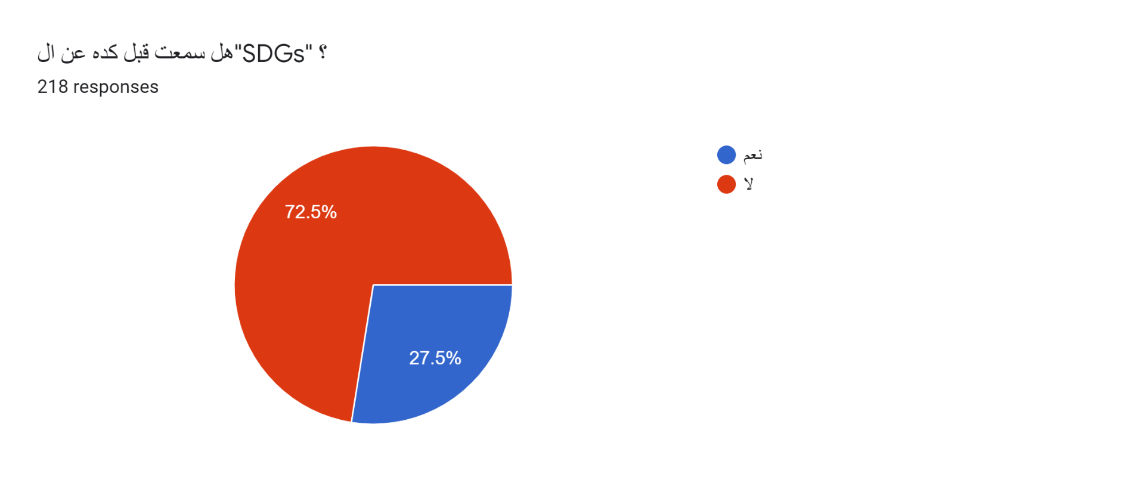

Figure : Survey questions no.3

Note that at least 70% of the students had no idea about what SDGs are even if these very same students’ answers in the next few questions show that they are willing to contribute to these goals and take an action, which again adds up to our problem statement of the weak knowledge of sustainability on the students’ level.

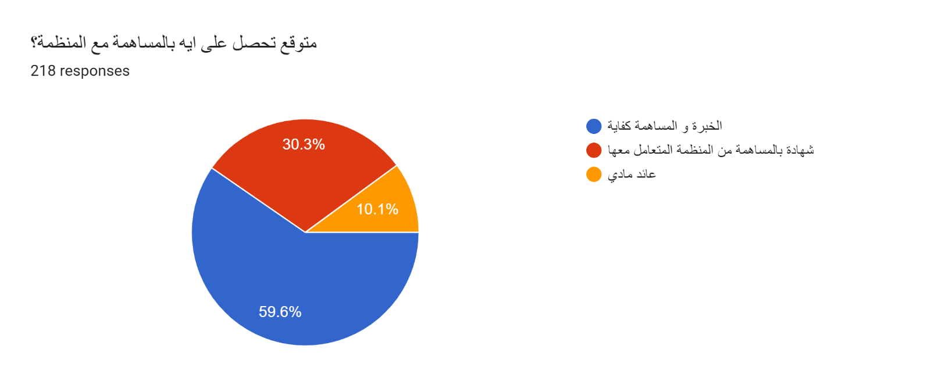

Figure : Survey questions no.4

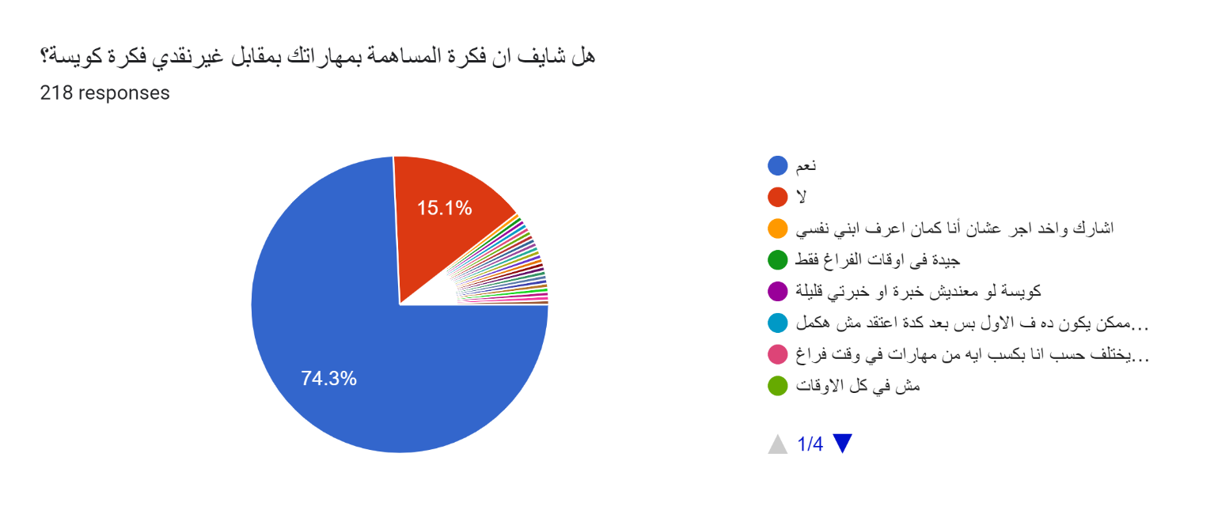

Figure : Survey questions no.5

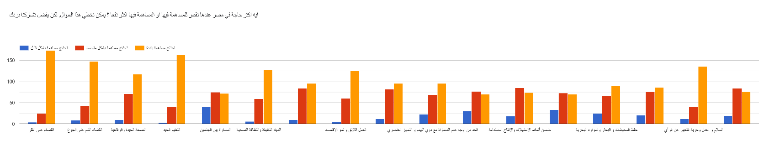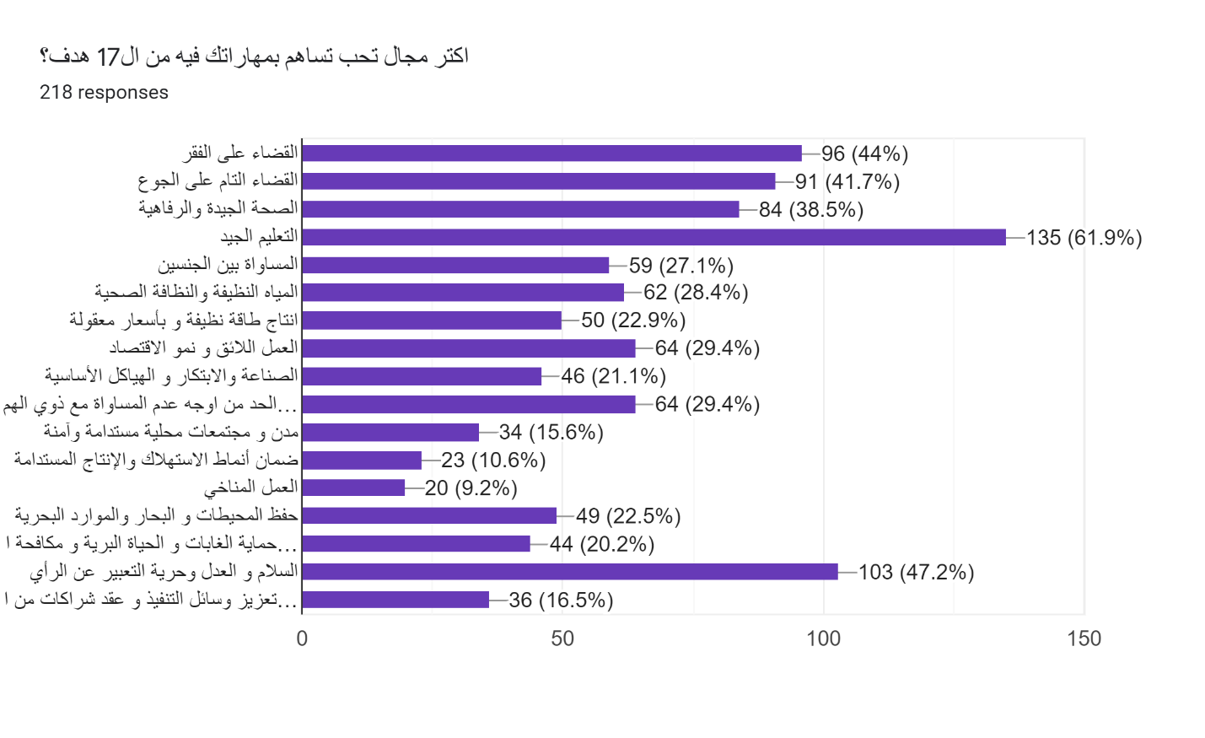

Figure : Survey questions no.6

The next questions’ purpose was to understand how accessible corporate social responsibility or volunteering programs are to students and how much of their time are they willing to give for such programs.

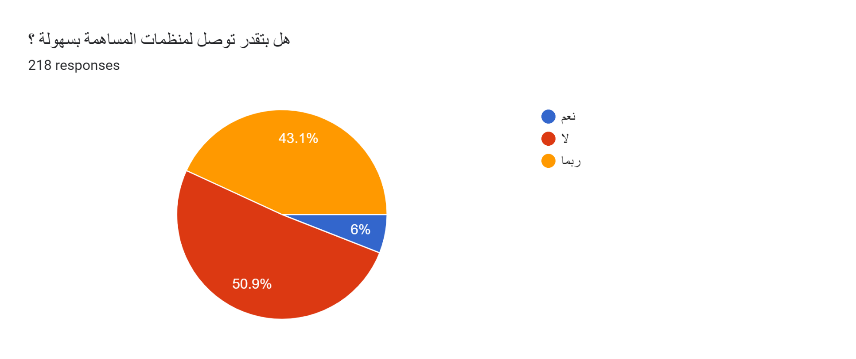

Figure : Survey questions no.7

As it is shown here these programs are not very accessible and so combining them in one place would help the students find their desired programs easily and help the organization find more applicants.

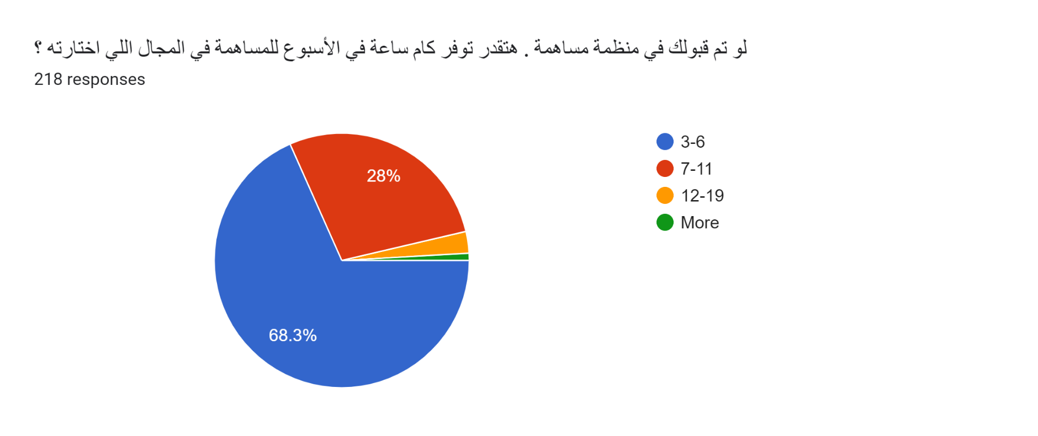

Figure : Survey questions no.8

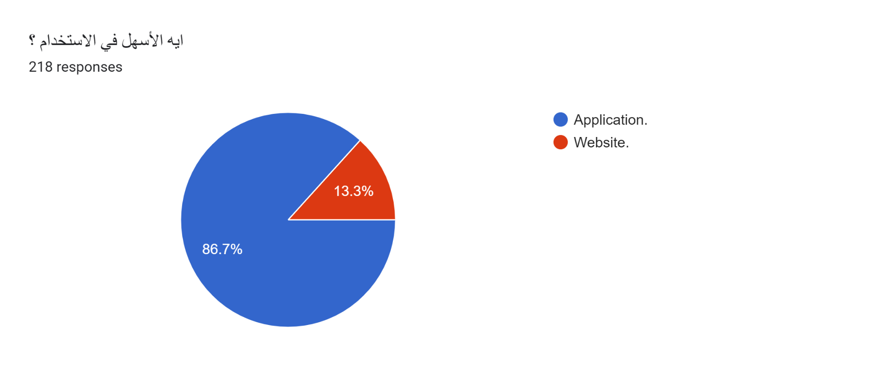

Figure : Survey questions no.9

And finally, we wanted to know whether our users visualize the idea better in the form of an application or a website and almost 90% said they preferred it as an application and hence our choice of it being a mobile App.

Note that we also created a website, but it is mainly for branding and publicizing the idea.

Secondly, we held an interview with a NFO (not for profit organization) called “Save” which we used to assess the idea from the organizations point of view, the purpose of this interview was only to gather information and provide more clearance and reality to our perspective, it was not to pitch our idea.

The interview was very brief we explained our idea and how we intend to implement it, we presented some of the application’s UI to help visualize the idea and their responses were very positive of the idea.

**Students’ data analysis**

To have a better understanding of the students’ behavior and the effects of extracurricular activities on their social and academic behavior we did some research on studies analyzing this and from what we’ve found out from the following report was that almost all studies done proved that extracurricular activities could only have positive effects on the students, it even results in better academic performance and claiming that it affects their study hours is not true. We even found out that practicing extracurricular activities enhances the students’ life satisfaction both directly and indirectly.

In the details of all three studies below you will find an introduction including the purpose of the study, sample size and information then some statistical findings and the conclusion.

The first study titled “Life Satisfaction and Extra-curricular Activities among Medical Students at Ain Shams University”

(Which we consider to be the most fit study because it was held in Egypt in an Egyptian University).

This study was conducted to measure the level of life satisfaction (LS) using The Multidimensional Students‟ Life Satisfaction Scale (MSLSS), to measure the percentage of students participating in extracurricular activities (EAs) among medical students at Ain Shams University, and to identify the relationship between LS, EAs, and academic achievement among the studied group. A cross-sectional study was applied on a sample of 240 students using a self-administered questionnaire including socio-demographic data, faculty related data including average grade, data related to EAs participation and the MSLSS.

RESULTS AND DISCUSSION

A cross-sectional study design was used to collect data from medical students at Ain Shams University. Pass program was used to calculate sample size yielding a sample of 196 students by setting the type-1 error (α) at 0.05 with a distance from the mean to the confidence limits equal to 0.08. Results from a previous

study (Corea et al., 2017)22 showed that the mean overall satisfaction among

participants was 4.62±0.57. Convenience sampling was used. self-administered questionnaire was used; the questionnaire included four sections: Section 1: covering Socio-demographic data (e.g. age, gender, residence …etc.). Section 2: containing data related to the faculty including average grade, time spent in the faculty per week, studying time.

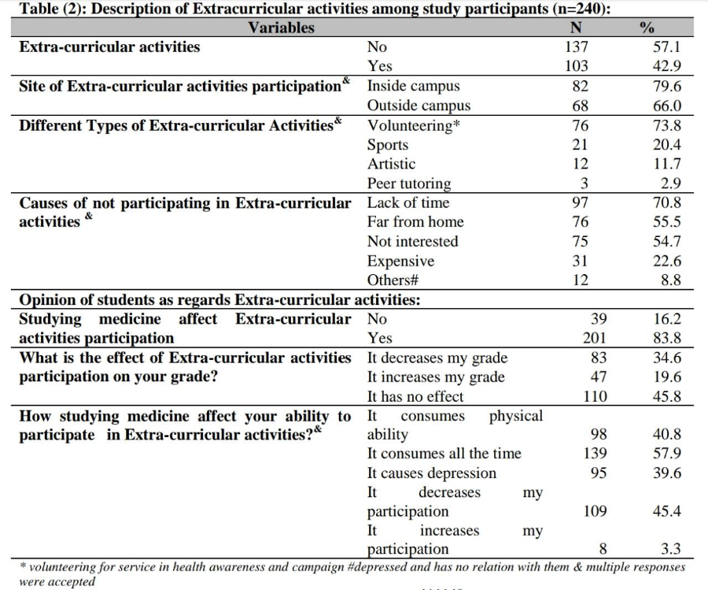

Section 3: questions on participation in EAs, the frequency, type, and perception of EAs influence on academic achievement and EAs participation barriers. Section 4: The Multidimensional Students’ Life Satisfaction Scale (MSLSS; Huebner, 1994) is a 40-item instrument used for adolescents to measure overall life satisfaction and satisfaction across five domains including family, friends, school, living environment, and self.

CONCLUSION

In summary, this study has identified several significant factors that affect LS and participation in EAs among a group of medical students. The study results can help designing interventions to encourage students to increase their physical

activity and to spend less free time surfing the internet thus significantly promoting life satisfaction. Furthermore, the results can help in integrating EAs in the design of the medical curriculum and in planning student support services to enhance the students‟ quality of life so that students might obtain the best out of their EAs for their personal development, future career, and psychological health. As the present study was applied to a limited group of undergraduate medical students at one governmental university in Cairo careful interpretation of the study results is crucial. Additional research is needed with university student populations from different faculties including private as well as governmental universities.

The second study titled “Extracurricular activities and their effect on the student’s grade point average: Statistical study”

This research was conducted to know whether the students’ grade point average in King Abdulaziz University, Faisaliah campus is affected by their participation in the ECA. The study sample includes 239 students chosen via simple random sampling method. The study used inferential statistics to analyze this study design. a questionnaire (comprising 19 questions) was designed. The results showed that participation in ECA affects the students’ GPA in a positive way. The study found that those who participated in ECA have higher GPA than those who did not; the study also found that the time spent participating in ECA did not affect the time students usually spend on studying (the result showed there wasn't any relationship between them). Furthermore, the study showed that students, based on faculty, are generally satisfied with the available extracurricular activities in the campus.

RESULTS AND DISCUSSION

According to the aims of the study, four claims were:

The 1st null hypothesis states: “the students are not satisfied about the available ECA”. The answers of 126 students who participated in ECA, which are 52.72% of the total sample were analyzed. The normality test was significant (P=0.002) thus the non-parametric test (Abozaid, 2005) Wilcoxon was used. By setting the hypothetical median M as 3, Table 2 shows that the number of negative ranks were greater than positive ranks (M < Students’ Satisfaction), which means that 106 students out of 126 were satisfied about the ECA held in the campus. The test statistic was also significant (P=0.000). This finding supports the rejection of the 1st null hypothesis which means the students are satisfied on ECA. Also, this study tested whether being a student in certain faculty may have an effect on their satisfaction of ECA. Here this study uses the type of faculty as an independent variable. Using the nonparametric test Kruskal-Wallis, the study found that the test was not significant (P=0.56) therefore; the ECA are fair for all faculties. The next hypothesis examines whether the GPA is affected by participation on ECA.

The 2nd claim states: “There is no significant effect of participation in ECA on the student’s GPA”. This hypothesis tests the difference in the GPA of students who participates in ECA and those who don’t. The nonparametric test Mann-Whitney was used. The test statistic was significant (P=0.020) and supports the evidence to reject the 2nd null hypothesis. Figure 2 showed that the group of those who don’t participate in ECA had wider range in GPA in contrast to the other group of those who participate. Also, the median of the GPA for the group who participate in ECA (3.853) was higher than the median of GPA for the other group (nonparticipants). Thus, the ECA doesn't prevent students to get high scores. The next hypothesis tested whether student in certain faculty who participated in ECA got more scores. Also, do participants in certain faculty take more hours of activities?

The 3rd null hypothesis states: “There is no significant effect in faculty that student are in on the hours of participation in ECA and their GPA”. This hypothesis is meant to study if there was any effect of being a student in a certain faculty on the number of hours spent on participating in ECA and their GPA. To test this hypothesis, a One-Way MANOVA test (Doudeen (2009)) was conducted. The assumption of equality of error variance for each dependent variable (GPA & Participation hours) was met; Levene’s test was not significant (P=0.507 & 0.640). The test statistic of Wilk’s Lambda was significant (P=0.000), which provides sufficient evidence to reject the 3rd null hypothesis.

Table 3 showed that faculty’s effects on participation hours was statistically not significant (P=0.619). Whereas, faculty’s effect on students’ GPA was statistically significant (P=0.000). This implies that there is a significant difference in the students GPA among the three faculties. To compare the mean GPA of each faculty, Scheffe test was used. The test statistic of students’ mean GPA for faculty of computers and information technology and faculty of science was found significant (P=0.000). Also, the test statistic of students’ mean GPA for faculty of computers and information. . Thus, student in certain faculty who participated in ECA got more scores. Also, based on faculties there are no differences of participants’ hours.

The 4th null hypothesis states: “There is no significant effect of the students’ type of faculty and participation in ECA on their GPA”. Two-Way ANOVA test was conducted to evaluate the effect on students GPA based on whether they participate in ECA or not and on the students’ type of faculty. The interaction between the two independent variables (Participation and Faculty) was statistically not significant (P=0.815) as shown in Table 4, which provides sufficient evidence not to reject the 4th null hypothesis.

On the other hand, the test statistic for the type of faculty affects student GPA was significant (P=0.000), which supports the result of the 3rd null hypothesis. Also, the test statistic of participation in ECA was also significant (P=0.010), as previously proven in the 2nd null hypothesis.

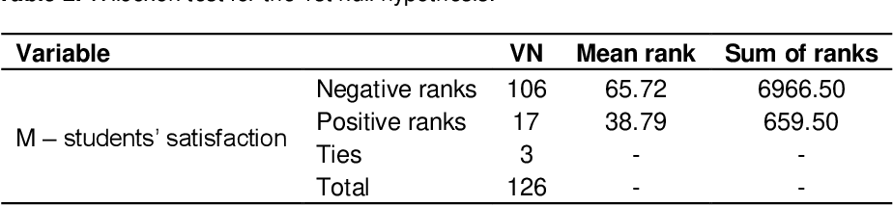

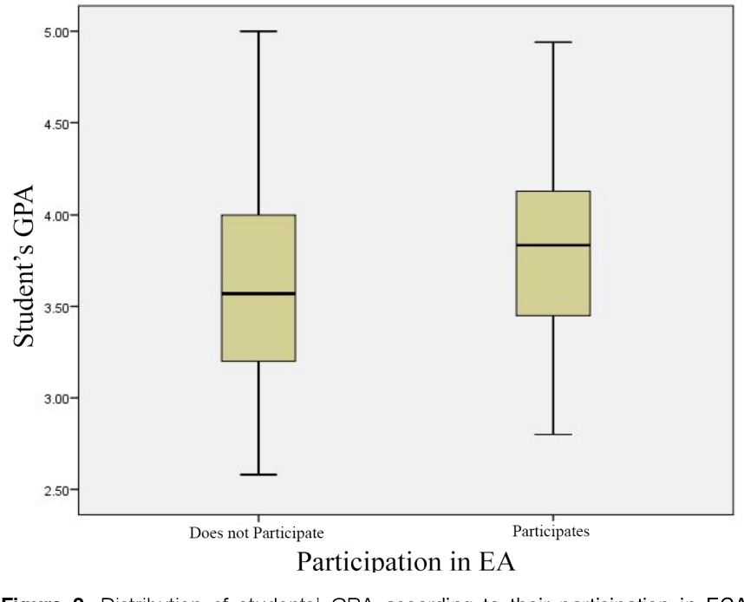

Figure : Box plot in Data analysis

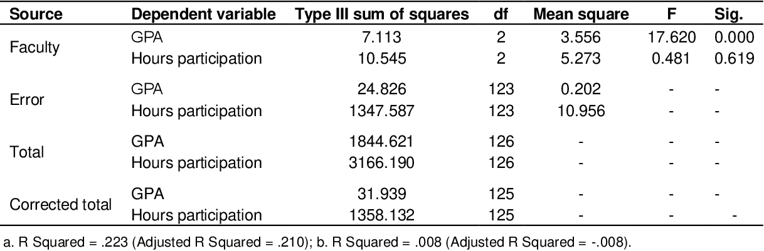

CONCLUSION

The study found that there are significant differences in the GPA of the students who participated in ECA and other nonparticipants; the median of the GPA of those who participated in ECA is higher than those of the nonparticipants. This correlates with the result of Silliker and Quirk (1997), Richard and Aries (1999) and Massoni (2011).

The results showed that student’s satisfaction on the available ECA does not really differ irrespective of their faculties. The result also showed that student’s willingness to participate in ECA is the main and only purpose for satisfaction; and neither affected by the type of faculty nor by the current level. Also, the hours spent in studying are the same for each group (those who participated in ECA and those who did not); participating in ECA does not really affect the students study hours; ECA does not prevent the student from studying. The study also found that there is no interaction between the students’ types of faculty and their participation on ECA on their GPA. Although the GPA of a student may differ by faculty, their participation in ECA will always positively affect GPA as previously reported.

The third study titled “Research-Based on Big Data Analysis on The Influence of Extracurricular Activities on the Character Education of High School Students in China and Indonesia.”

This study has three purposes: first, to find out whether extracurricular activities affect students' character education; second, to find out whether there are differences in the effect of extracurricular activities on students' character development between China and Indonesia; third, in order to know whether the level of implementation of extracurricular activities affects character education or not. This comparative study involves 1739 participants from high school students between classes 11 and 12 in China and Indonesia. This research is using a network-based online research system, then the collected data is analyzed using big data visual analysis. This study indicates that extracurricular activities have a significant effect on the development of student character education. The influence is determined by the level of implementation of activities managed by the school.

RESULTS AND DISCUSSION

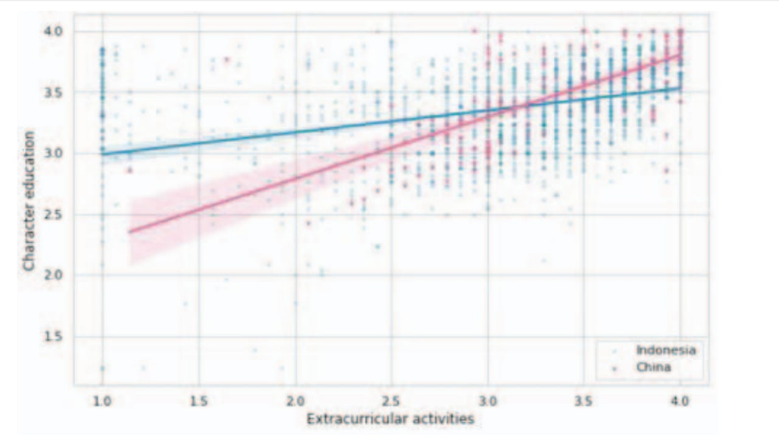Analysis of the influence of extracurricular activities on character education of high school students. The results of this study indicate that there is an effect of extracurricular activities on students' character development. extracurricular activities are a systematic and conscious process in civilizing young citizens to have the maturity as a provision of life that will expand knowledge and increase skills. This can be seen from the results of simple linear regression tests in China and Indonesia.

In China

The regression equation and hypothesis test From the Fig.1 it can be seen that the magnitude of the influence of extracurricular activities on character education in China can be seen to be higher than in Indonesia.

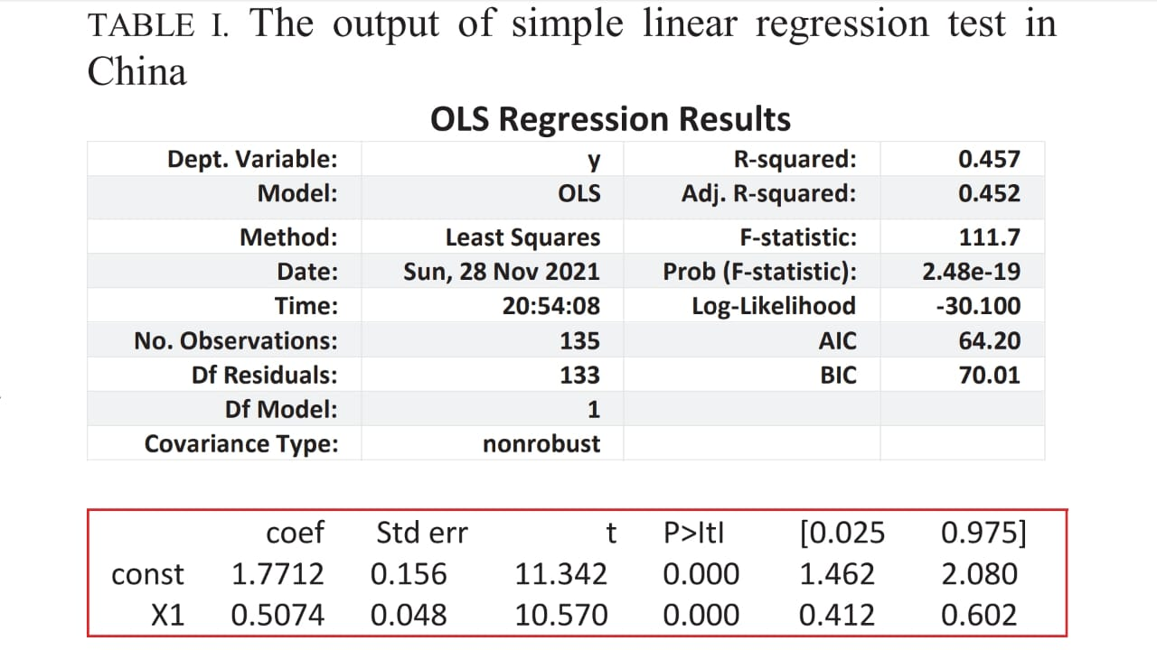

The magnitude of the effect can be seen from the R Square value of 0.457. This means that extracurricular activities affect character education by 45.7% and the remaining 54.3% is explained by other variables not discussed in this study.

In linear regression analysis, a regression equation (coefficient value) is developed to find the value of the dependent variable from the known value of the independent variable. This analysis is used to predict where there are dependent and independent variables. The regression equation obtained from the table is Y=1.7712 + 0.5074X, where Y is a character education and X is student participation in extracurricular activities. From these equations, it can be concluded that the regression coefficient of extracurricular participation is 0.5074, meaning that if the extracurricular participation variable (X) increases by 1% and the constant (a) is 0 (zero), then the character education of students increases by 0.5074. It shows that the participation variable in extracurricular activities contributes to or has a positive influence on the development of student character education so that the better the school administration in extracurricular activities, the higher the moral value or character education of students. At the same time, the Sig values are 0.000 and 0.000, which means the sig value is smaller than the alpha value of 0.05. It can be concluded that participation in extracurricular activities has a significant influence on character education.

In Indonesia

From the Fig.1, it can be seen that the magnitude of the influence of extracurricular activities on character education in Indonesia can be seen to be lower than in China. The regression equation (coefficient value) obtained from the table above is Y=2.8070 + 0.1804X,

The analysis of the level of implementation of extracurricular activities in China and Indonesia involving 1739 participants in 17 high schools, between classes 11 and 12 they were classified into three groups, namely high, medium, and low.

CONCLUSION

The study has drawn conclusions, First, extracurricular activities have a significant influence on the personality development of students from China and Indonesia. The better the school manages this activity, the higher the influence of the activity is on the character development of students. Second, based on the analysis of the level of implementation of extracurricular activities carried out in 17 high schools classified into three groups, namely high, medium, and low, it can be concluded that there are significant differences between the three groups.

The results of this study are expected to provide an overview implementation of extracurricular activities in both countries. In addition to encouraging students' academic improvement, extracurricular activities encourage the development of students' personalities to become human beings with good characters.

*You can find links to the full studies in the references page.*

# **Chapter (3): Analysis and Design**

### **3.1 Data Flow diagram**

Our data flow diagram consists of mainly three levels; context level, level zero and level one whereas some processes required further elaboration, so we added a level two to them.

*Context level diagram* shows that B17 system is responsible for connecting the organization entity and student entity through executing some processes which will be shown in detail in the next level.

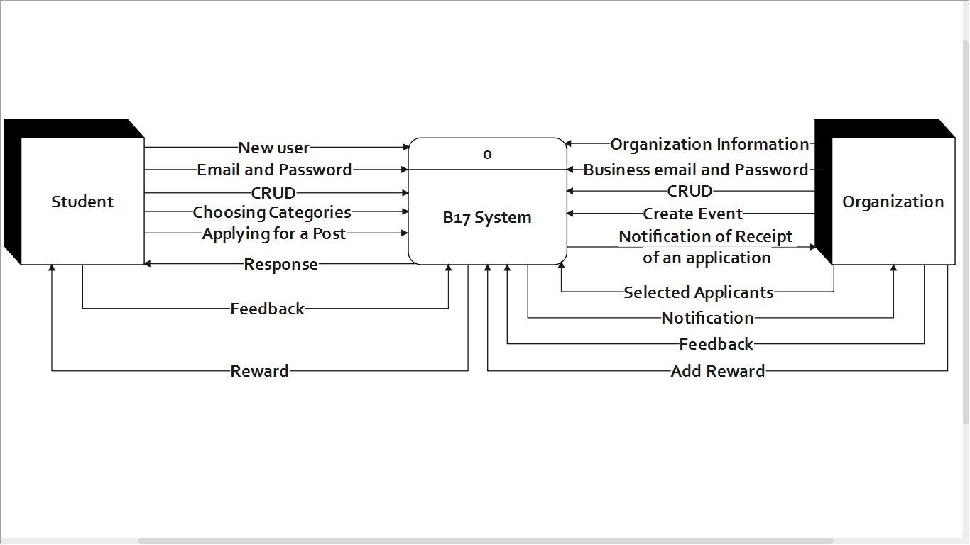

Figure : DFD - Context level

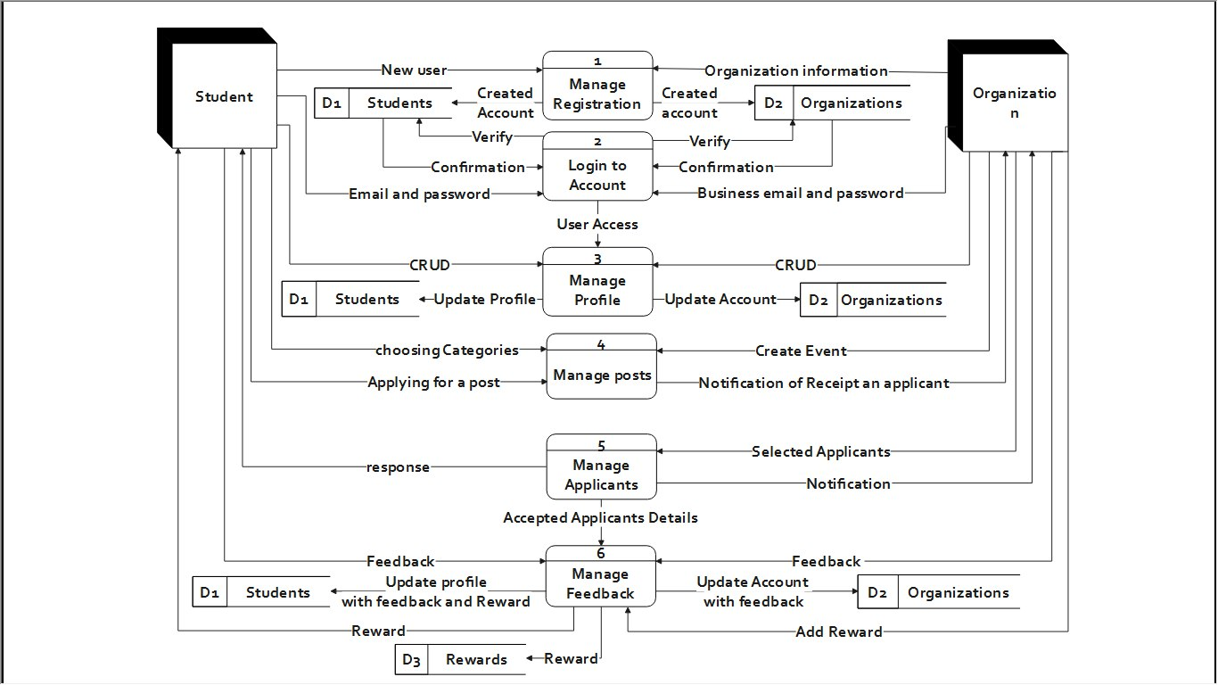

Figure : DFD - Level 0

*Level zero* consist of six processes performed by the two entities,

1. The first process is managing the registration of student and organization, which is simply creating an account for first timers and saving the information in the database.
2. The second process is login to account which enables each entity to use the account it just created.
3. The third process, manage profile, is to enable both entities to add, update and delete features or posts from their profiles.
4. The fourth process differs according to which entity is interacting with it, to the organization it would allow it to create events, create and manage posts about them and receive notifications when students apply to any. Whereas to the student, it allows them to choose the suitable events and apply to their desired posts.
5. The fifth process is managing applications and selecting the best from them then sending responses to the accepted students, this process is exclusive to the organizations of course.
6. The sixth process is triggered by the end of the student’s task or the end of the activity, it is mainly about sending the feedback from the student’s side and sending the reward from the organization’s side.

The next figures show level one diagrams for process 1, 3, 4 and 6 where process 3.5 and 4.1 and further elaborated in level two diagrams below their level one diagrams.

Note that process 2 and 5 were excluded because they required no further elaboration and were self-explanatory.

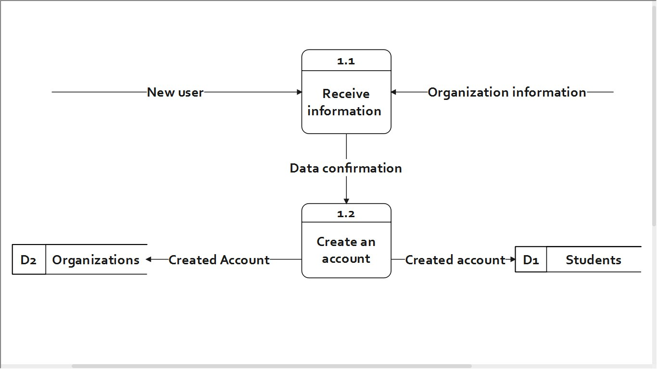

Figure : DFD - Level 1 Process 1

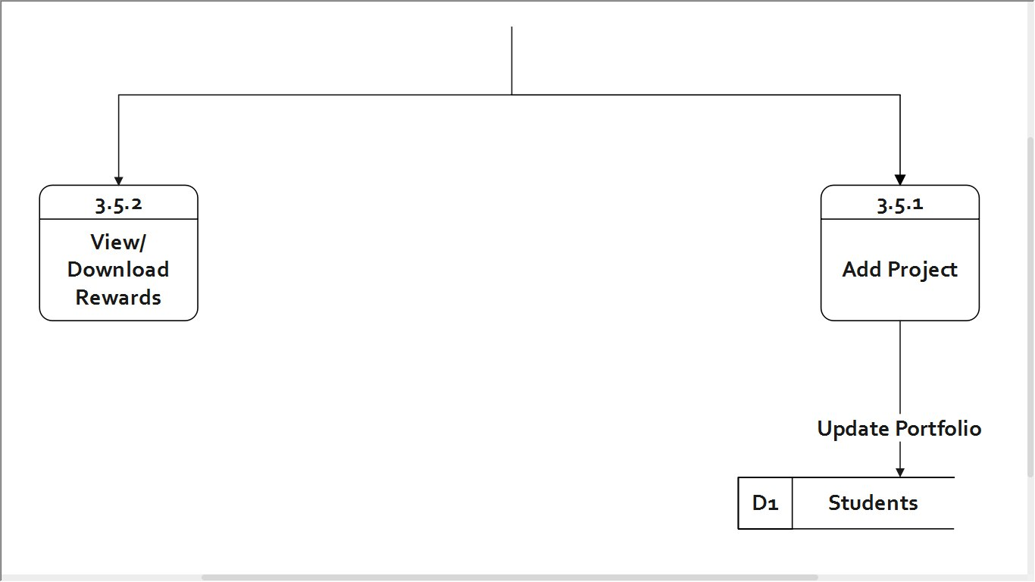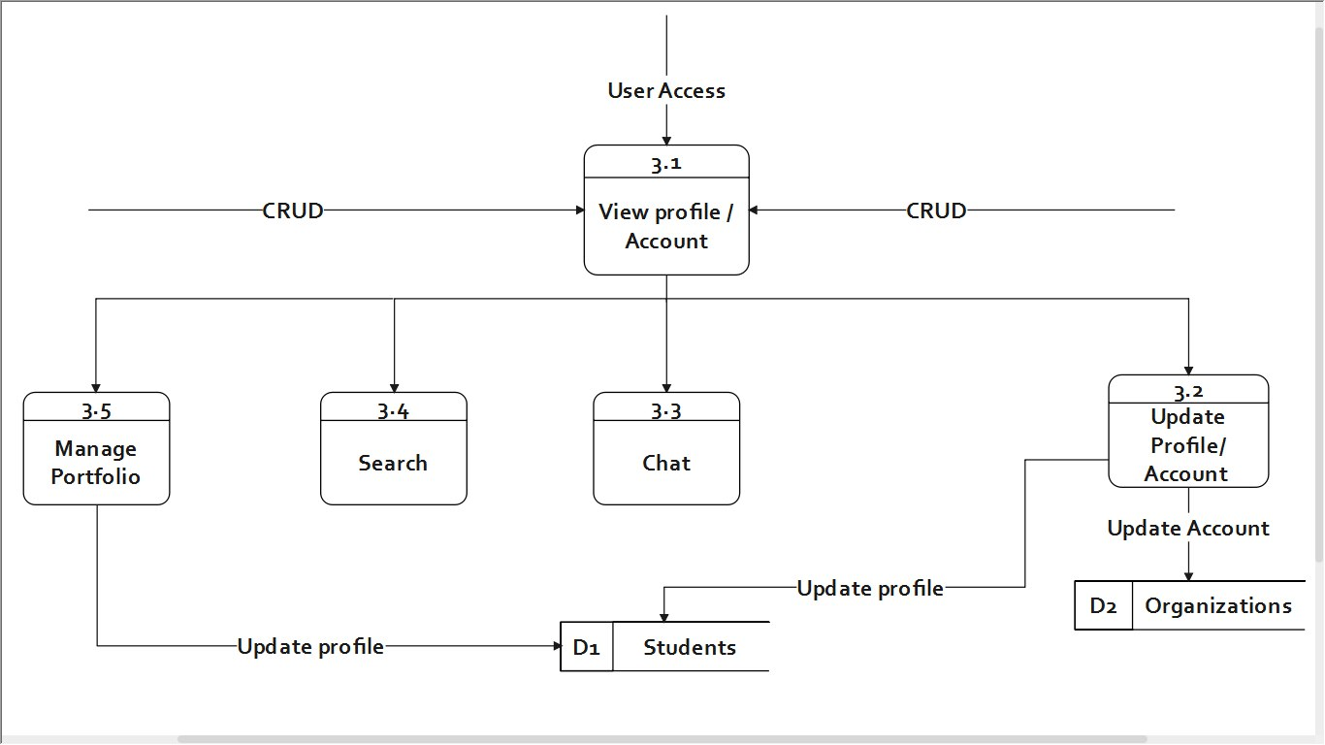

Figure : DFD - Level 2 Process 3.5

Figure : DFD - Level 1 Process 3

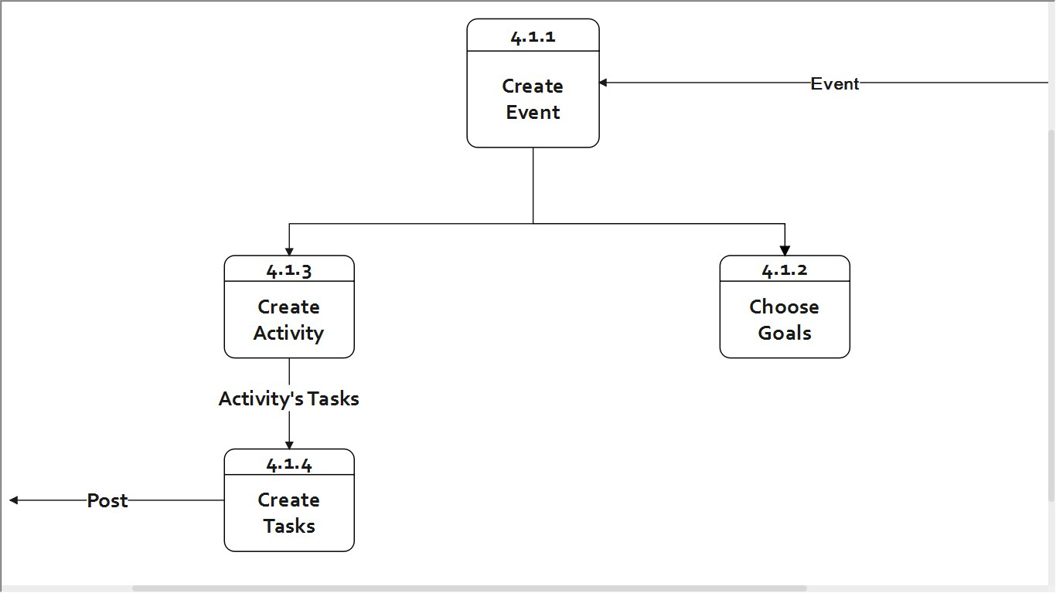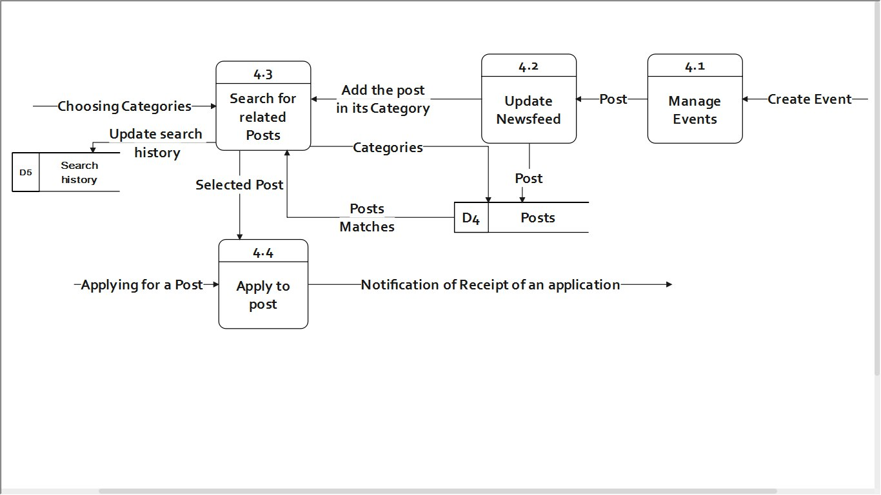

Figure : DFD - Level 2 Process 4.1

Figure : DFD - Level 1 Process 4

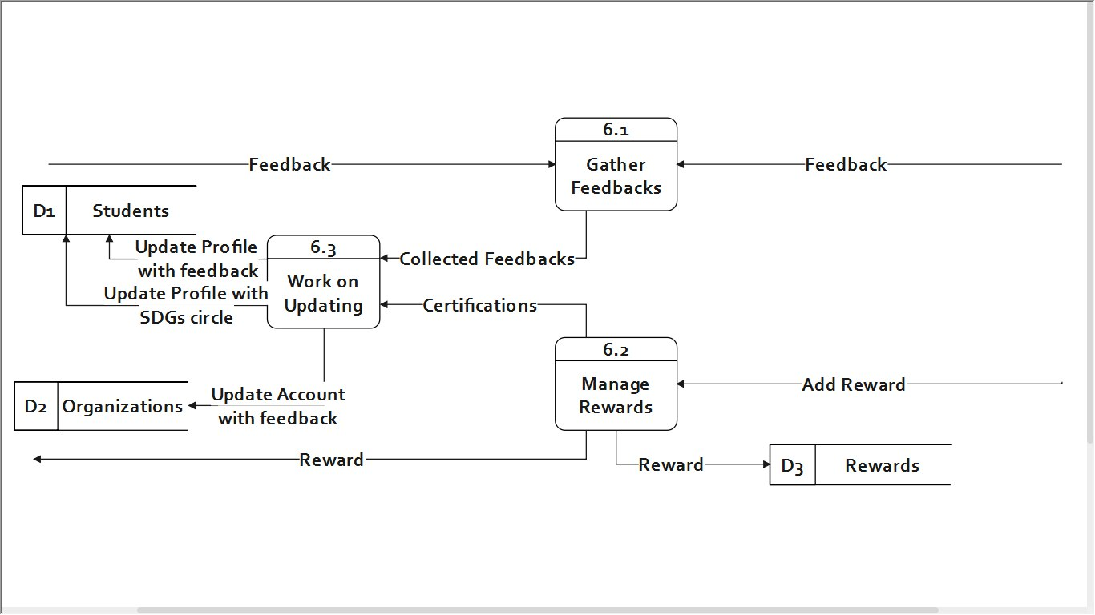

Figure : DFD - Level 1 Process 6

### **3.2 UML**

#### **Use Case Diagrams:**

After knowing and tracing our flow of data in the Data Flow diagrams, we decided to use Unified Modeling Language to specify the behavior and structure of system in more detail.

Firstly, we created a Use-Case diagram that shows all the possible interactions between our four actors; Student, Organization, Admin and Database, notice that two of these actors were shown in the DFD as entities and the other two were added here for the Use Case to make more sense.

The Use cases in the figure reflect all the features and interaction in our system from registration to sending feedback and reward. Most of the use cases include the ‘update database’ use case because any change occurring to these use cases will require a parallel change in the database.

Note that the Admin actor is connected to only one use case, ‘login’, because the admin has access to view and alter (if required like for safety purposes for example) all user interaction that happen post login and connecting the Admin to all use cases didn’t seem like the most efficient idea hence, the one connection to ‘login’.

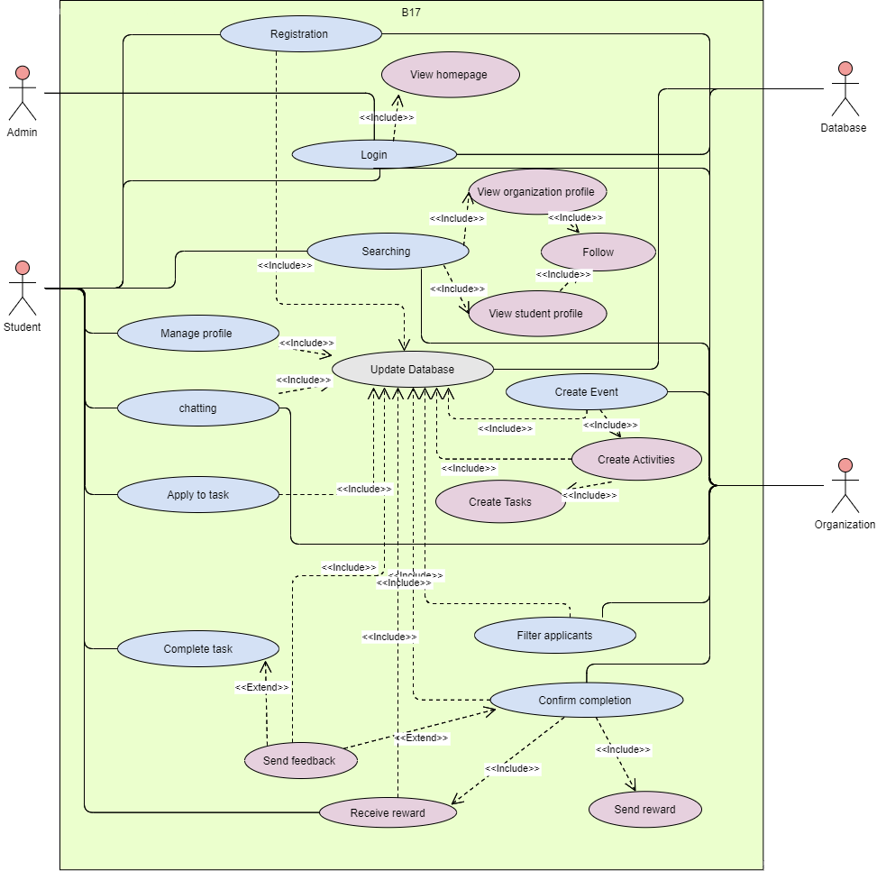

Figure : Use Case Diagram

#### **Activity Diagrams:**

Events activity diagram:

This activity diagram shows the activity flow in the following use cases: Create Event, Create Activity, Create Tasks, Apply to task, Filter applicants.

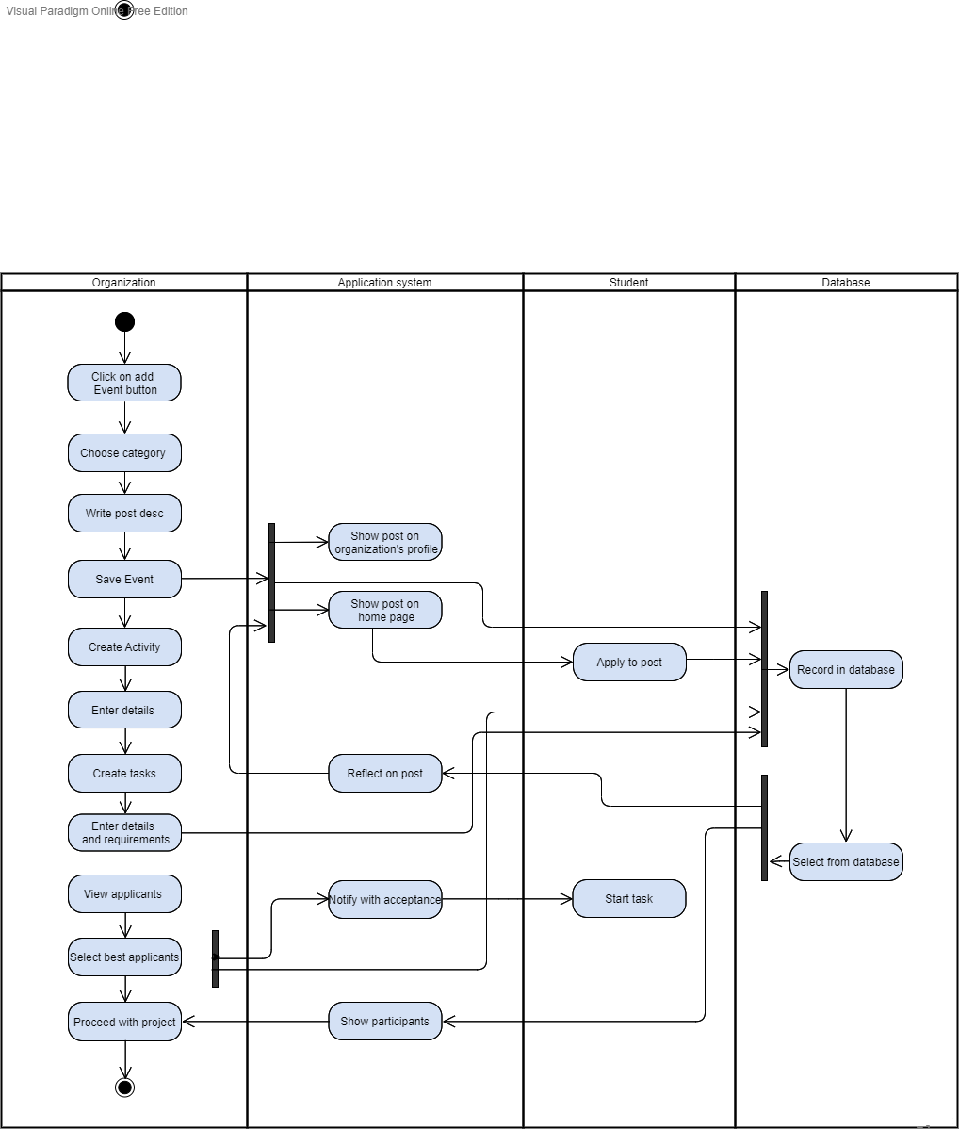

Figure : Events Activity Diagram

*Post-Event activity diagram:*

This activity diagram shows the activity flow in the following use cases: Complete task, Confirm completion, Send feedback, Send reward, Receive reward.

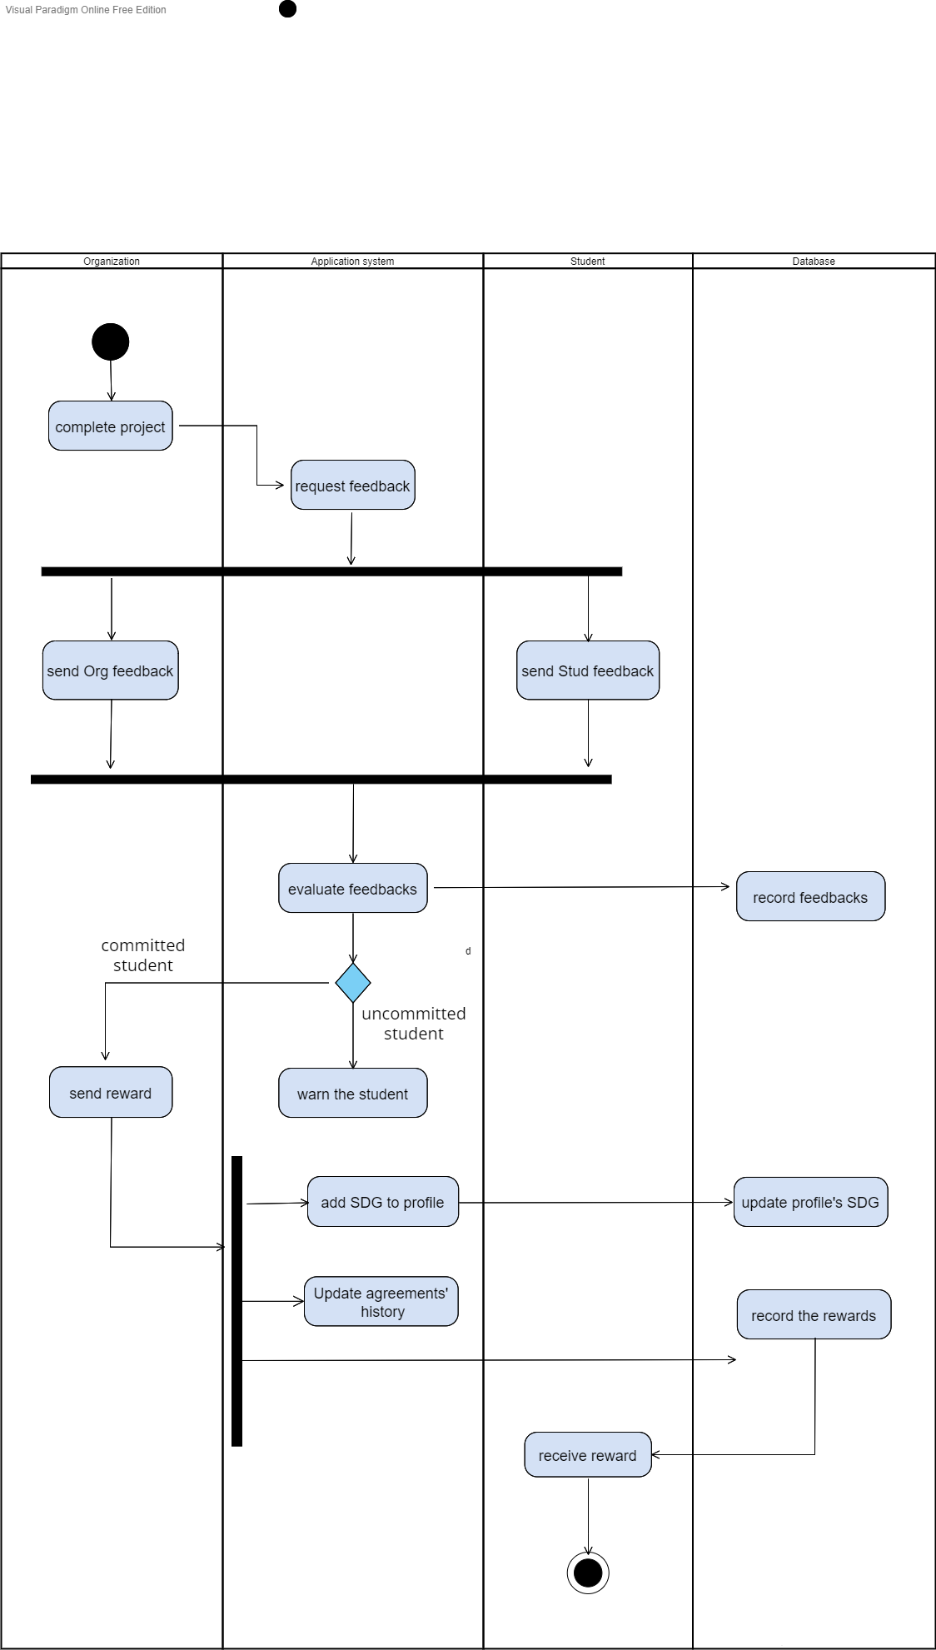

Figure : Post- Events Activity Diagram

#### **Sequence Diagrams:**

*User sequence diagram:*

This diagram describes the sequence of interactions and data for a user on our system, by user we mean both organization and student users because all the actions shown below is common in both.

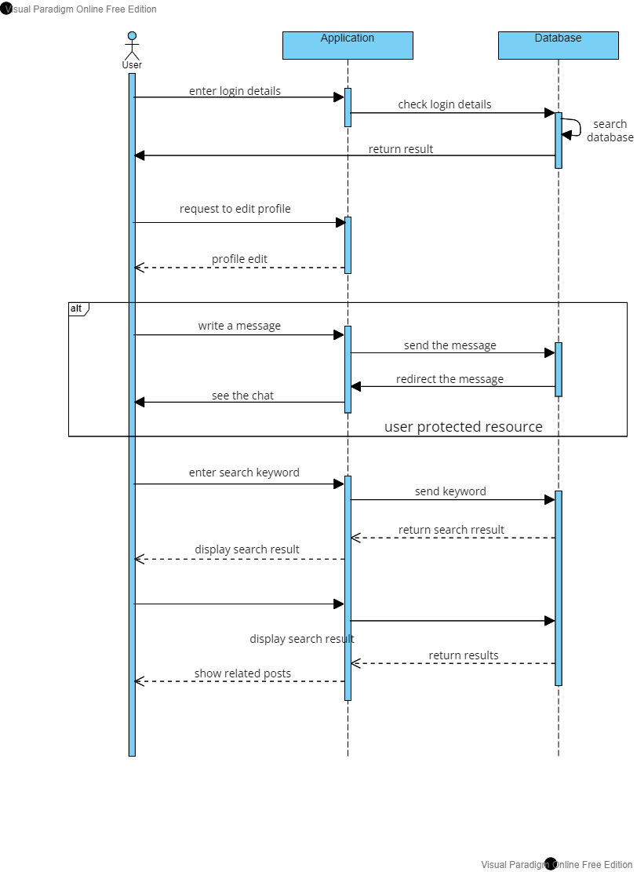

Figure : Sequence Diagram - User POV

*Student sequence diagram:*

Unlike the previous diagram, this diagram shows the sequence of interactions with respect to the student users only.

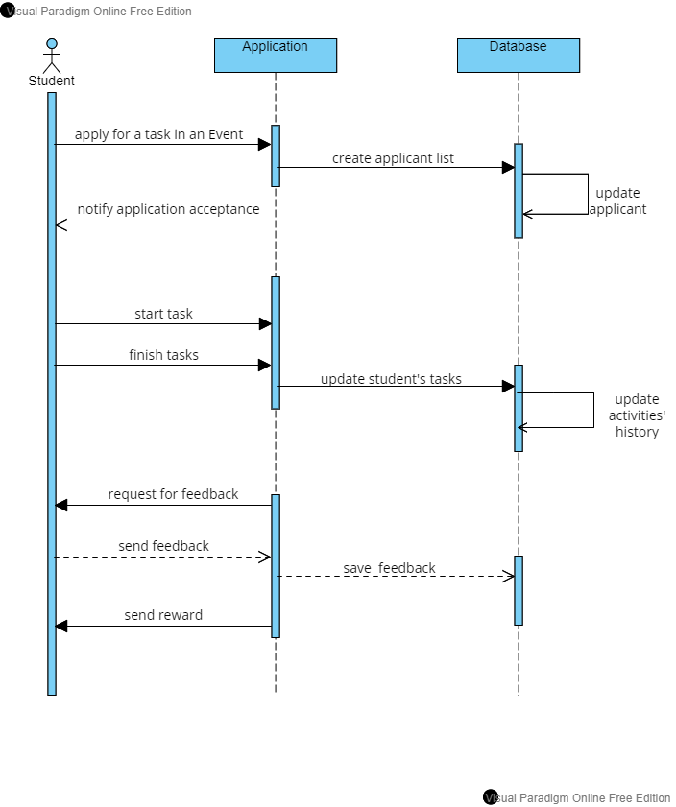

Figure : Sequence Diagram - Student POV

*Organization sequence diagram:*

This diagram shows the sequence of interactions with respect to the organizations users only.

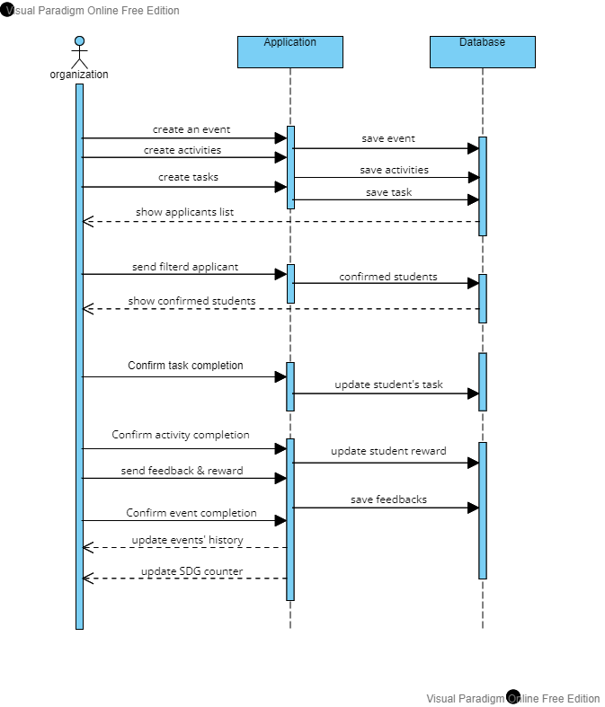

Figure : Sequence Diagram - Organization POV

### **3.3 Entity Relationship diagram**

After analyzing our system’s data flow, structure, interaction, and behavior we build up our ER diagram.

ERD entity map:

*Contains the organizations’ names and other attributes*

*People who order munchies madness products whether in*

*the shop or through the online app.*

*People who order munchies madness products whether in*

*the shop or through the online app.*

*People who order munchies madness products whether in*

*the shop or through the online app.*

Organizations

1. :contains

*Contains the successfully registered students*

Students

*Contains student’s skills which is a multi-valued attribute*

Skills

*Contains every student skill details*

Skills details

*Contains student’s interests which is a multi-valued attribute*

Interests

*Stores only accepted applicants for each event and task*

Selected students

*Contains the posted events*

Events

*Contains the activities of each event*

Activities

*Contains the tasks of each activity*

Tasks

*Contains the rewards sent to Students and its attributes*

*Contains the 17 Sustainable Development Goals*

*Connects the event with the SDGs it’s contributing to*

Rewards

SDGs

Event SDGs

*Stores the events as posts with posting details*

Post

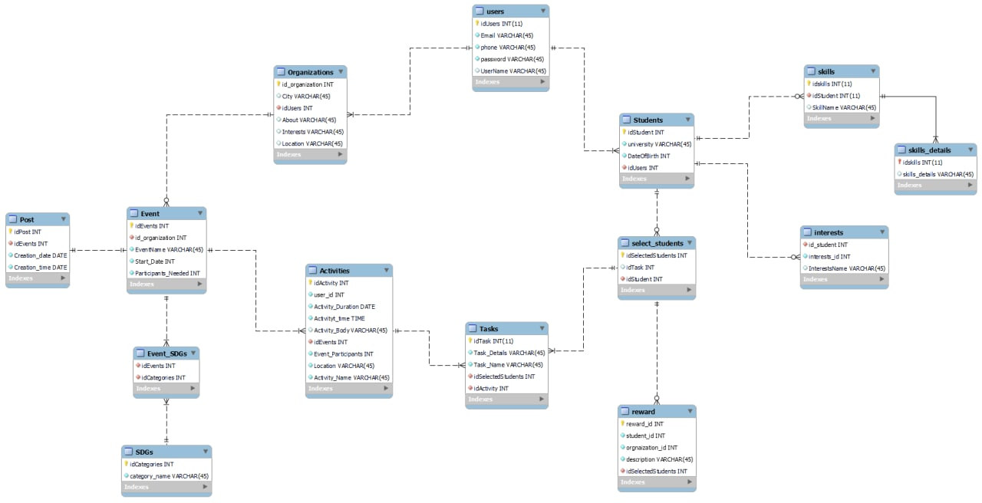

Figure : Entity Relationship Diagram

# **Chapter (4): Feasibility and (lean) Business Model Canvas**

## **4.1 Business Model Canvas**

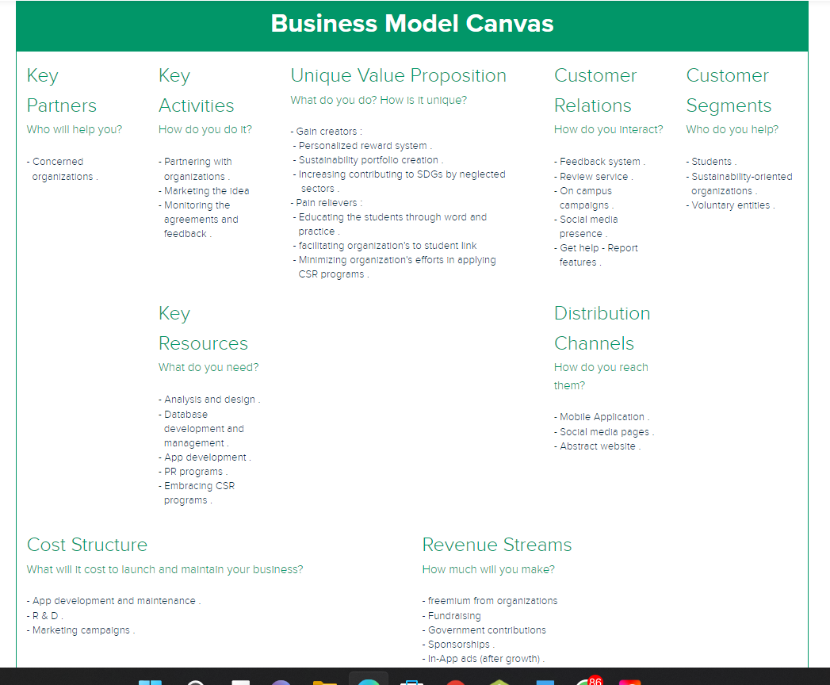

Figure : Business Model Canvas

## **4.2 Competitor’s analysis**

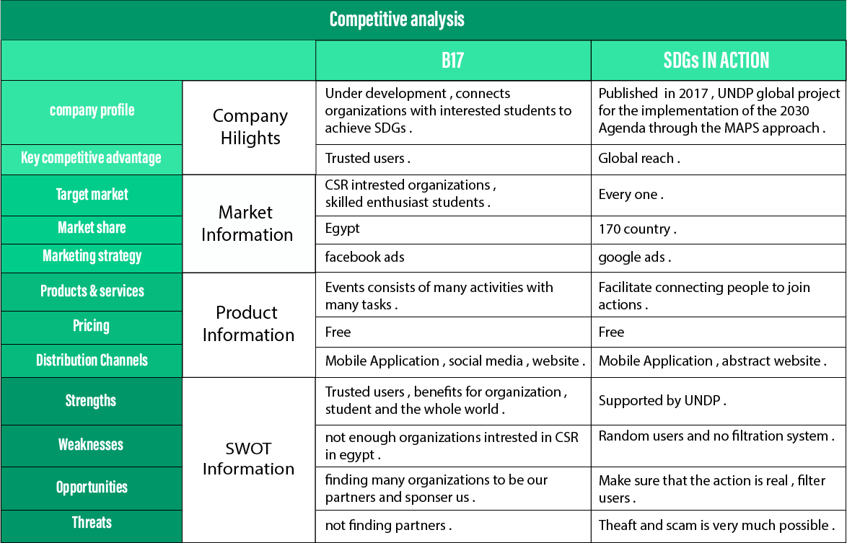

Figure : Competitors’ Analysis

## **4.3 Revenue stream analysis**

Our revenue stream model is divided into two phases, where each phase consists of a specialized mix of revenue model components that best fit it, the phase’s duration is controlled by the App development, which is mainly measured by the number of active users and number of posts created.

*The first phase* focuses primarily on covering all the marketing and PR costs exhausted in making the B17 brand and idea more popular and generating more users and posts until we reach our set target for this phase, so basically we want to break even, excluding all efforts exerted by us as owners and developers of course.

Our revenue streams are expected to be:

1. Fundraising
2. Sponsorships
3. Government contributions

*The second phase* is triggered by reaching a sufficient development level to apply the following methods of revenue streams:

1. In App advertisement

In App ads is a very profitable revenue source when used correctly with enough number of active users, we plan on marketing for this opportunity for relevant companies where our App gives them the perfect environment for ads and specific customer targeting. We intend to use this method for a very long time if successful.

1. Freemium

We are considering creating an extra package of services for the recruiting organizations which would facilitate their process, increase their visibility and recommendations for the interested students and offering it as a premium package, but we only intend to do this on the very long term. Also note that freemiums and In App ads go hand in hand, so that’s a plus.

## **4.4 Initial marketing plan**

To start off our initial marketing plan first we formulated our long-term and short-term goals and objectives as per the students and organizations.

*Our long-term goals are as follows:*

For the students:

* Provide the students with a very accessible space where they could find opportunities to practice their knowledge and studies and gain more practical experience.
* Teaching the students what SDGs are and make contributing to sustainability more beneficial on the personal level and simply more fun.

For the organizations:

* Facilitating the application of CSR programs with the hope of encouraging contributing to the sustainable development on the corporate level as well.

*Our short-term objectives are all timed up by the end of 2022 and they are:*

For the students:

we should have *50* students signed up and verified on the App

For the organizations:

We should pitch our idea to *20* or more organizations

Have at least *8* organizations signed up

Have at least *5* event posts created on B17

After researching the organizations in Egypt actively working towards a more sustainable future, we created the following list of the ones which we could target to partner with and pitch our idea.

Potential Organization partners list:

1. Banlastic
2. Safe
3. Goethe institute
4. Rotaract
5. Juhayna
6. Aiesic Egypt
7. AASTMT community service programs
8. HCC
9. Conferences
10. Tedx
11. Alexandria university
12. Library of Alexandria
13. Alexbank
14. CIB
15. NBE
16. Birla Carbon
17. ITIDA
18. TIEC

We plan on contacting these organizations and pitching them our idea, we found that a real life pitching whether through scheduling a meeting, networking in conferences or through an intermediate contact/acquaintance is the best way to get their attention, online meeting could work too, but emails are not the place to pitch it comes off as a promotion and that is not what we want.

Our marketing means:

* Social media marketing
* On campus campaigns
* SEO for our website
* YouTube video ads

# **Chapter (5): Implementation and Testing**

## **5.1 Tools used:**

**UX/UI Design Tools:**

 Adobe XD:

Is a vector-based UI and UX design tool and it can be used to design

anything from smartwatch apps to fully fledged websites.

Adobe Illustrator:

Is a software application for creating drawings, illustrations, and artwork using a Windows or MacOS computer.

Photoshop:

Is an image creation, graphic design and photo editing software developed by Adobe. The software provides many images editing features for pixel-based images, raster graphics and vector graphics.

Visual Studio Code (famously known as VS Code):

Is a free open-source text editor by Microsoft.

Bootstrap:

Is the most popular HTML, CSS and JavaScript framework for developing a responsive and mobile friendly website.

**Front end Tools:**

HTML:

Is an acronym which stands for Hyper Text Markup Language which is used for creating web pages and web applications.

CSS:

Cascading Style Sheets is the language for describing the presentation of Web pages, including colors, layout, and fonts.

JavaScript (JS):

Is a scripting language, primarily used on the Web. It is used to enhance HTML pages and is commonly found embedded in HTML code.

React Native:

Is a JavaScript framework for writing real, natively rendering mobile applications for iOS and Android. Plus, because most of the code you write can be shared between platforms, React Native makes it easy to simultaneously develop for both Android and iOS.

**3.Back-end Tools:**

MySQL Workbench:

Is a unified visual database designing. It provides SQL development, data modeling, data migration, and comprehensive administration tools for server configuration, user administration, backup, and many more.

XAMPP:

Is an open-source package of web solutions that includes Apache distribution for many servers and command-line executables along with modules such as Apache server, MariaDB, PHP, and Perl. It is a platform that furnishes a suitable environment to test and verify the working of projects based on Apache, Perl, MySQL database, and PHP through the system of the host itself.

GitHub:

Is an online software development platform used for storing, tracking, and collaborating on software projects. It enables developers to upload their own code files and to collaborate with fellow developers on open-source projects

Redux:

Is a predictable state container designed to help you write JavaScript apps that behave consistently across client, server, and native environments and are easy to test.

Firebase:

Is a Backend-as-a-Service (Baas). It provides developers with a variety of tools and services to help them develop quality apps, grow their user base, and earn profit. It is built on Google's infrastructure. Firebase is categorized as a NoSQL database program, which stores data in JSON-like documents.

**4.Statistics, Analysis and Documentation Tools:**

EdrawMax:

Is a powerful, all-in-one, and yet easy-to-use diagramming tool that can create and customize flowcharts, Venn diagrams, mind maps, organizational charts, Gantt charts, UML diagrams, electrical drawings, genograms, building plans, etc.

Data flow diagram (DFD):

Maps out the flow of information for any process or system. It uses defined symbols like rectangles, circles and arrows, plus short text labels, to show data inputs, outputs, storage points and the routes between each destination.

PowerPoint (PPT):

Is a powerful, easy-to-use presentation graphics software program that allows you to create professional-looking electronic slide shows.

Code documentation:

Is text that accompanies software code to explain what your code is doing, why it's written the way it is, and/or how to use it. There are two main categories of documentation: documentation inside the code and supporting documentation about the code.

UML:

Is popular for its diagrammatic notations. We all know that UML is for visualizing, specifying, constructing, and documenting the components of software and non-software systems.

Visual Paradigm:

Is a software application designed for software development teams to model business information systems and manage development processes.

Canva:

Is a free graphic design platform that's great for making invitations, business cards, Instagram posts, and more. A drag and drop interface make customizing thousands of templates simple and easy. Canva's wide array of features allow you to edit photos without extensive photo editing knowledge or experience

Academia:

Is a platform for sharing academic research.

Google Forms:

Is free online software that allows you to create surveys

## **5.2 User Interface design**

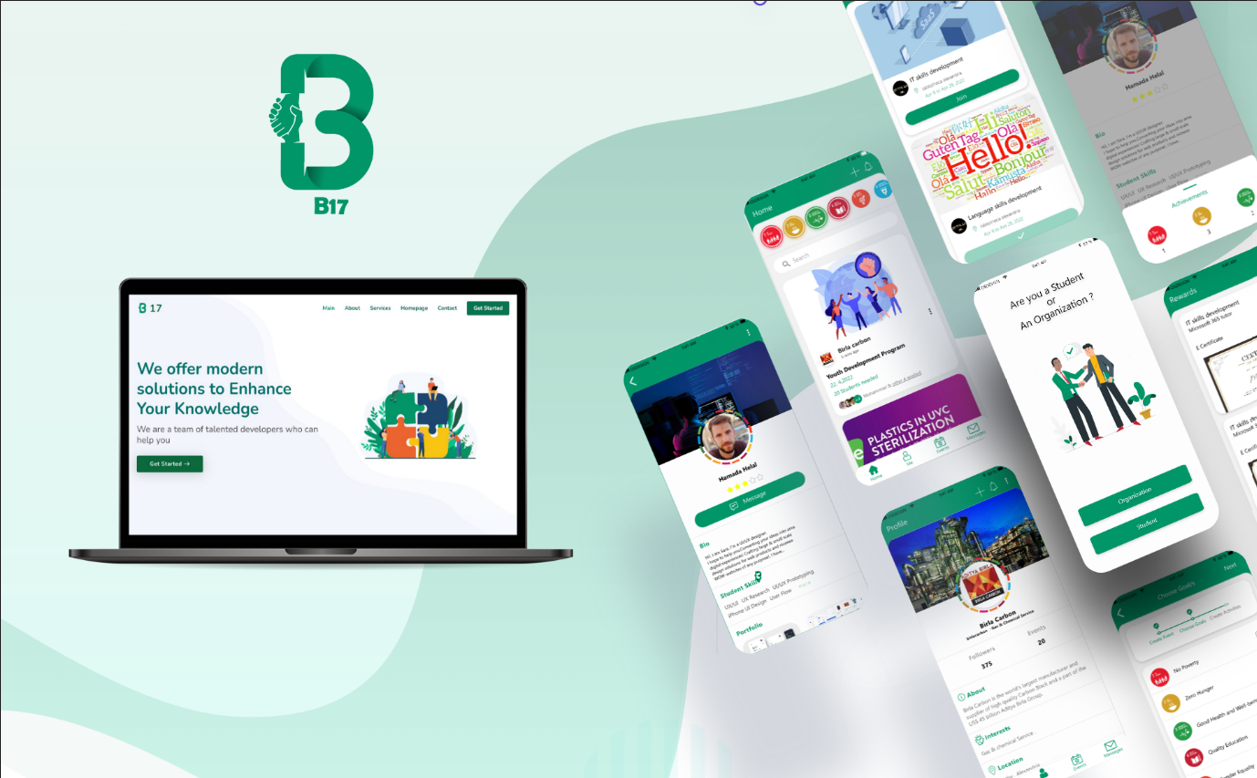

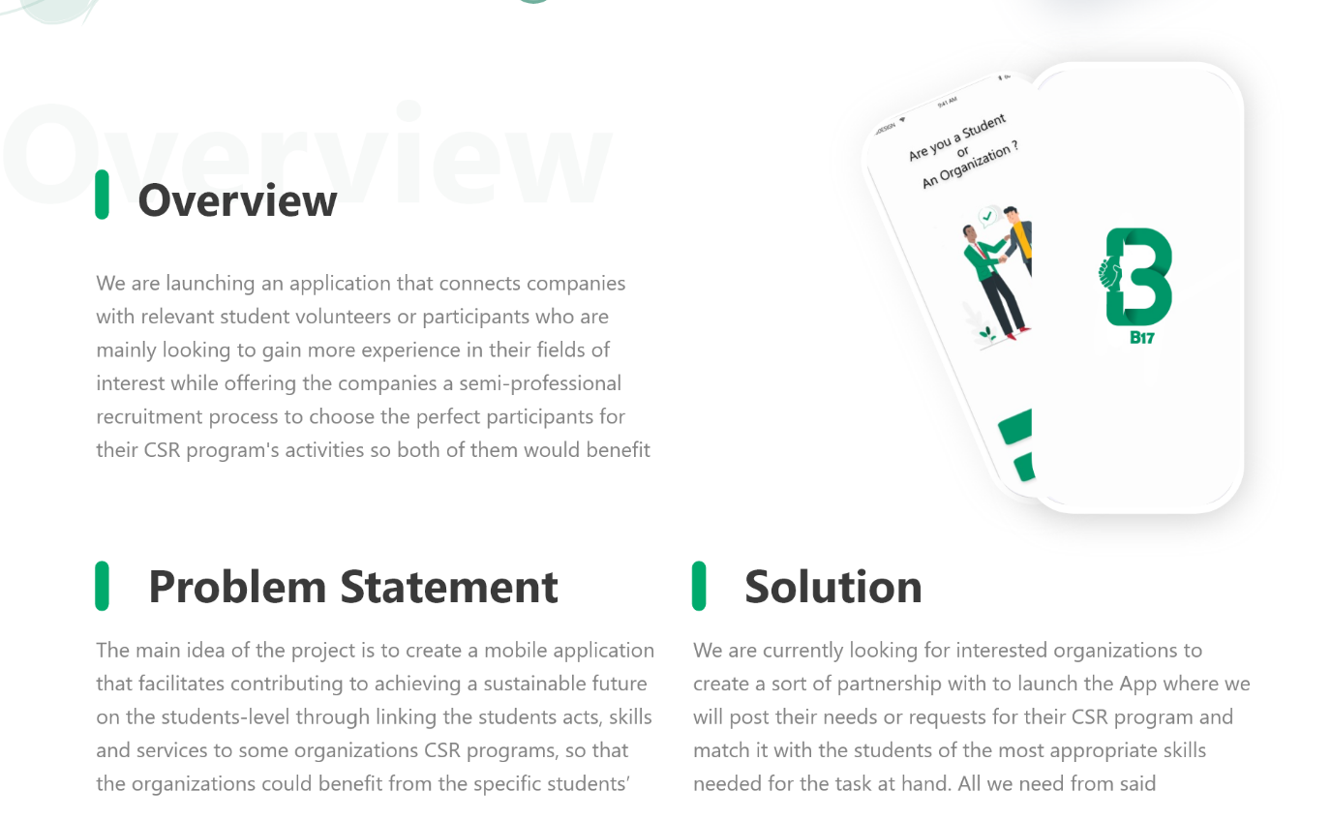

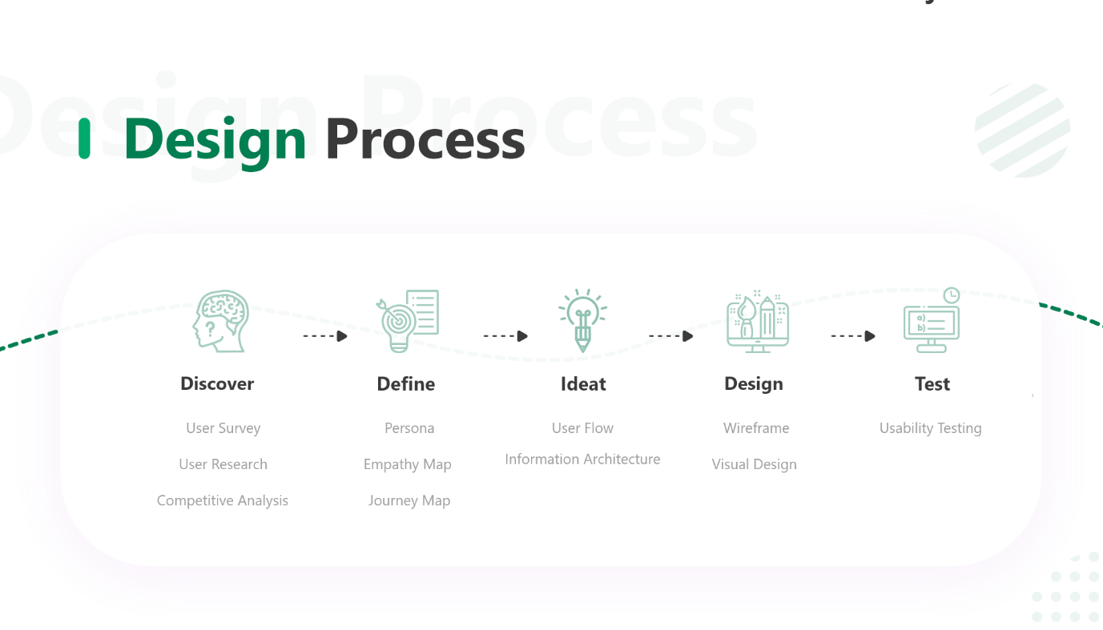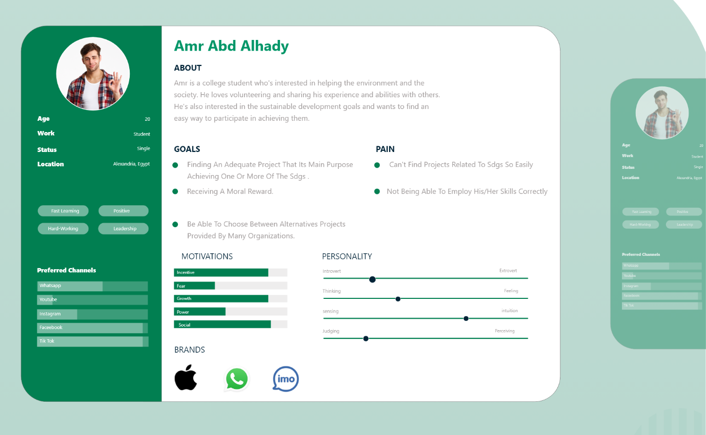

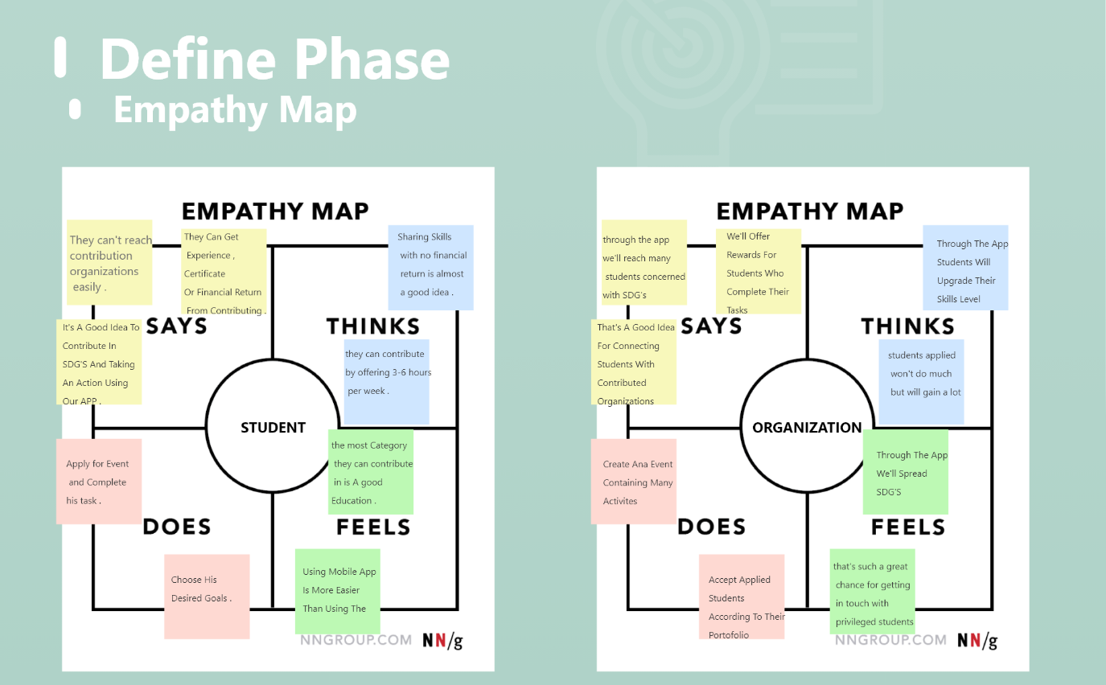

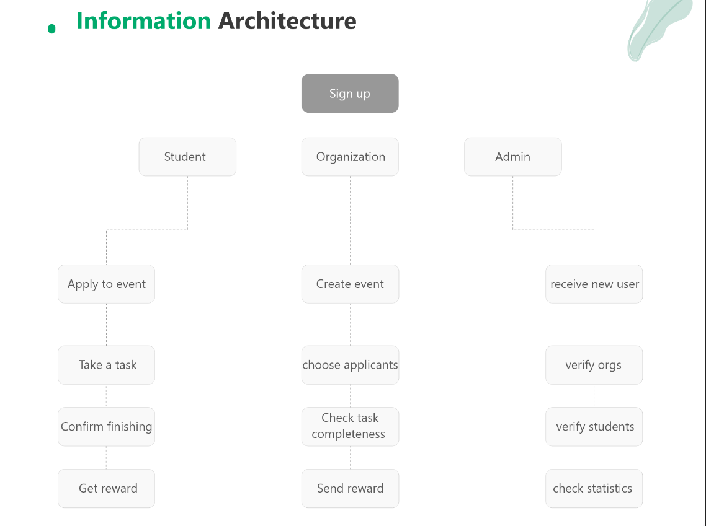

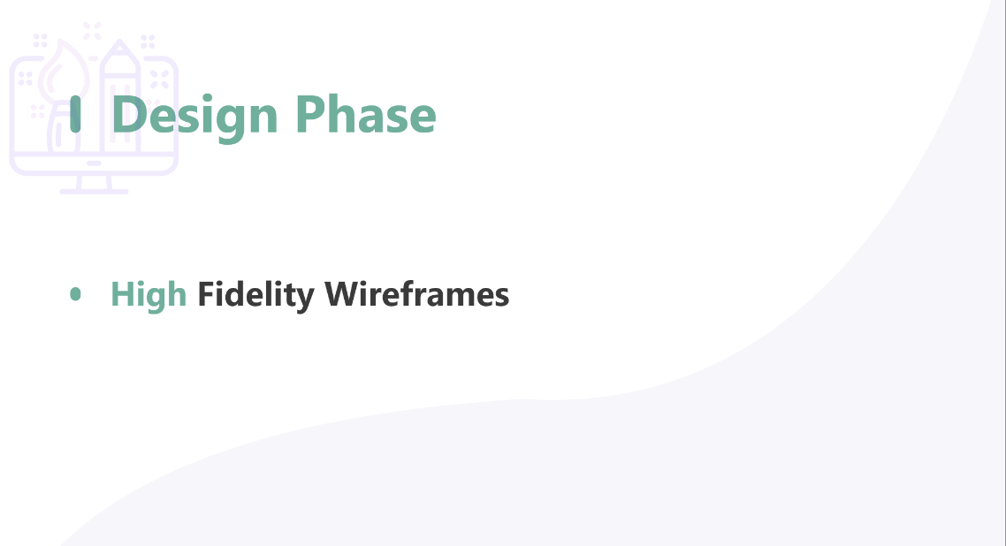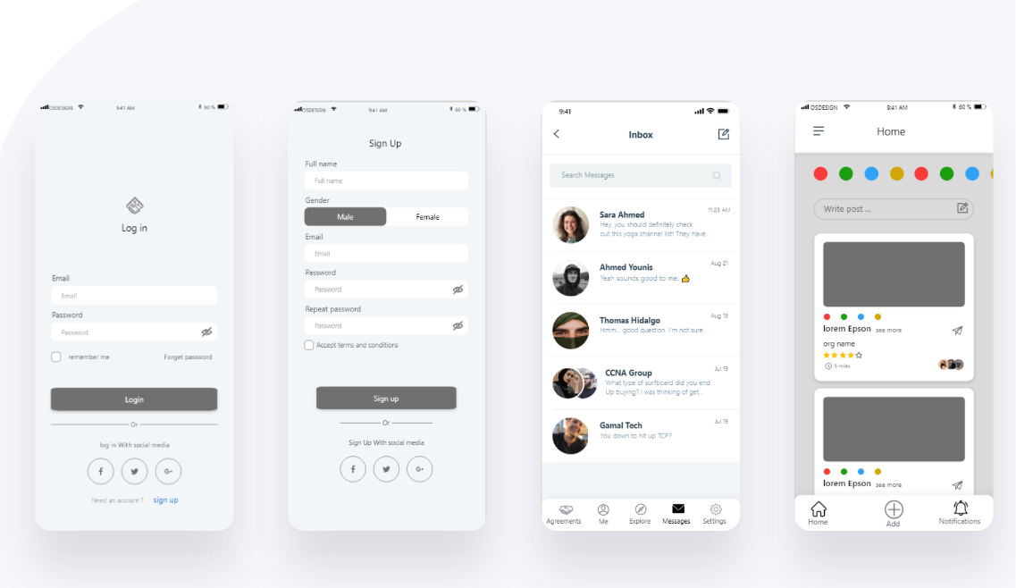

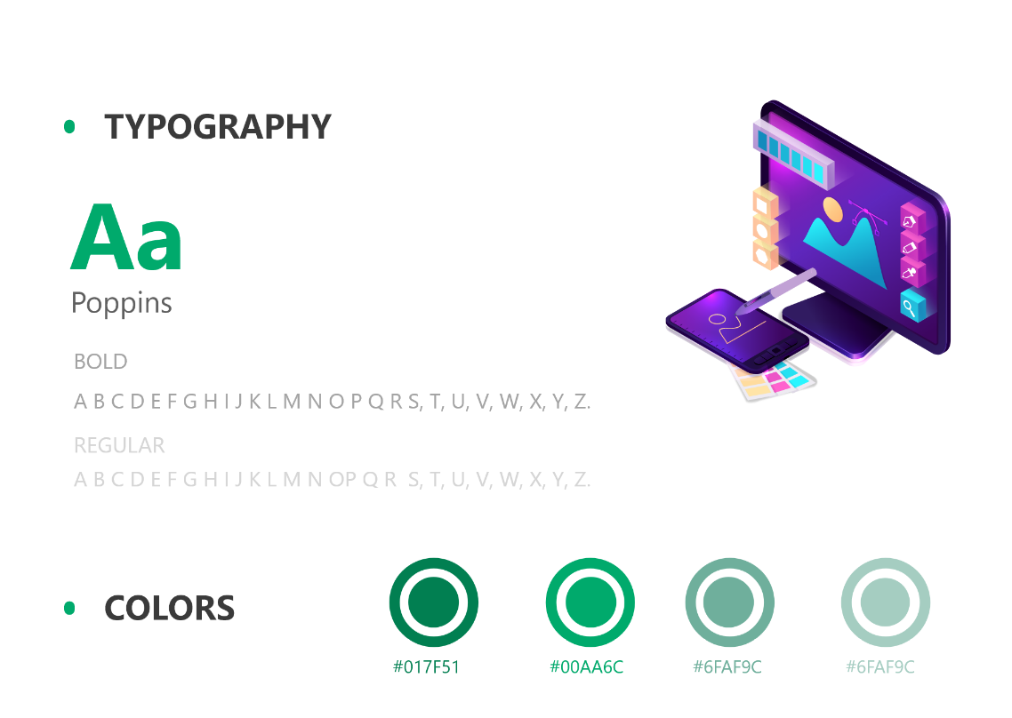

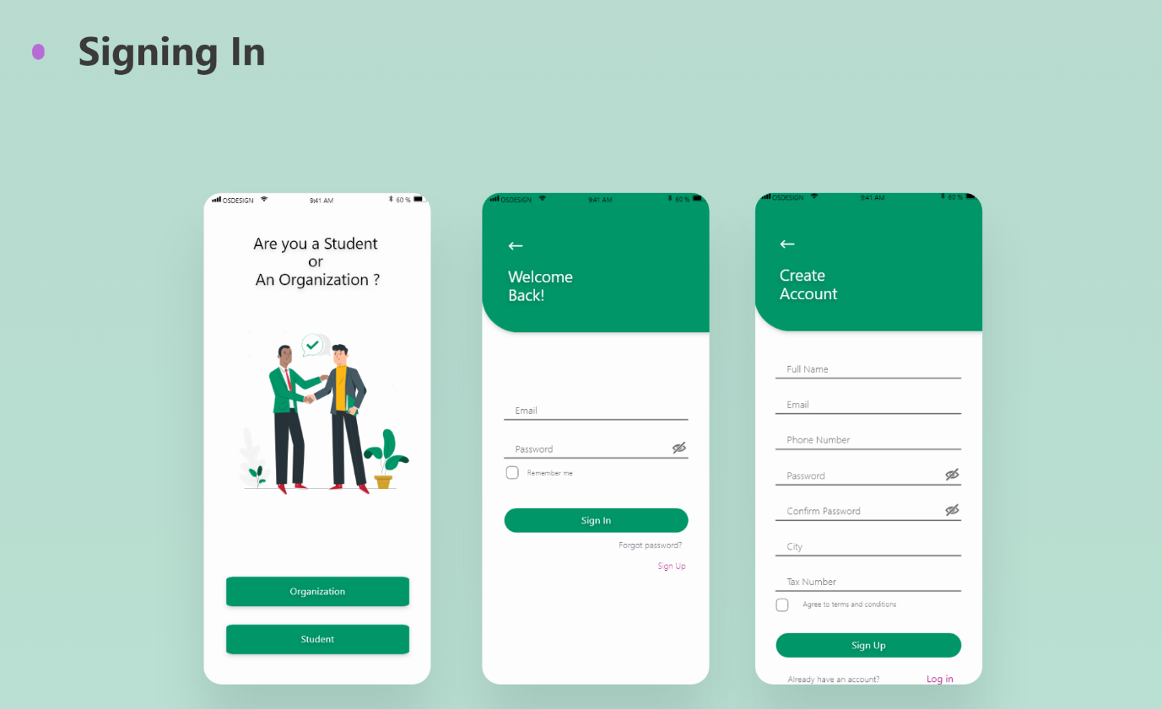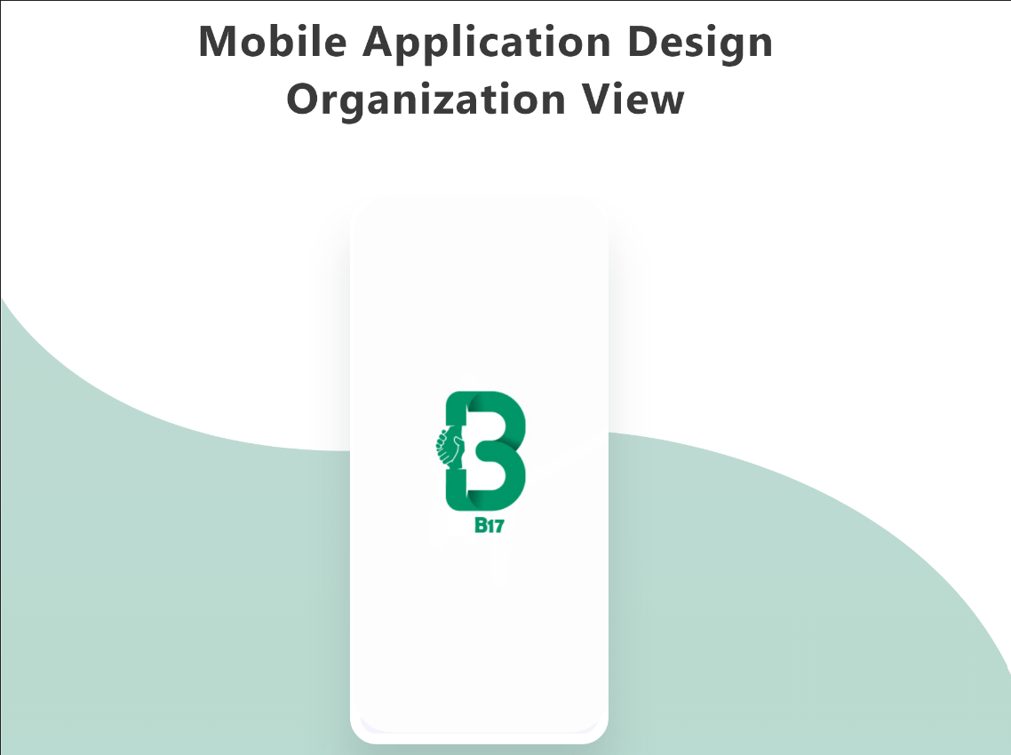

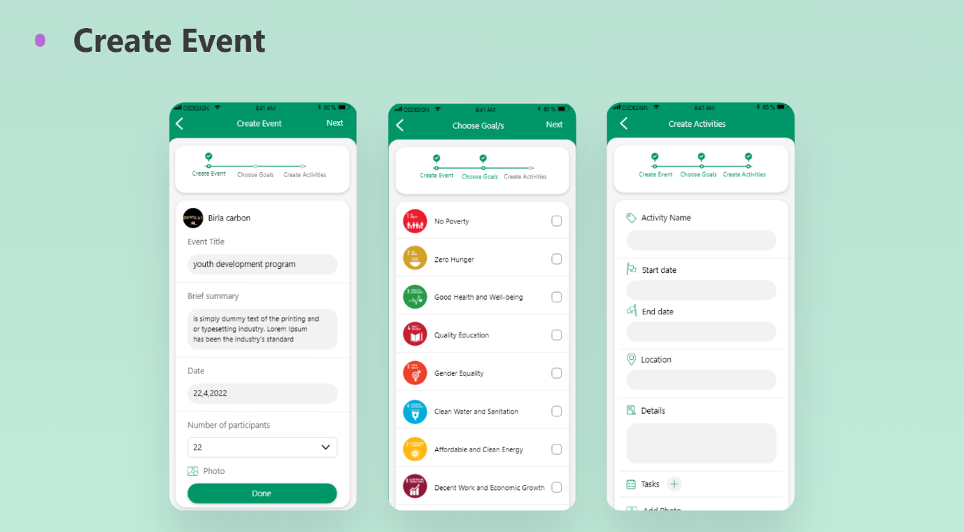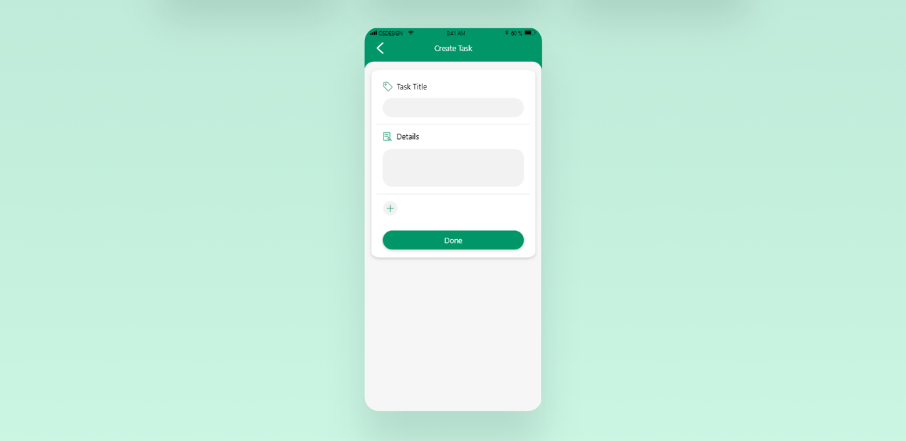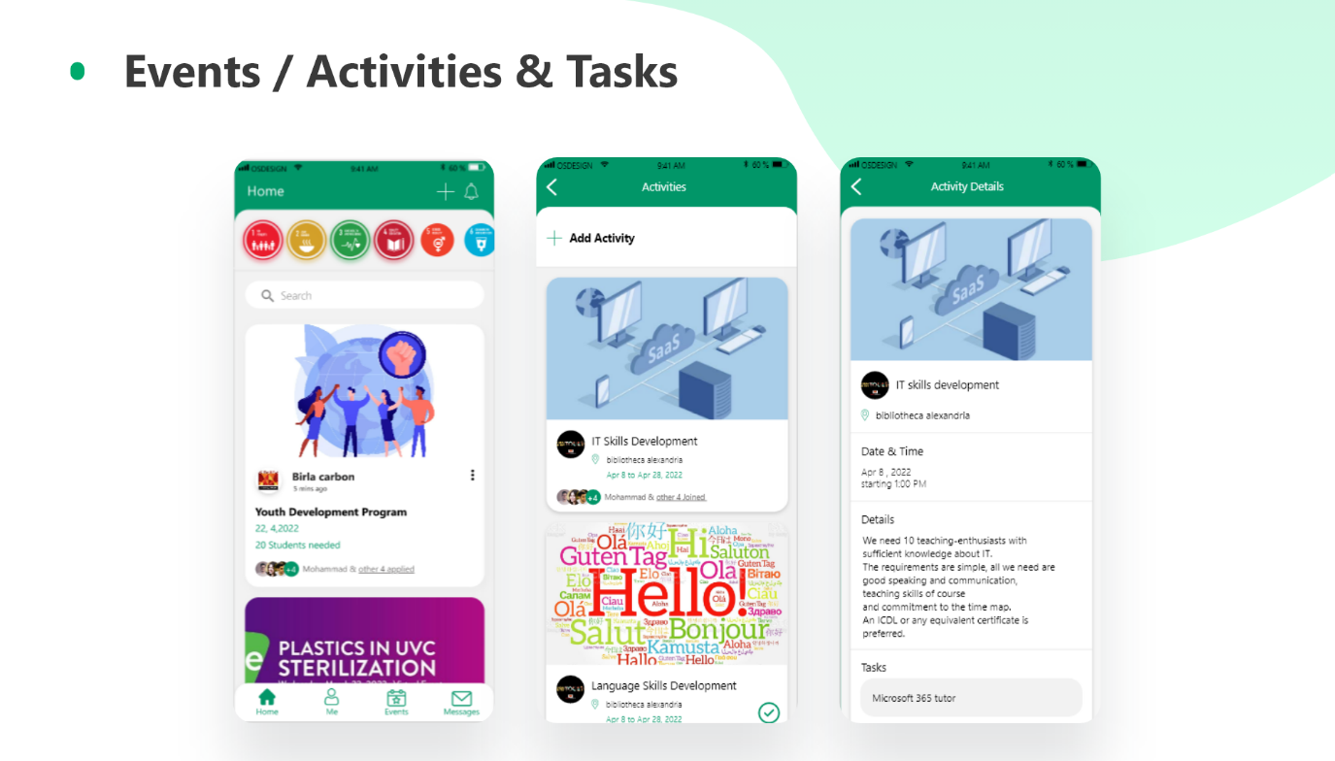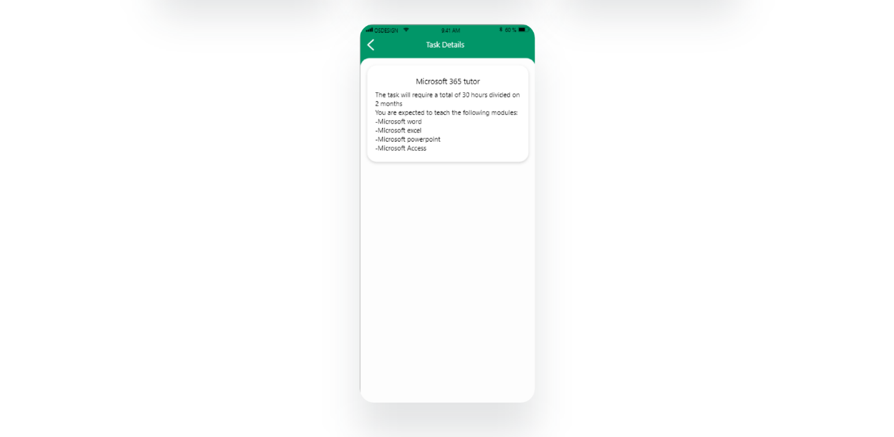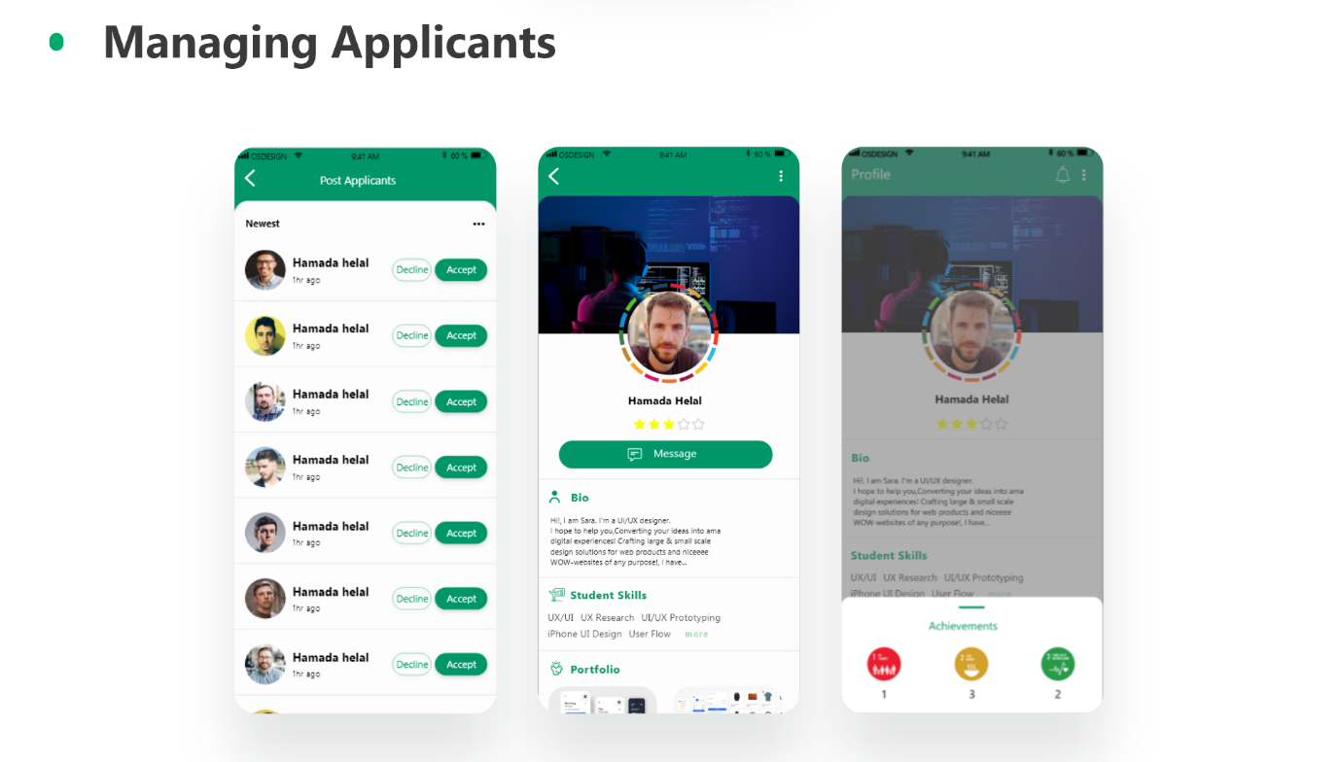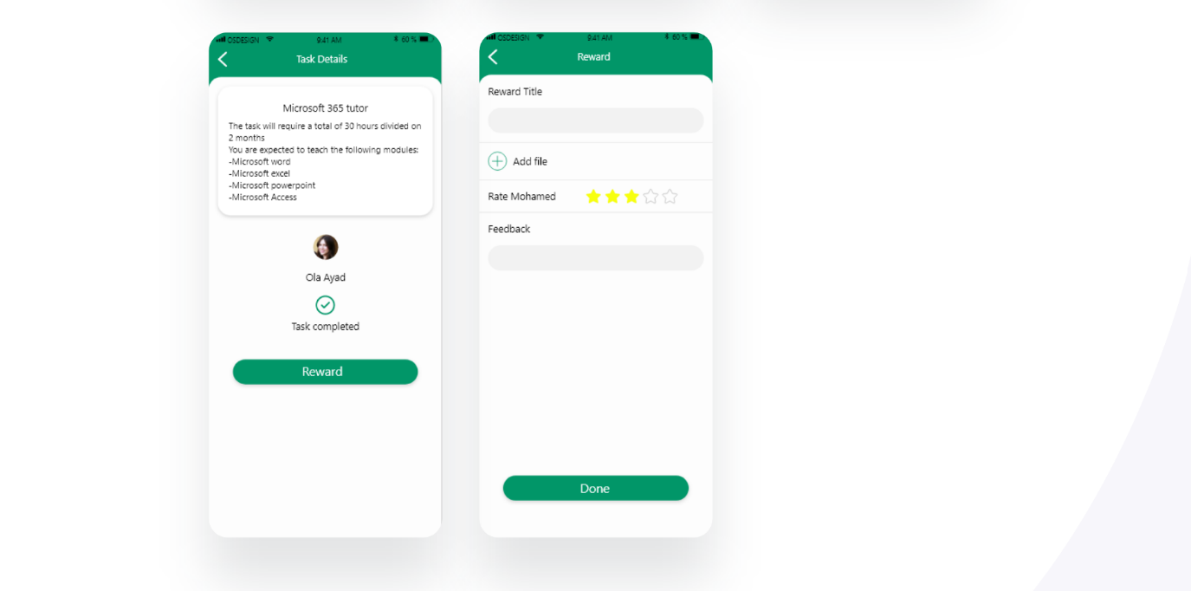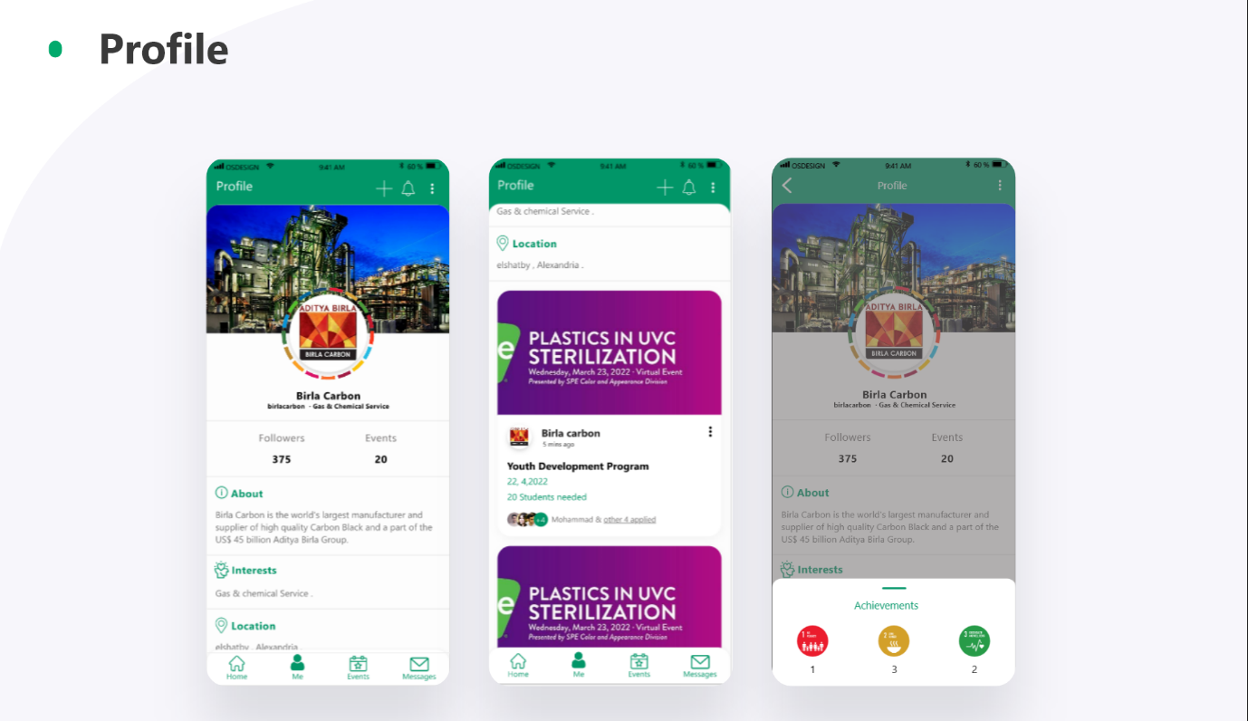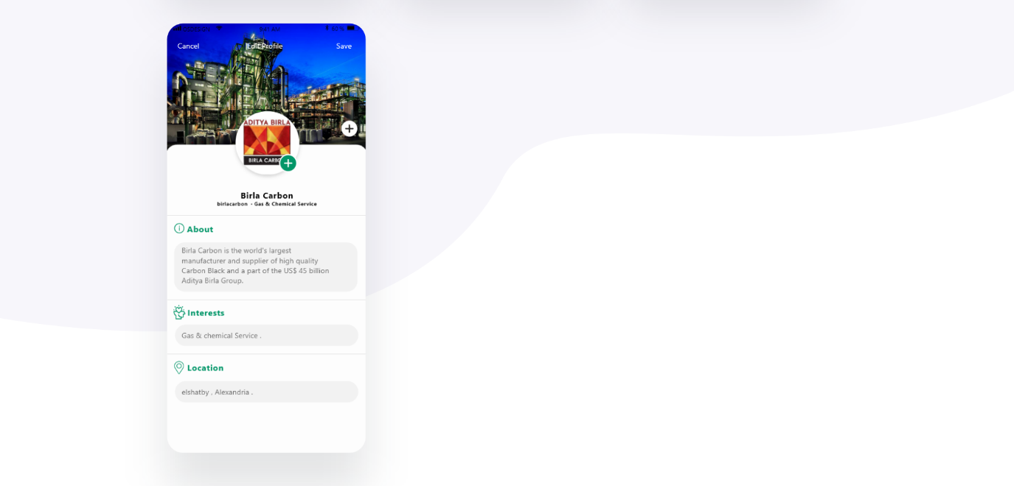

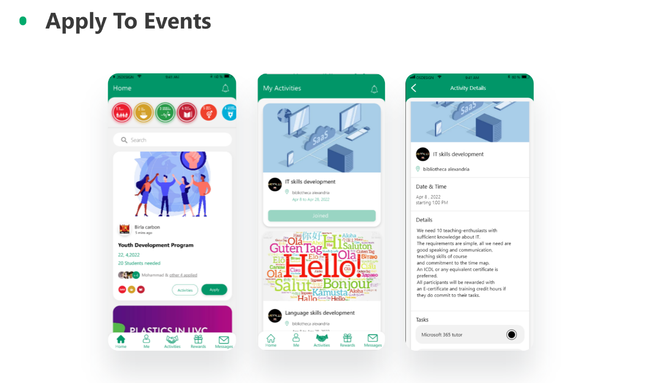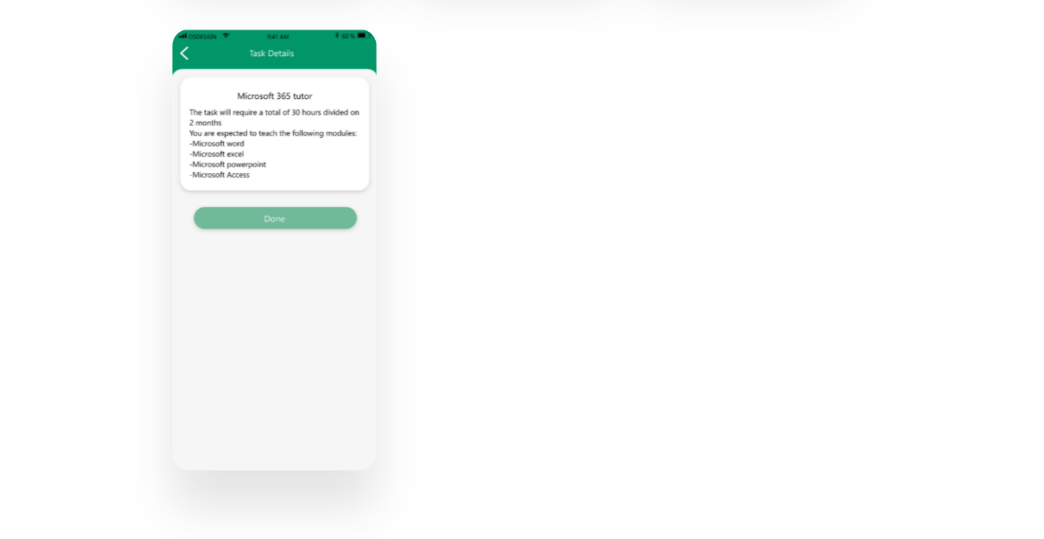

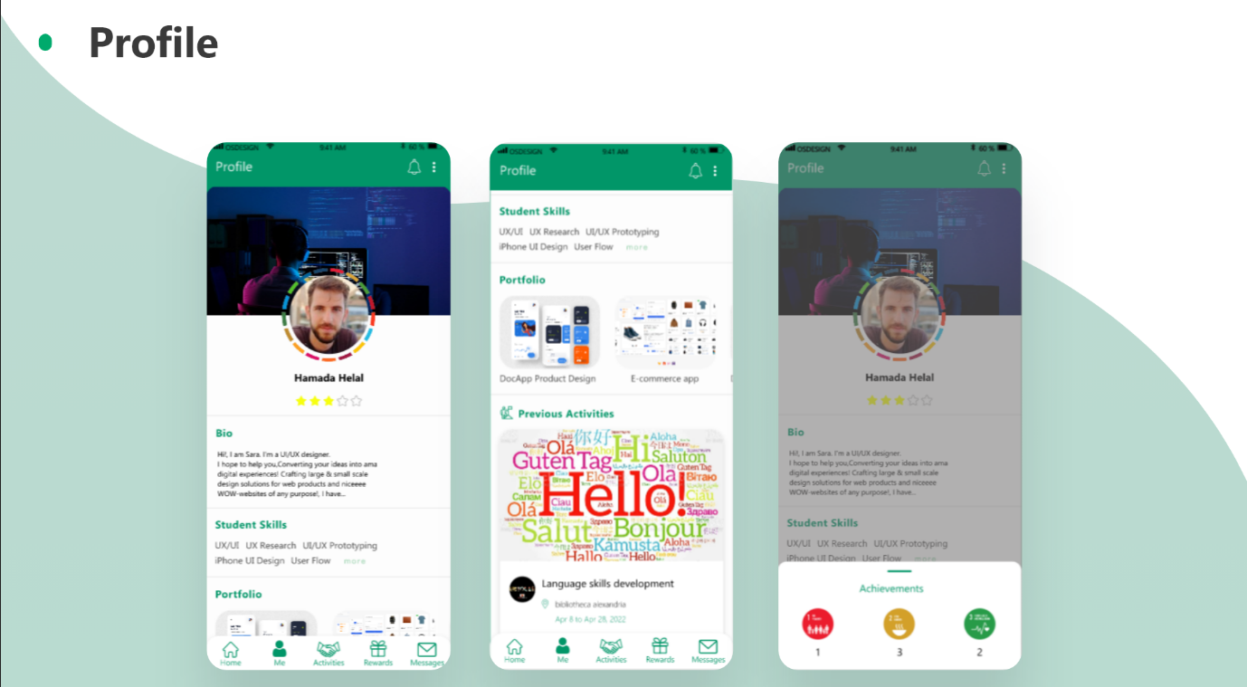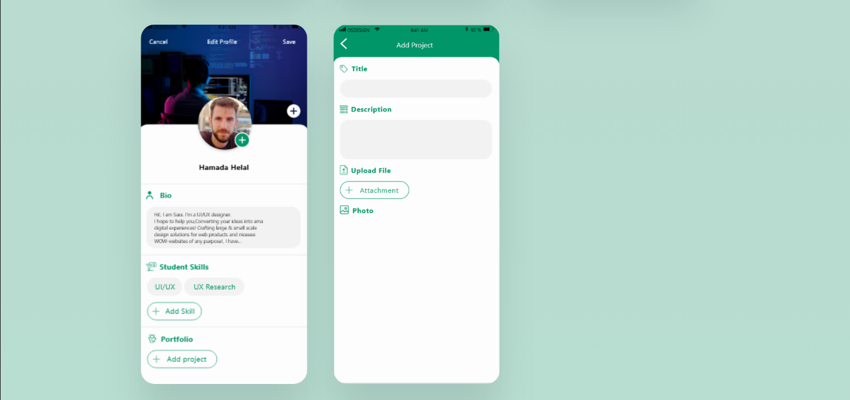

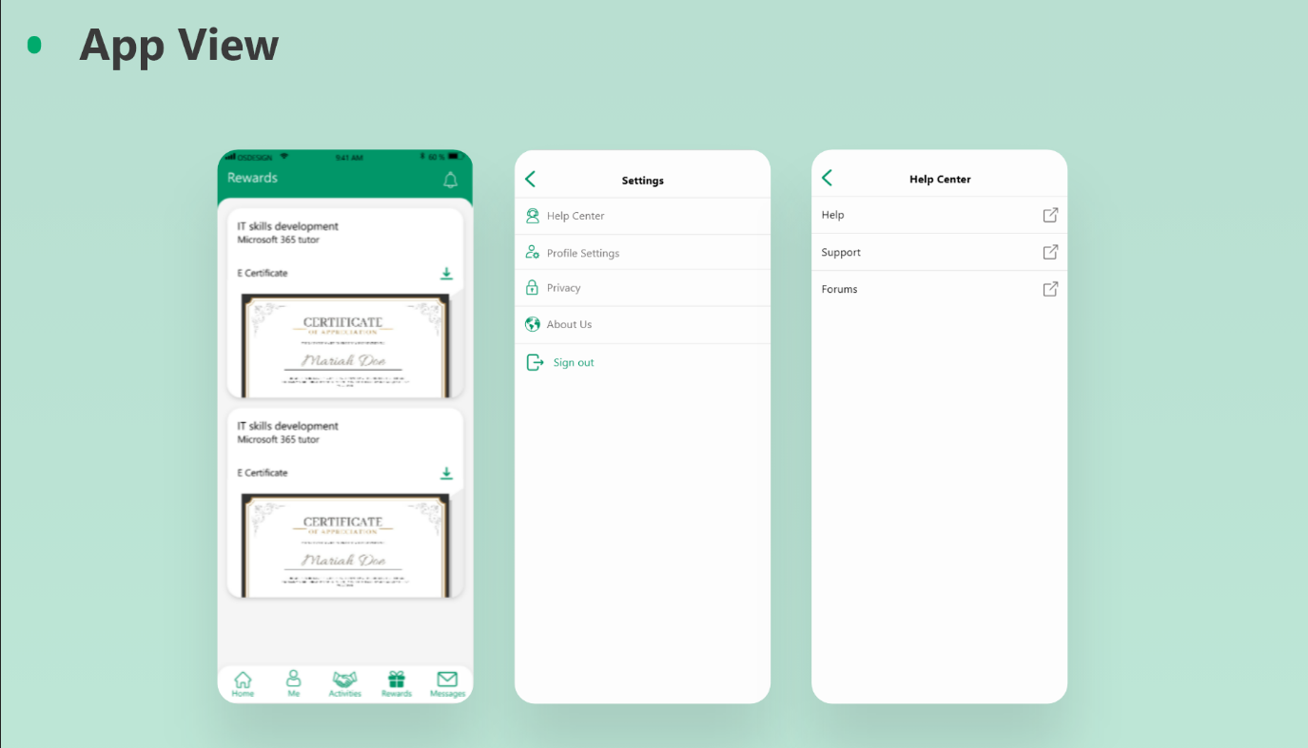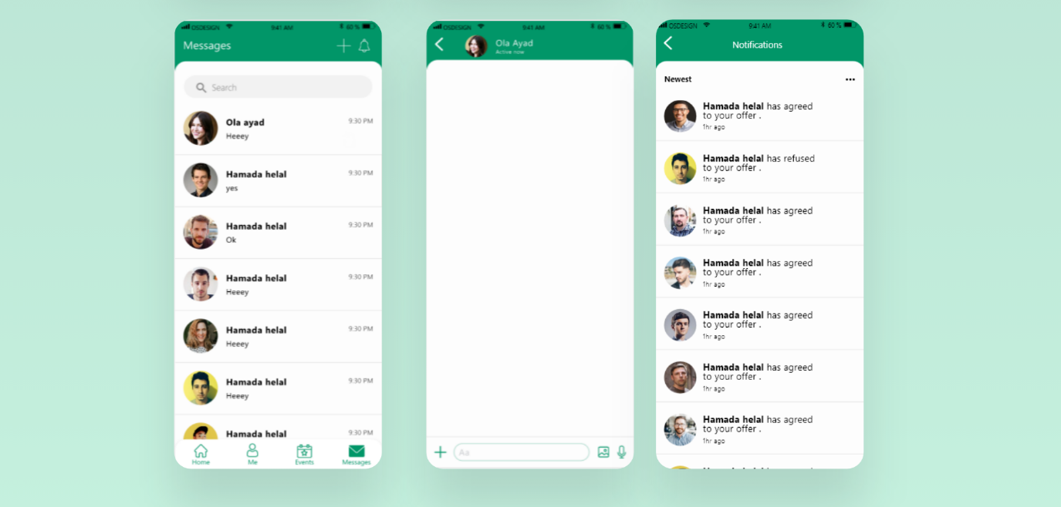

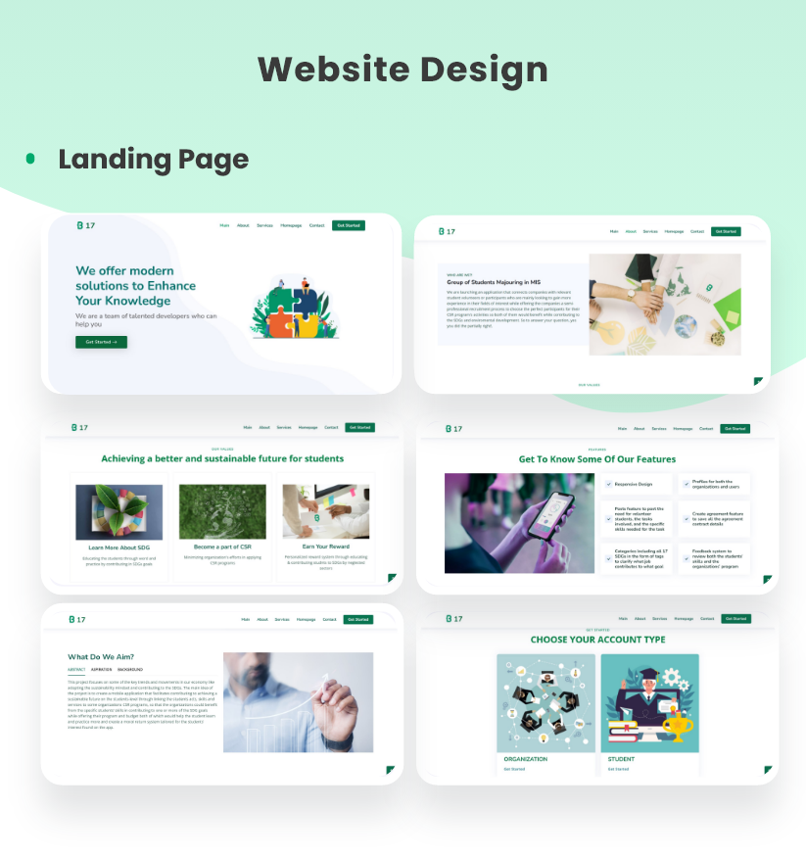

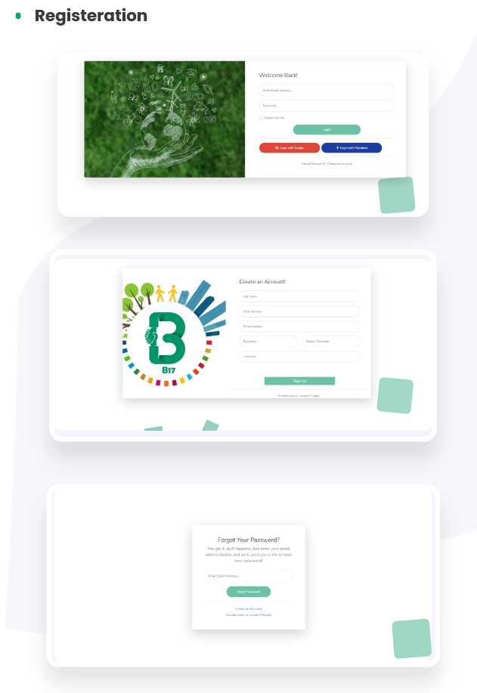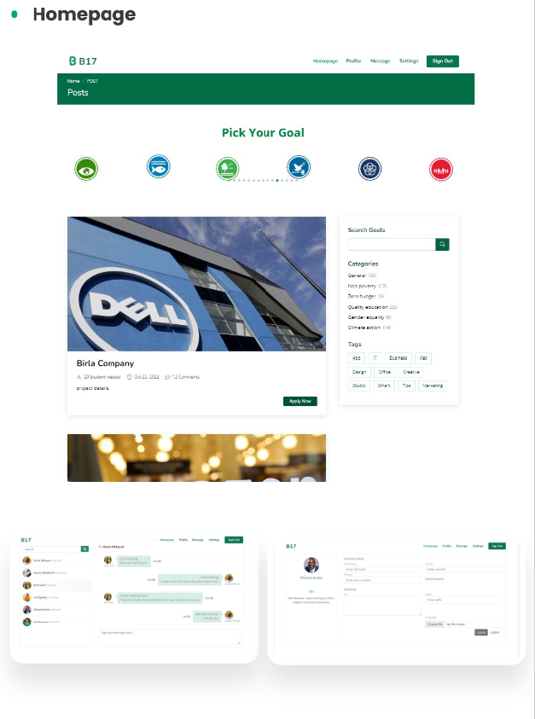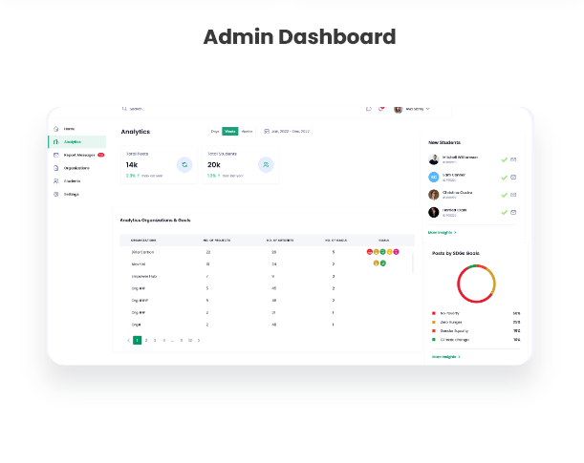

## **5.3 Application development**

In this section we will walk you through our App development and coding where we will firstly present you with the code itself and then the results as in the Application, presented as screenshots from the mobile app.

Listed below are all the languages, libraries and packages used shown as screenshots from the introduction chapter of the code’s documentation (a link to the full documentation file is found in the references page with a link to all code content as well).

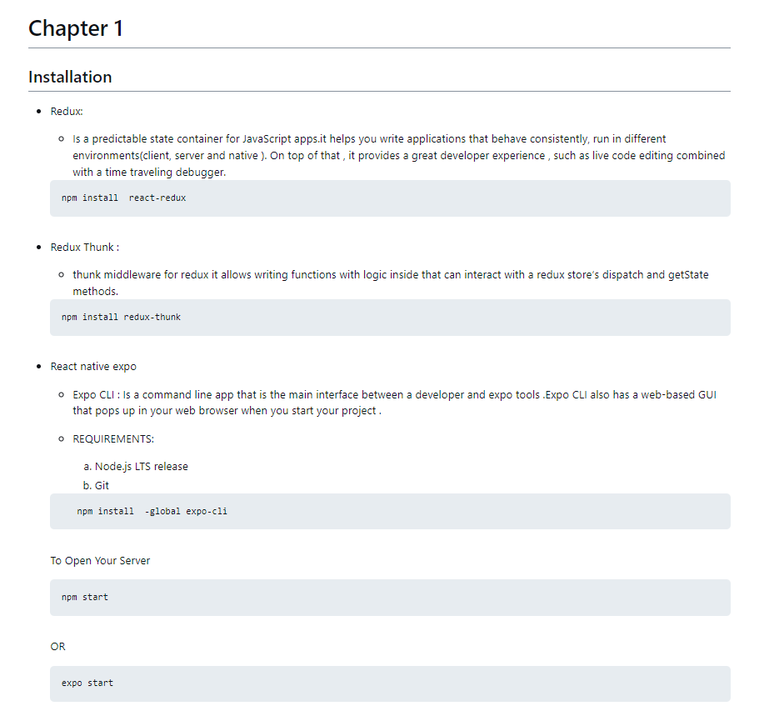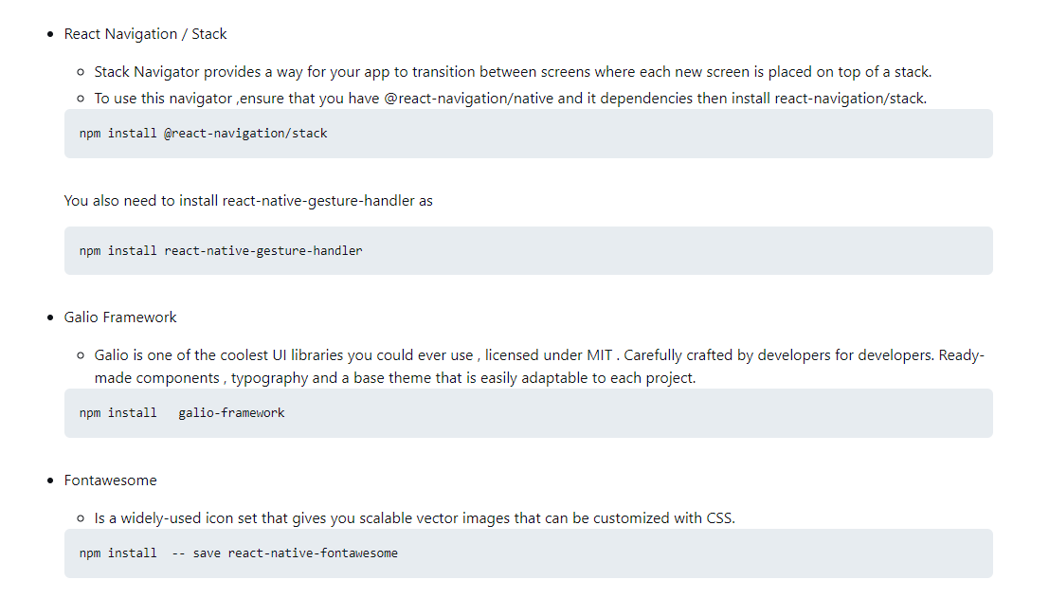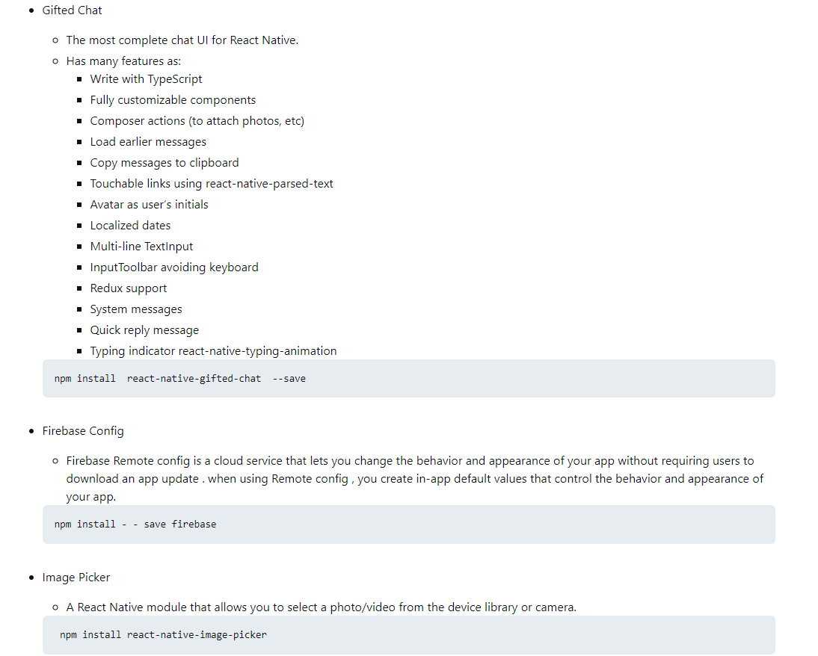

The following flowcharts explain how the Application works in the Backend sense using Redux and Firebase.

This flowchart illustrates the overall flow between processes and components in the Backend of the App.

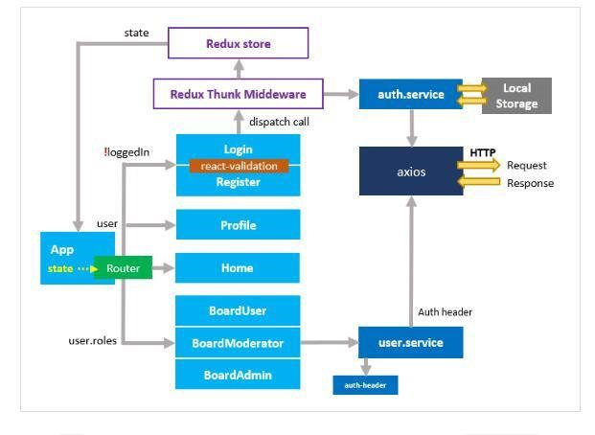

Figure 29: Application's backend overview

Whereas this flowchart illustrates how React components are connected to our Firebase using Redux.

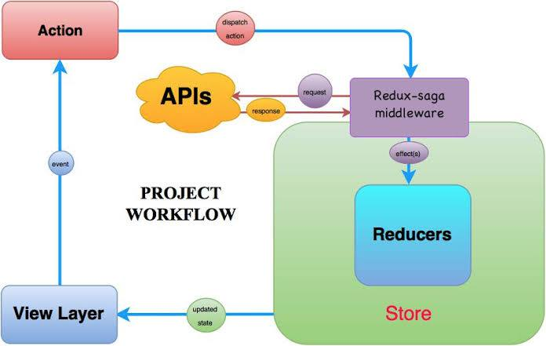

Figure 30: Application's Redux connection

The next pages contain screenshots from the mobile Application showcasing some of our main pages, to find a whole presentation of B17 application please refer to our explanation video.

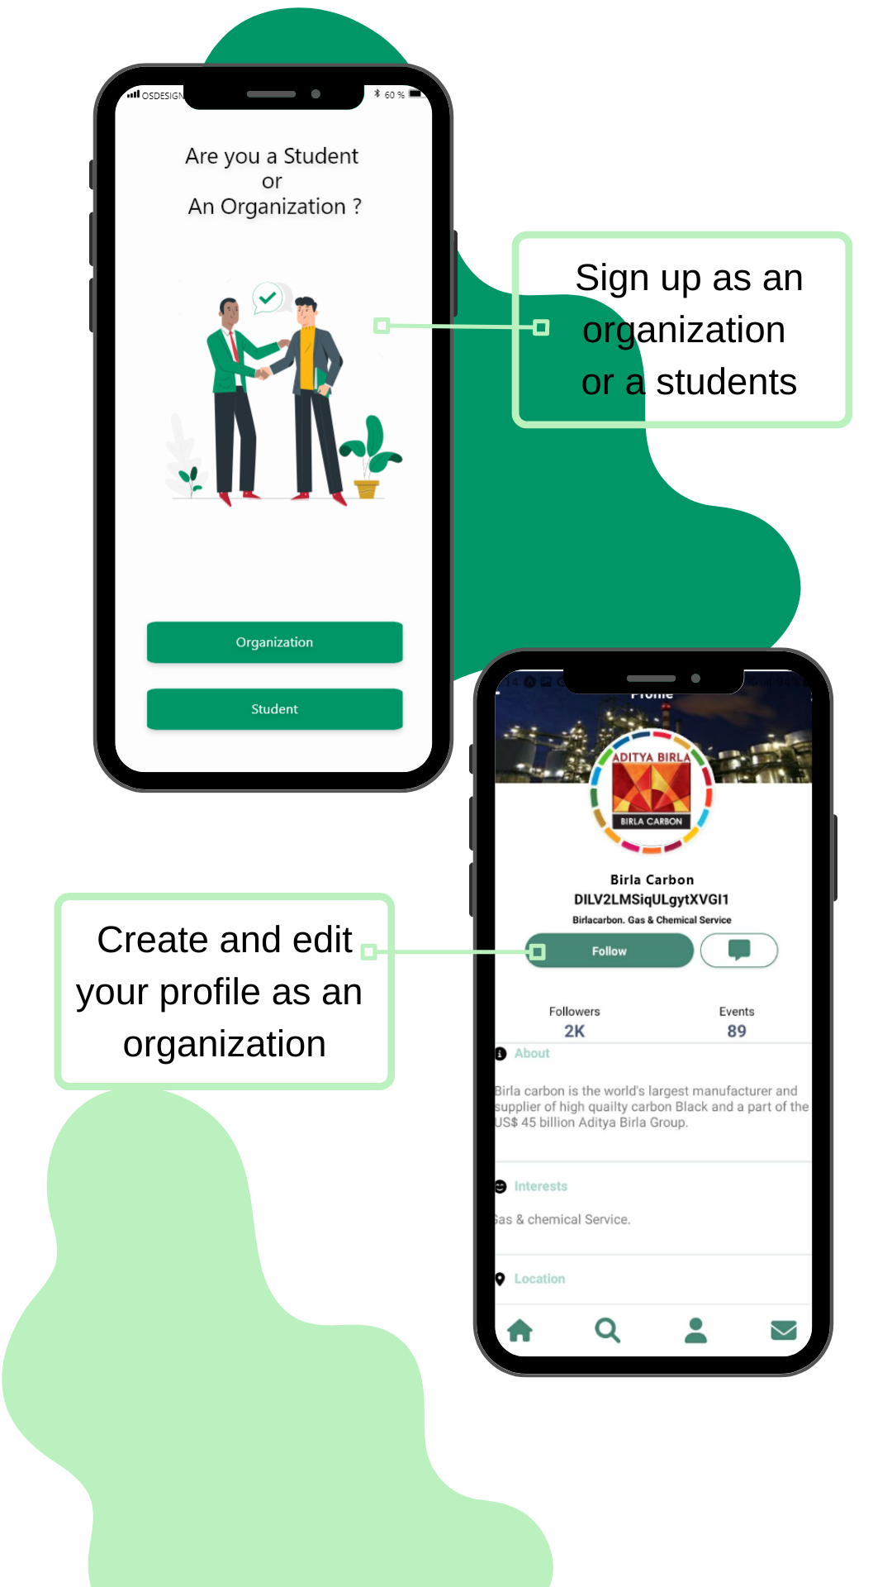

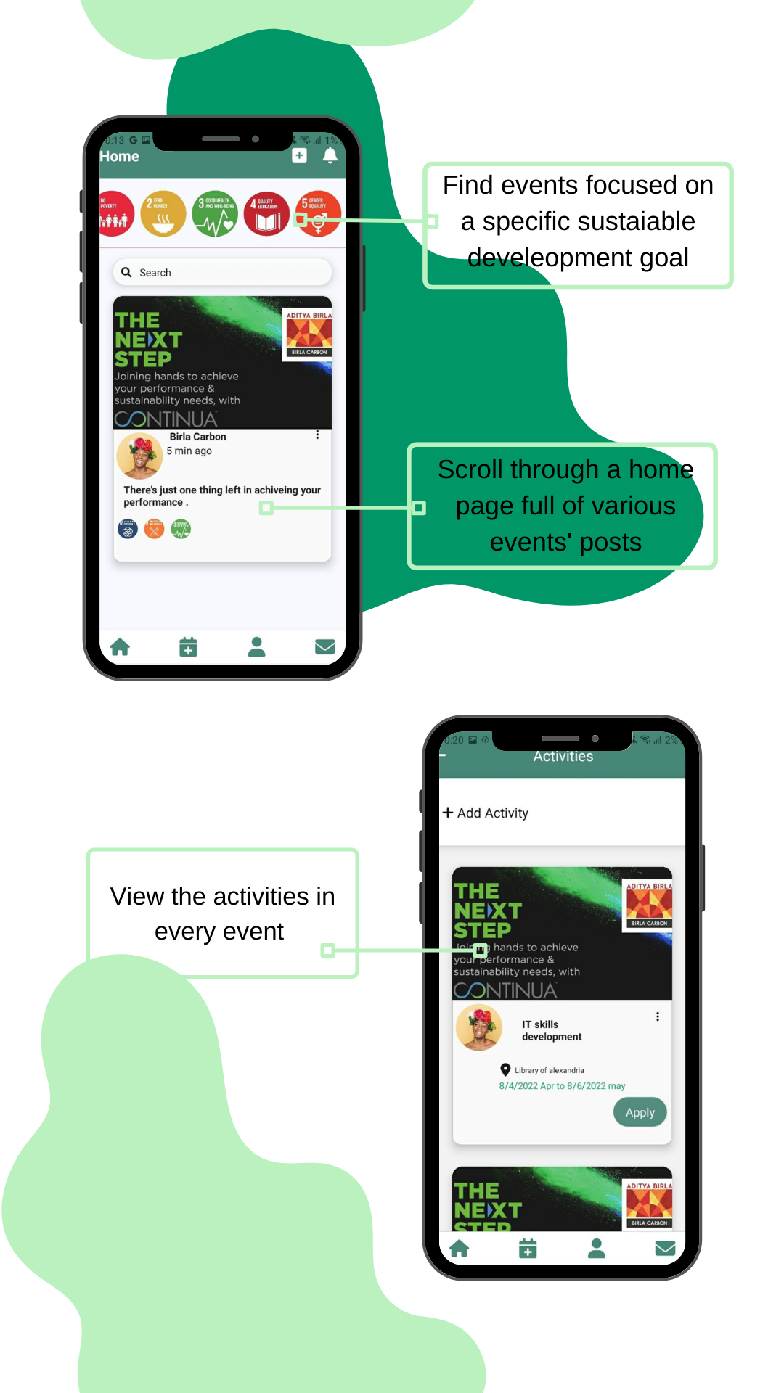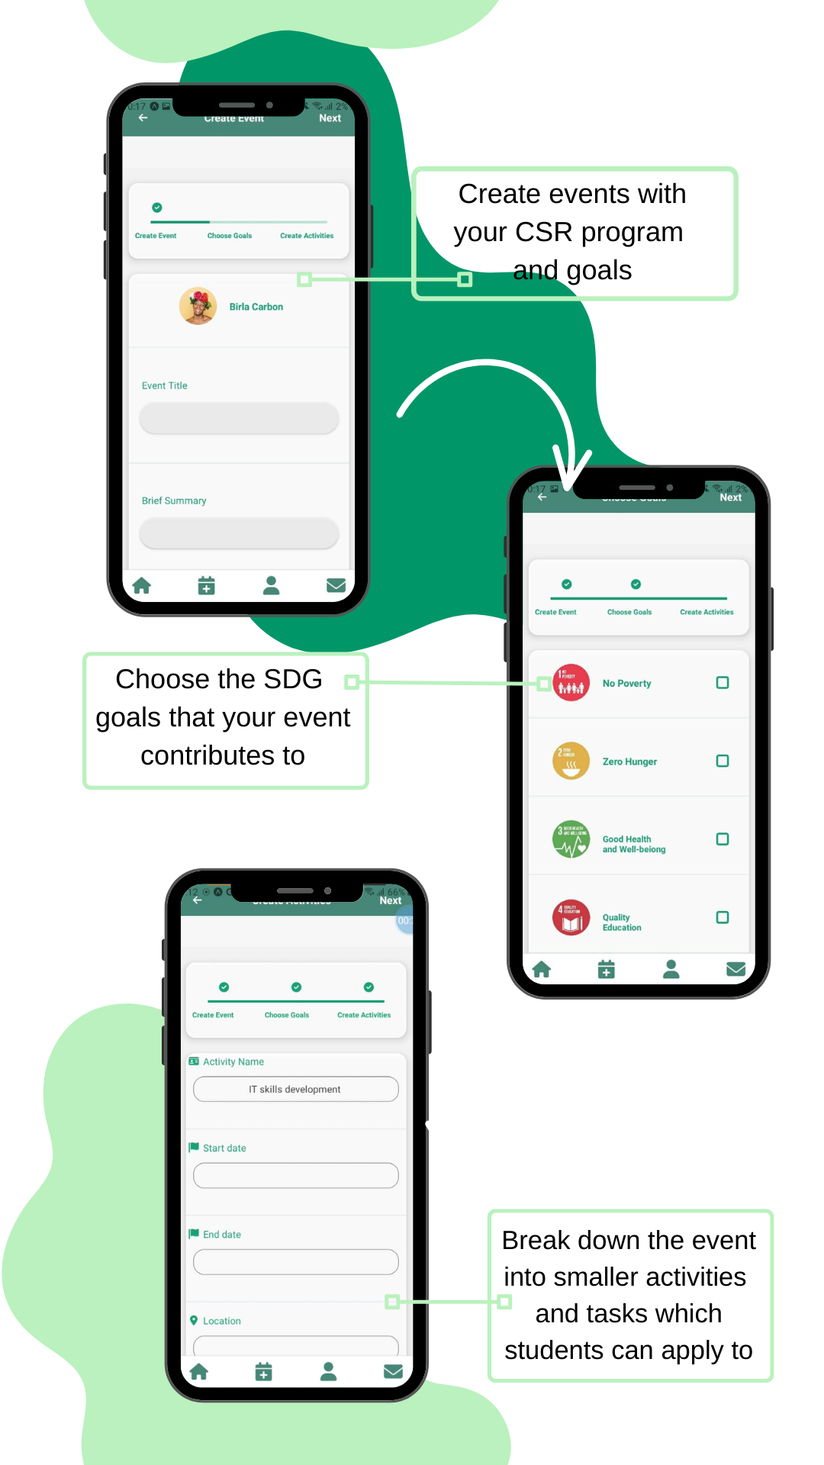

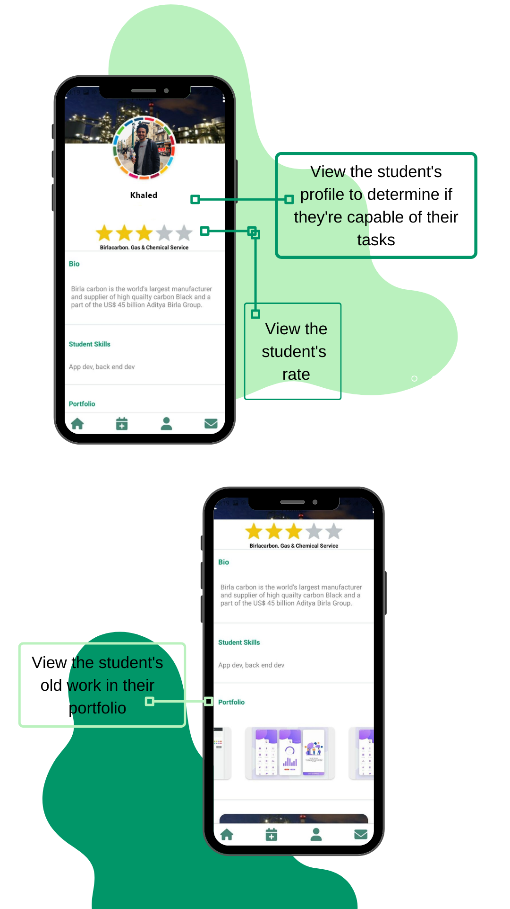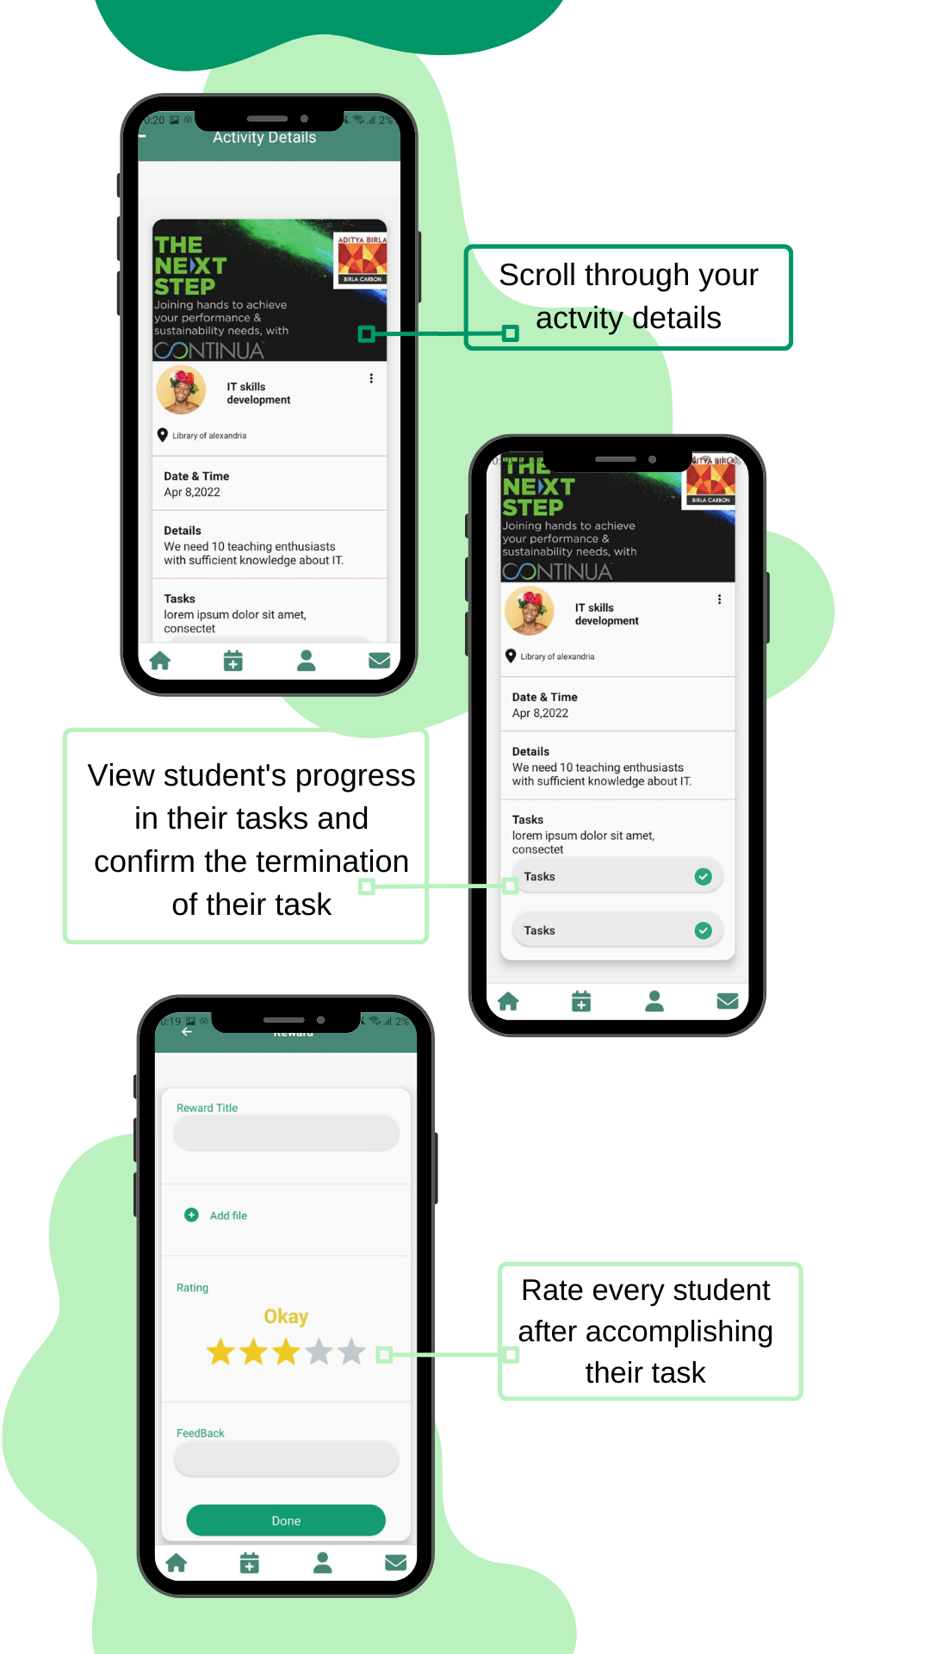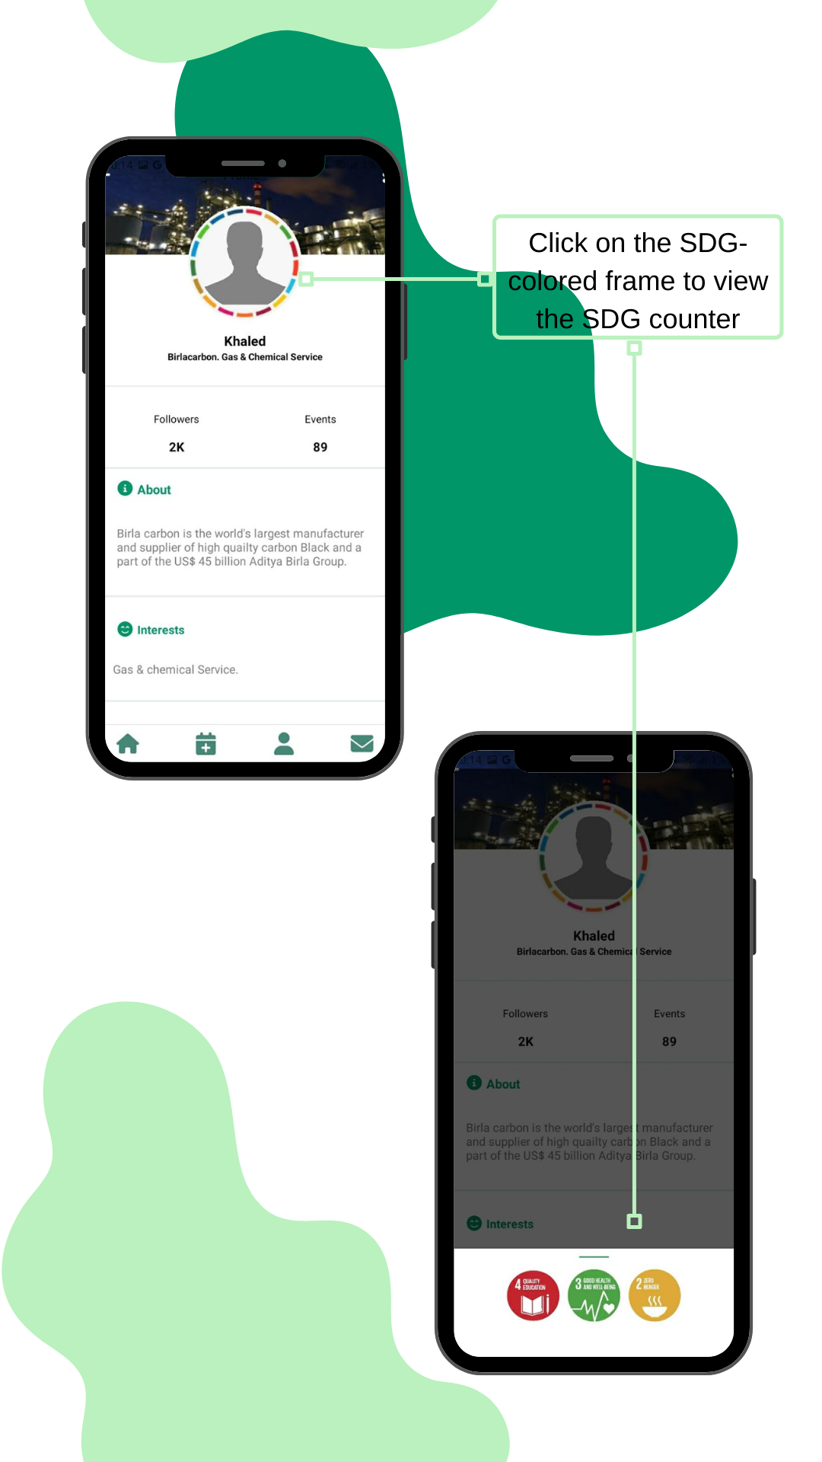

## **5.4 Website development**

After we were almost done with developing the Application, we started developing the website to brand our idea and to create a more flexible and reachable channel.

Listed below are all the languages, libraries and packages used shown as screenshots from the introduction chapter of the code’s documentation (a link to the full documentation file is found in the references page with a link to all code content as well).

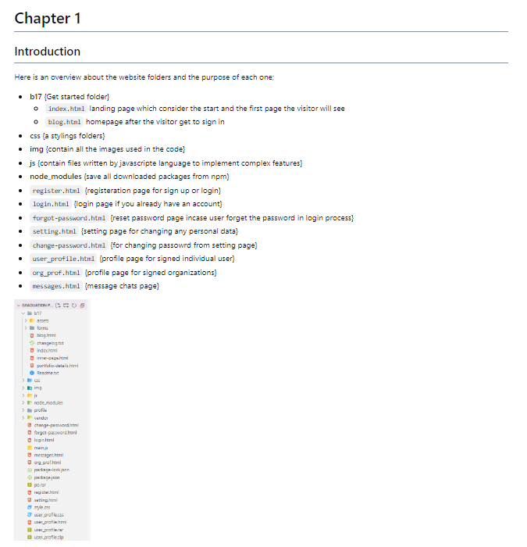

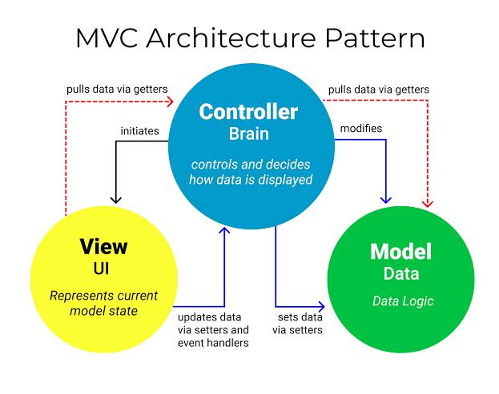

The previous flowchart illustrates the algorithm of the backend web development code and determines the flow of process and connection to servers and database.

The following are screenshots of the main pages in the actual website.

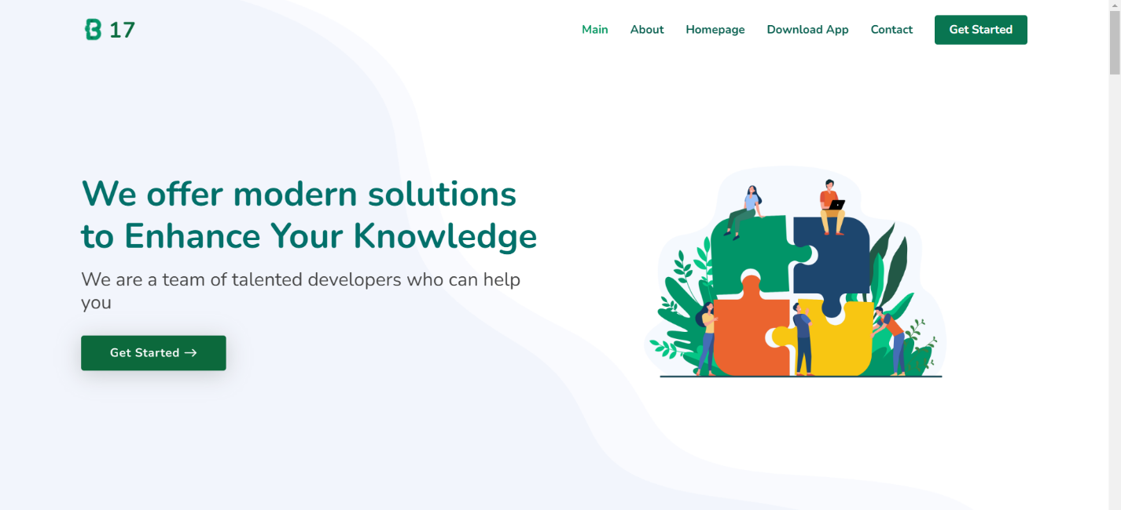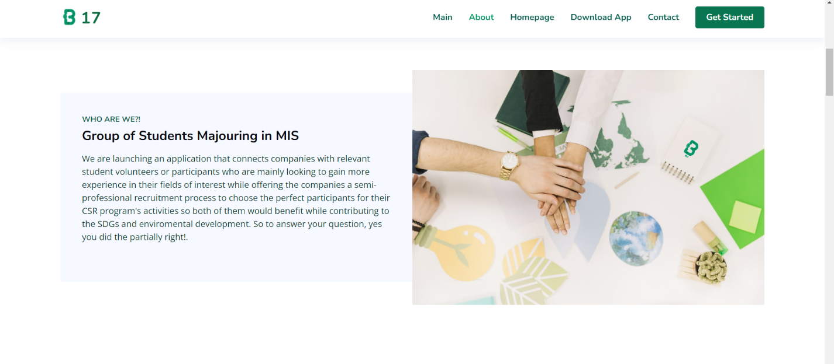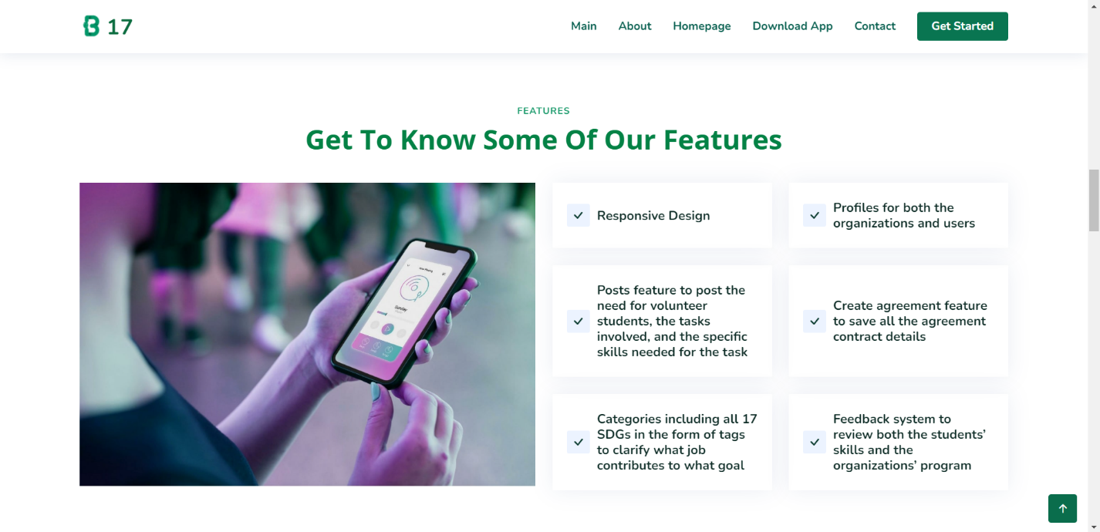

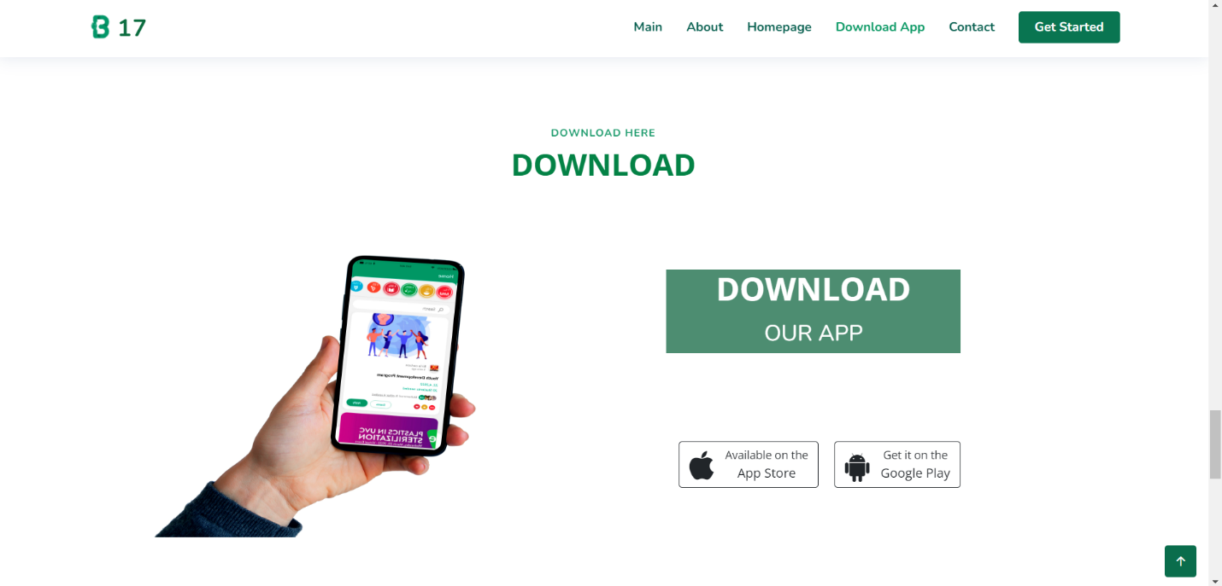

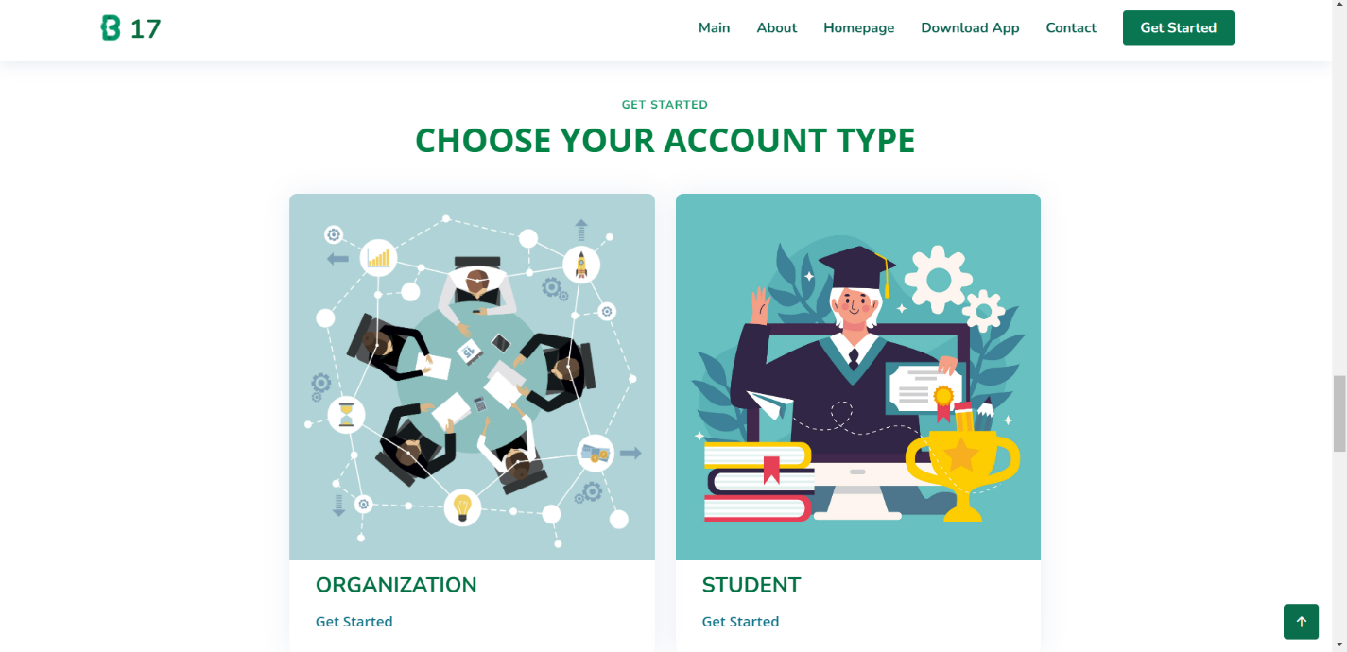

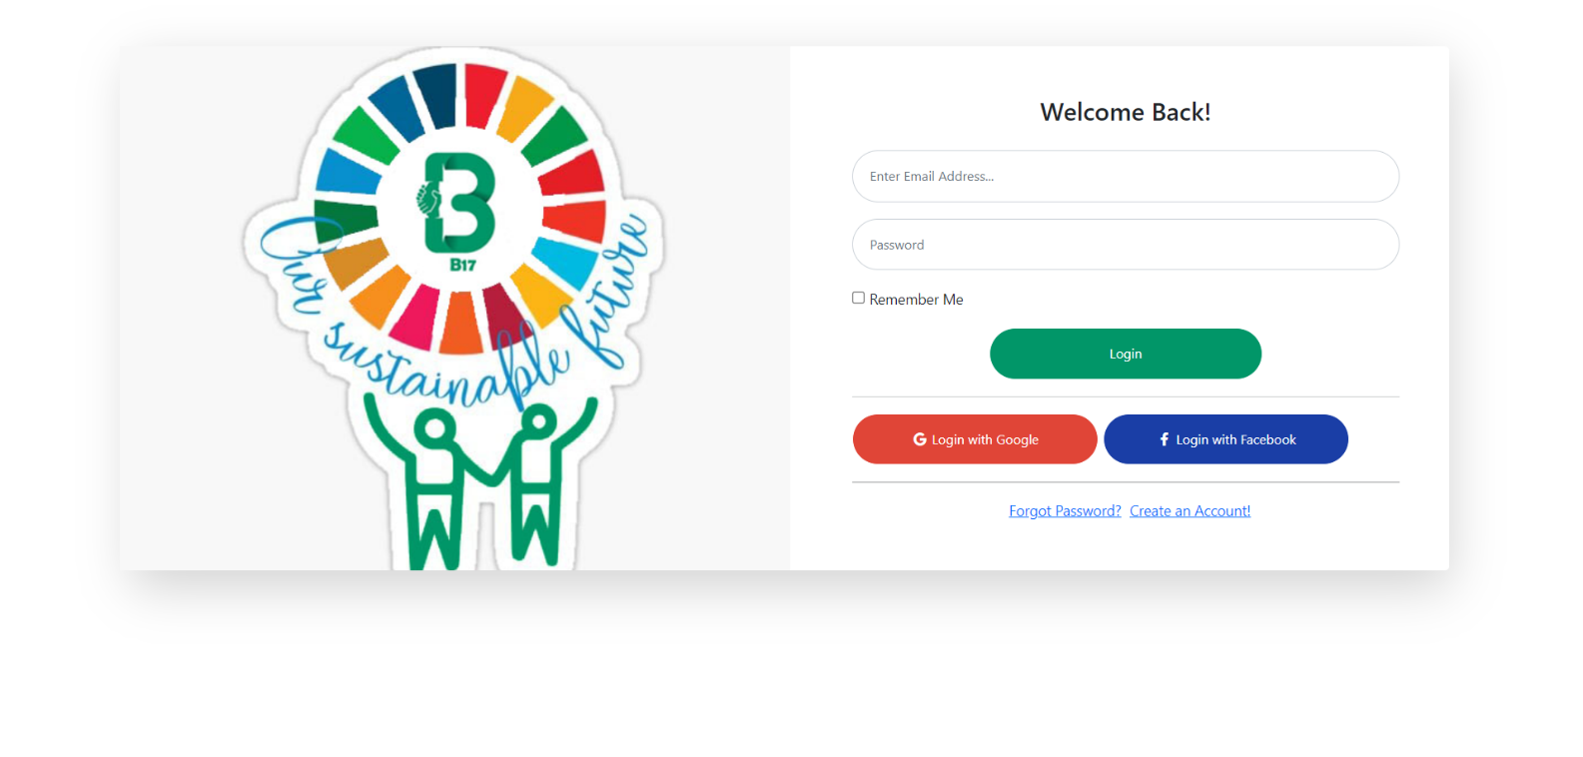

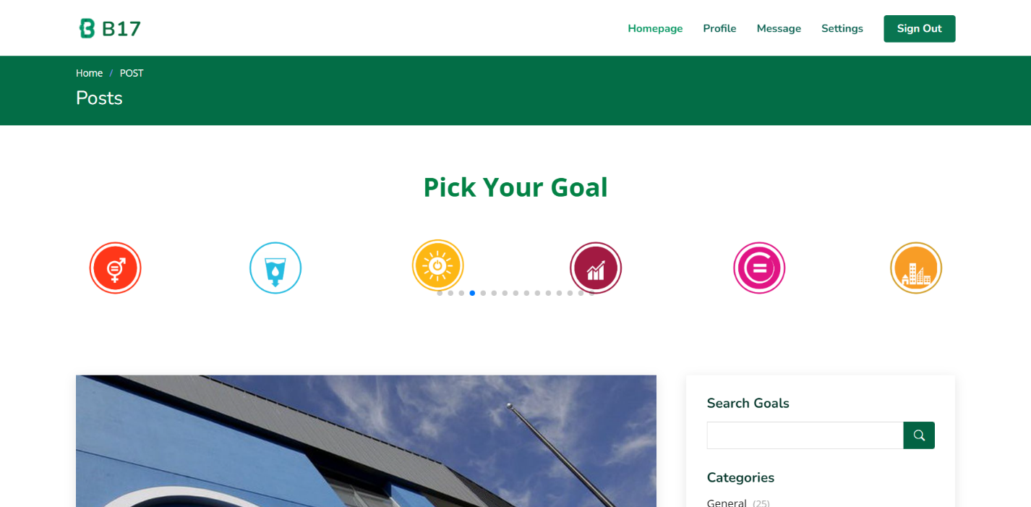

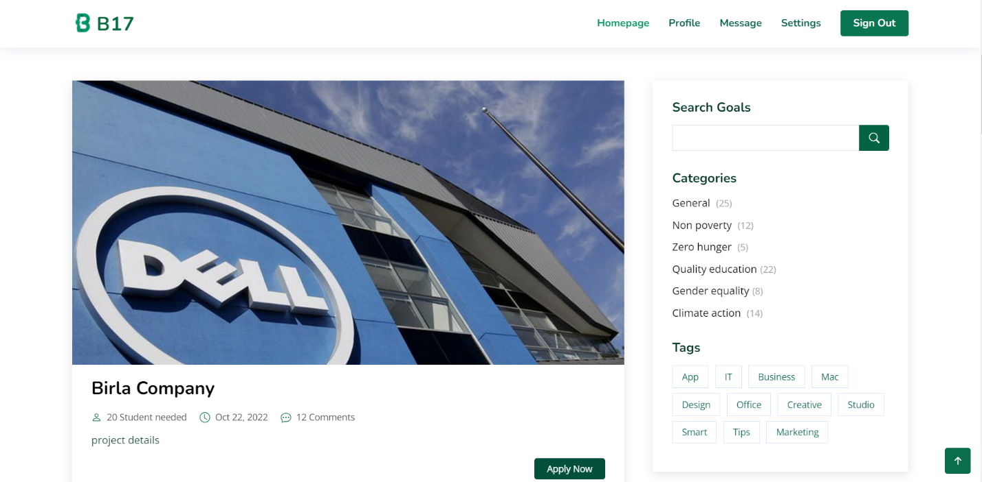

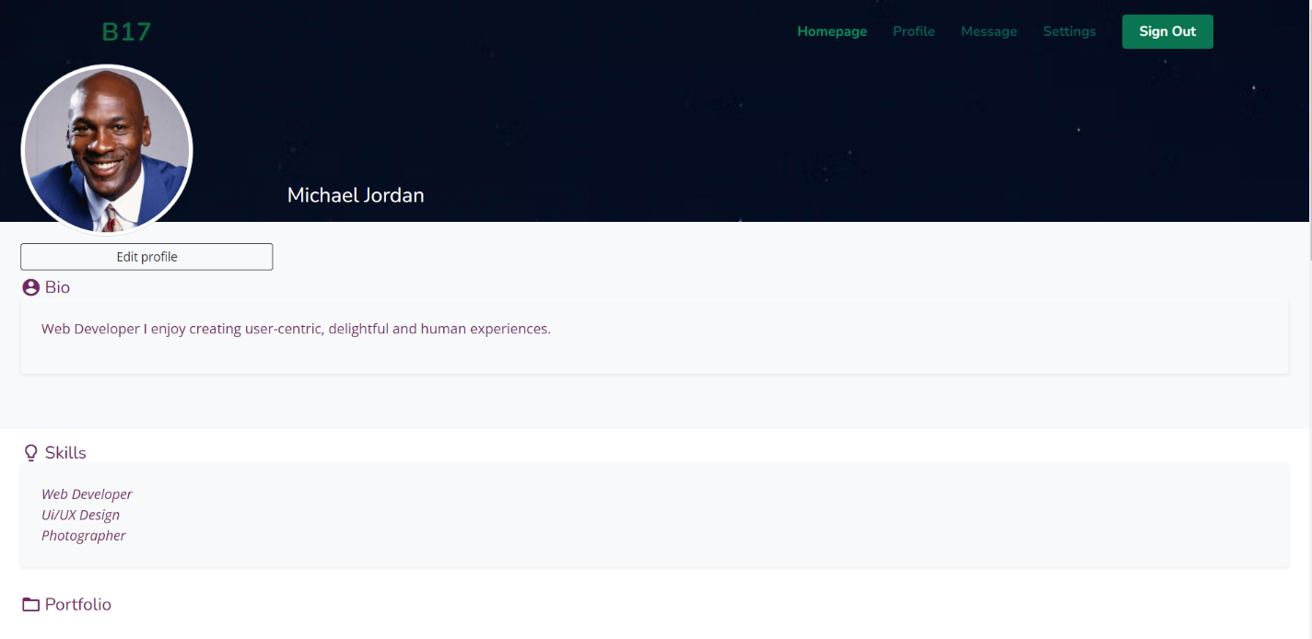

# **Chapter (6): Conclusion, results, and future work**

We did reach a satisfactory state with our project till now, but that doesn’t mean that we would stop here, we have a lot of things planned for our future development from extra features to exploring new markets.

In this chapter we will present some of the ideas we have planned for B17.

Firstly, we plan on becoming more data oriented or to be exact we want to use the data created in the best and most efficient way possible to provide even better services, this might not completely be in our team’s capabilities now, but we will learn and get there, that’s how we got here in the first place, right?

From this we want to create a fully functioning recommender system in our App’s ‘home’ page and ‘explore’ page, this would make finding suitable and relevant posts much easier for the students and would enhance their user experience.

We also want to add a simple matching algorithm that matches the applying student’s interests and capabilities with the task requirements automatically after applying and present them sorted by best fit in the ‘applicants’ page to facilitate the filtering process for organizations.

For our long-term aspirations, we want to create an even more advanced recommender system for the events’ posts and add it to a premium package with other services like notifying interested students when posting new events or activities and so much more.

There are also some small details we would like to add like: a save post or activity feature and maybe update our feedback system rather than it being organization to student we would like it the students to also feedback the programs created by the organizations.

Secondly, we want to focus on getting governmental or ministerial support, not necessarily in a financial way but we do need their approval and support for our idea to expand more and reach more students and firms.

That was just a hint of our plans for B17’s future, our plans and ideas are endless, and we just keep them coming.

# **Appendix A:**

**Mobile Application source code documentation**

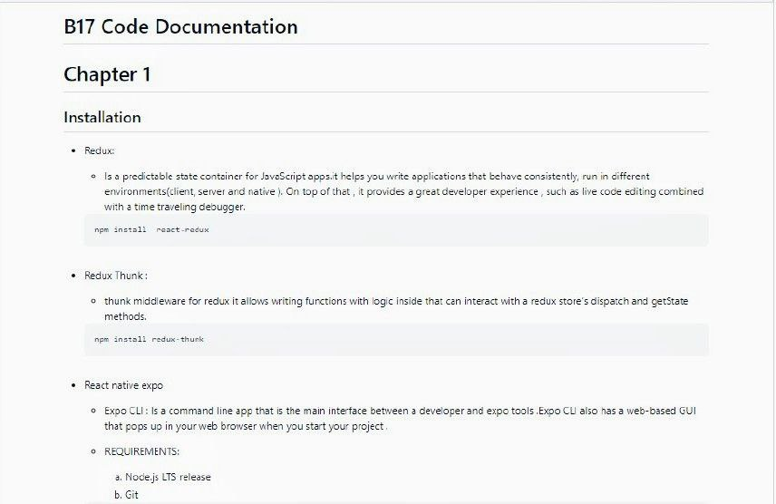

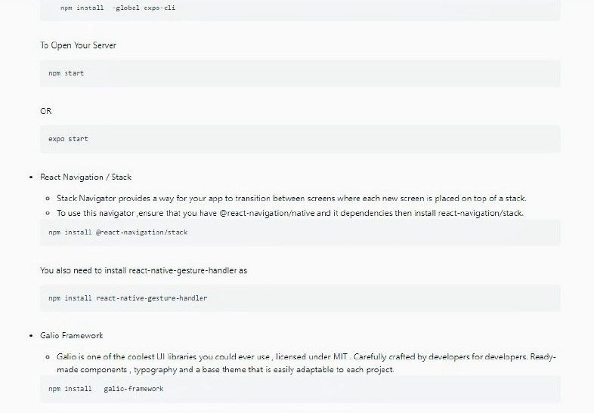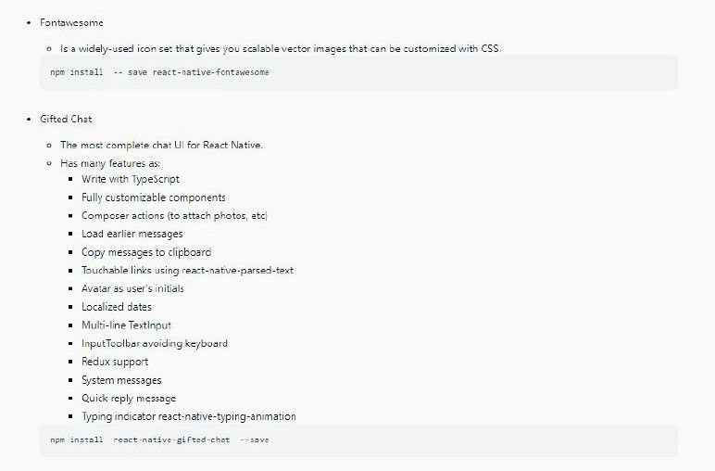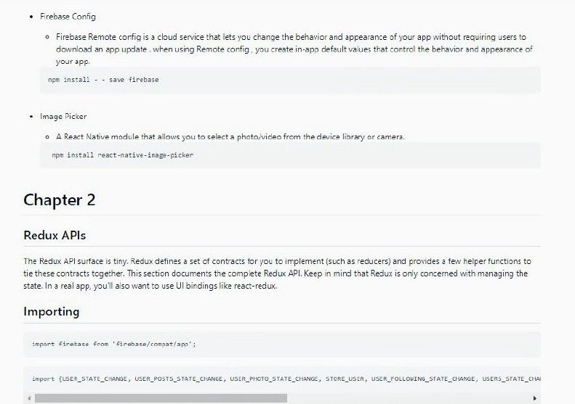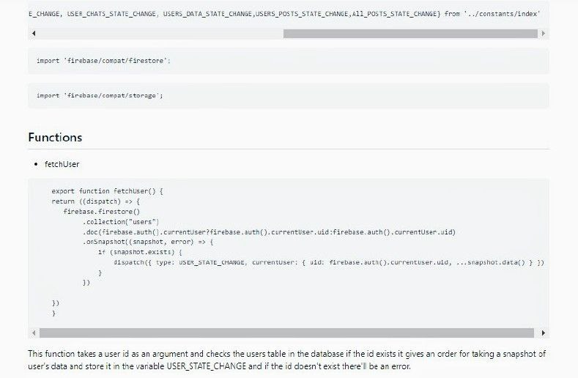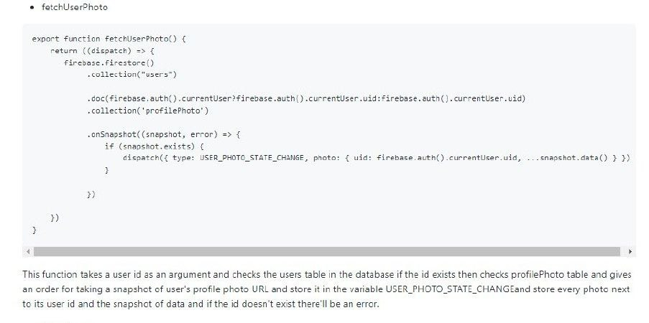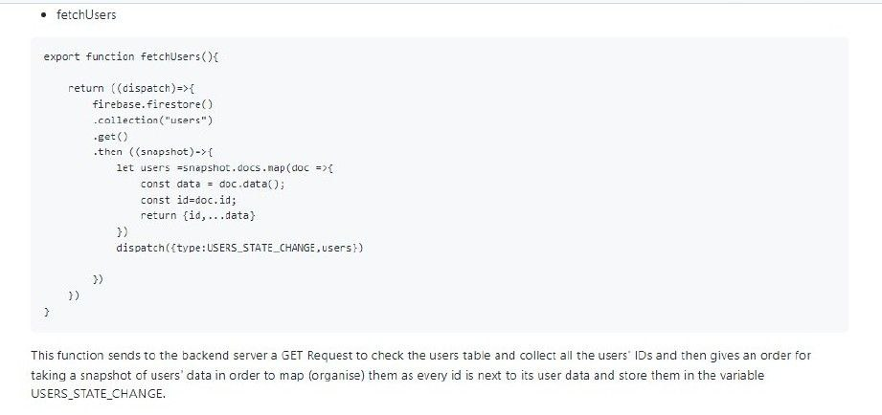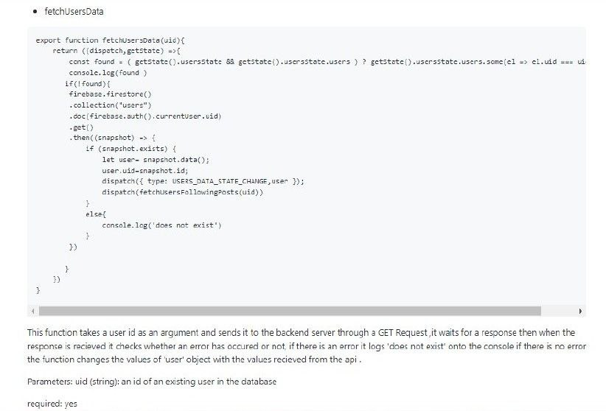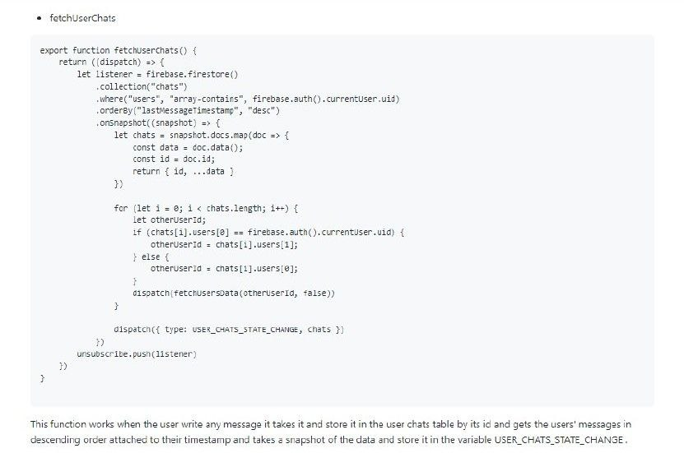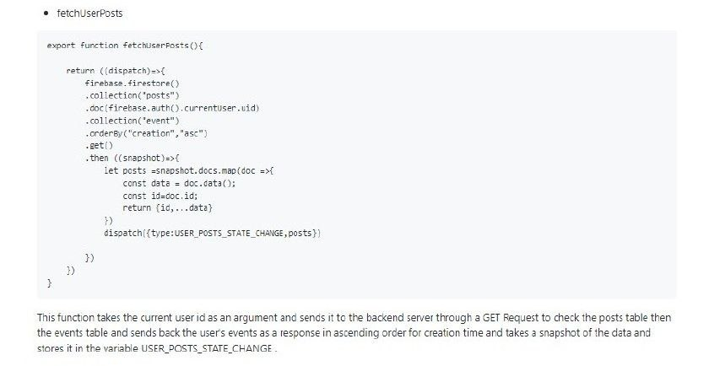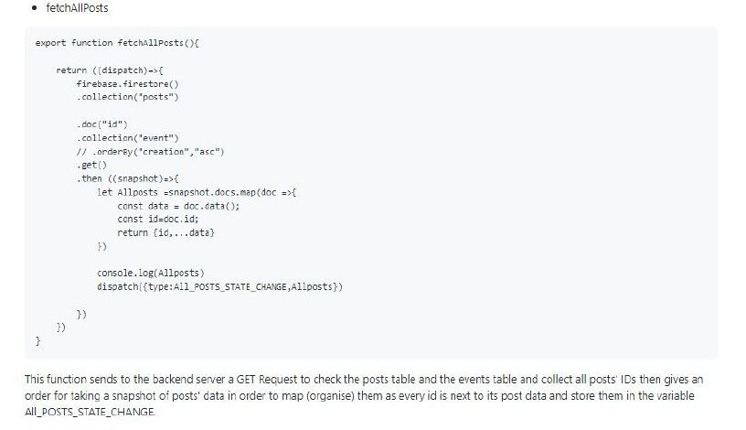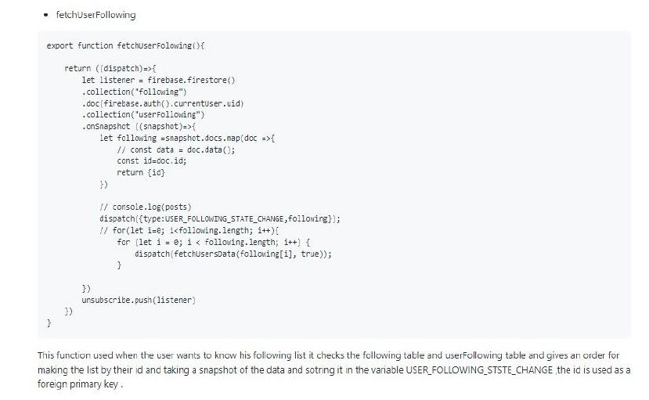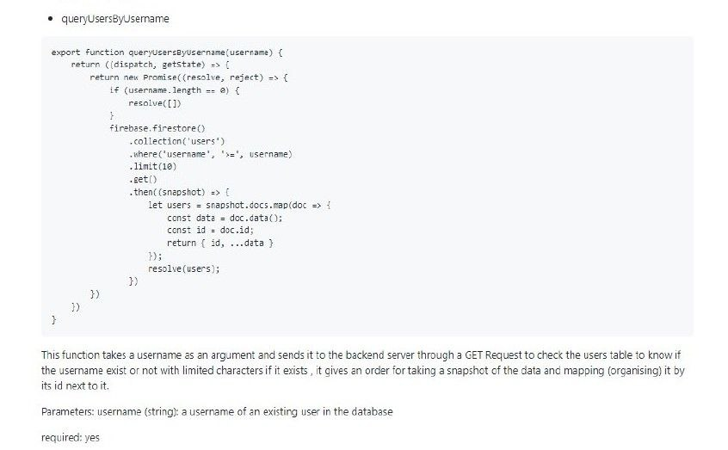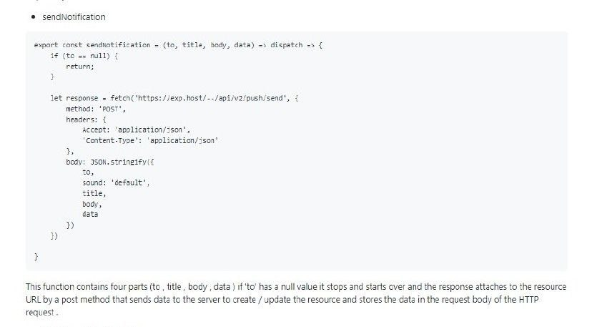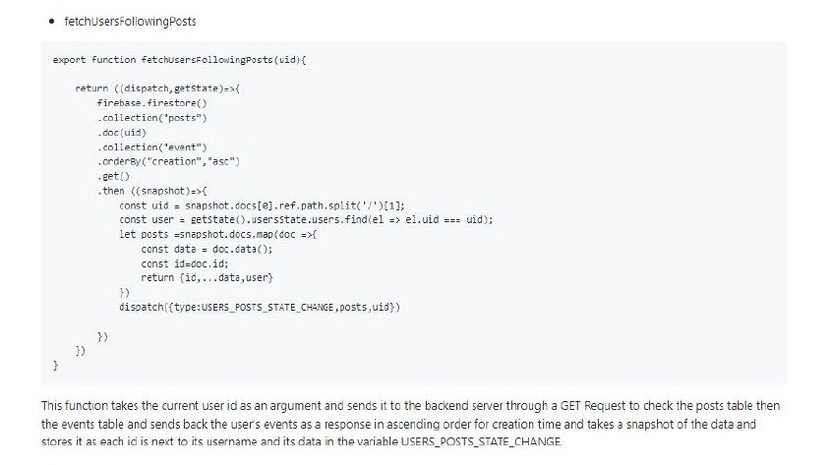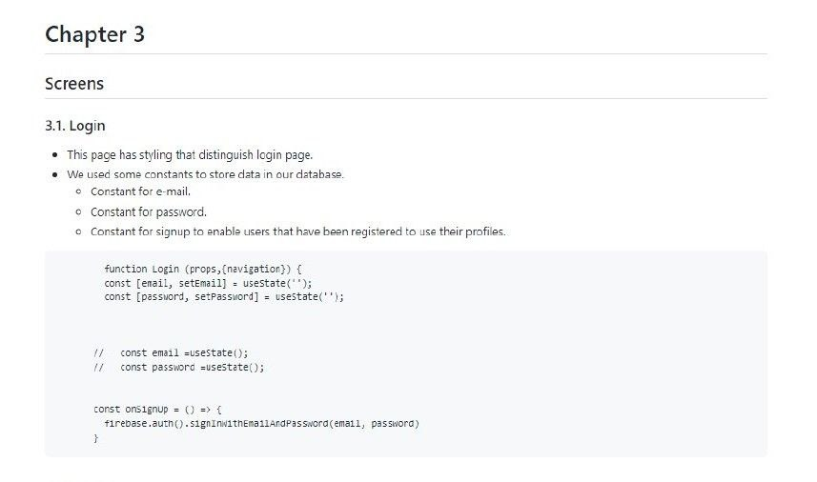

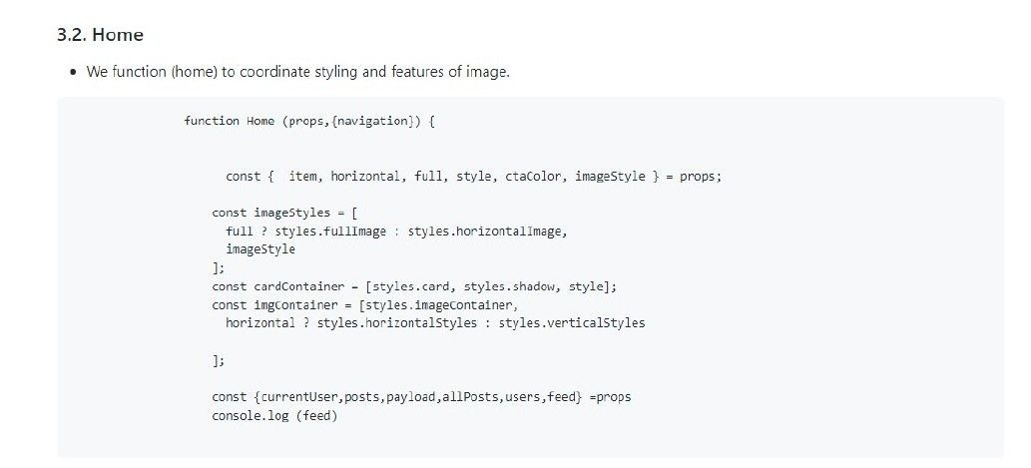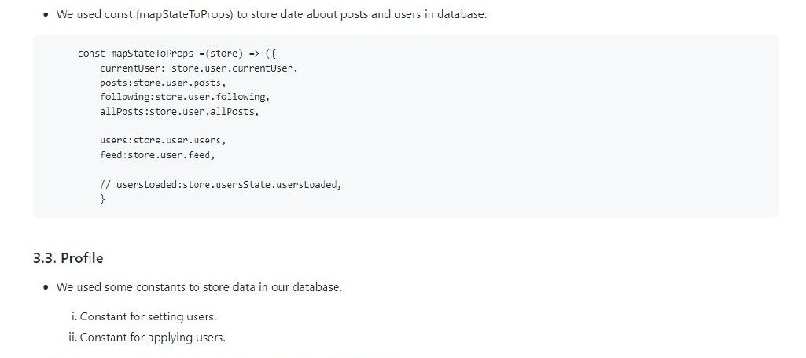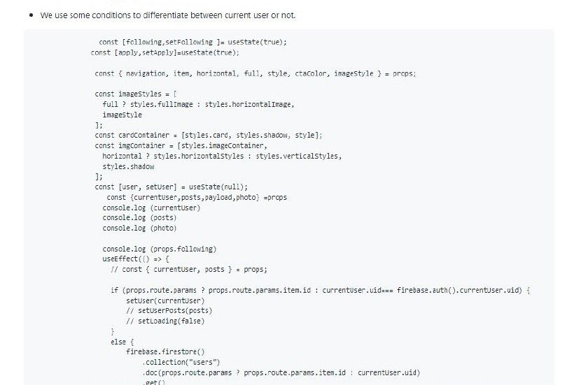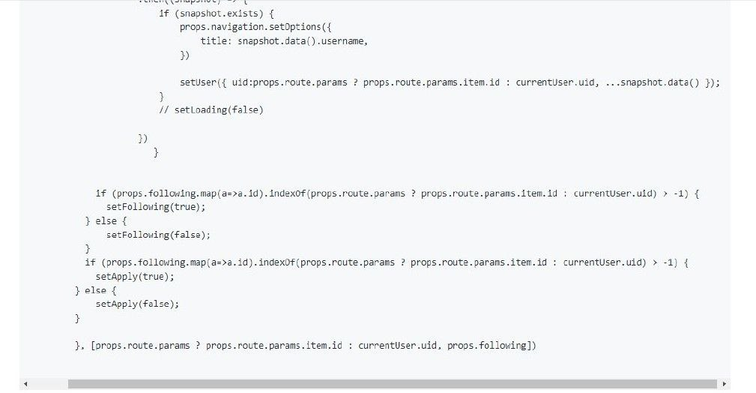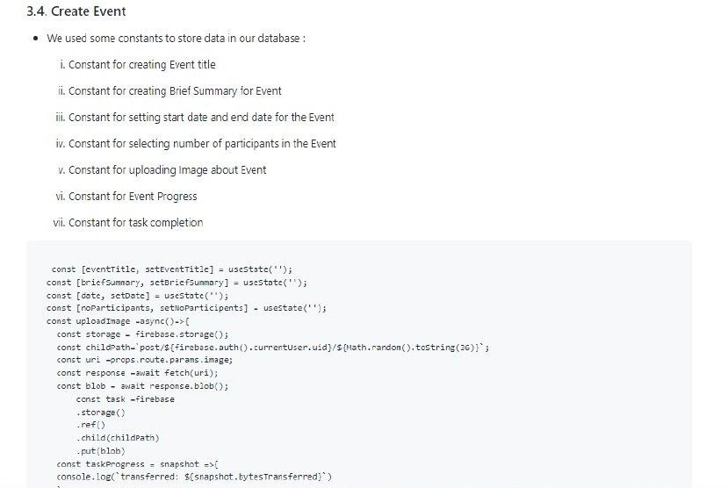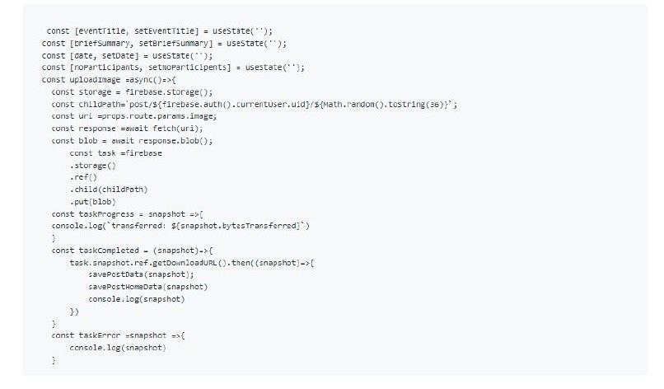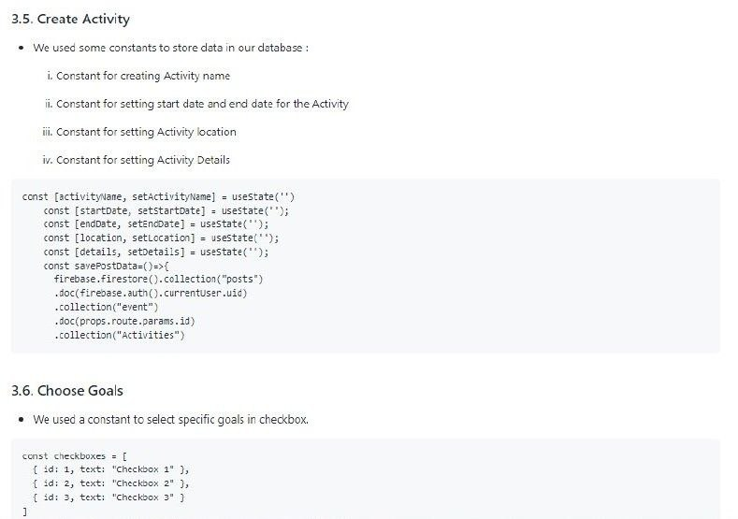

**Website source code documentation**



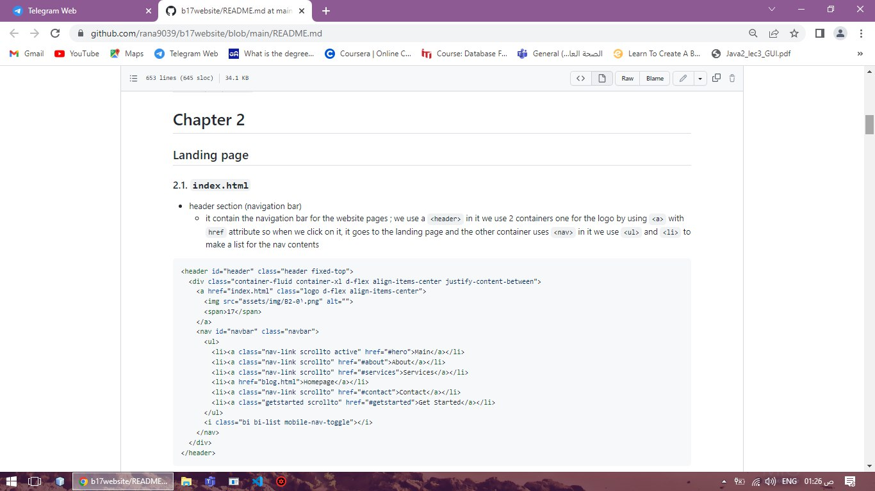

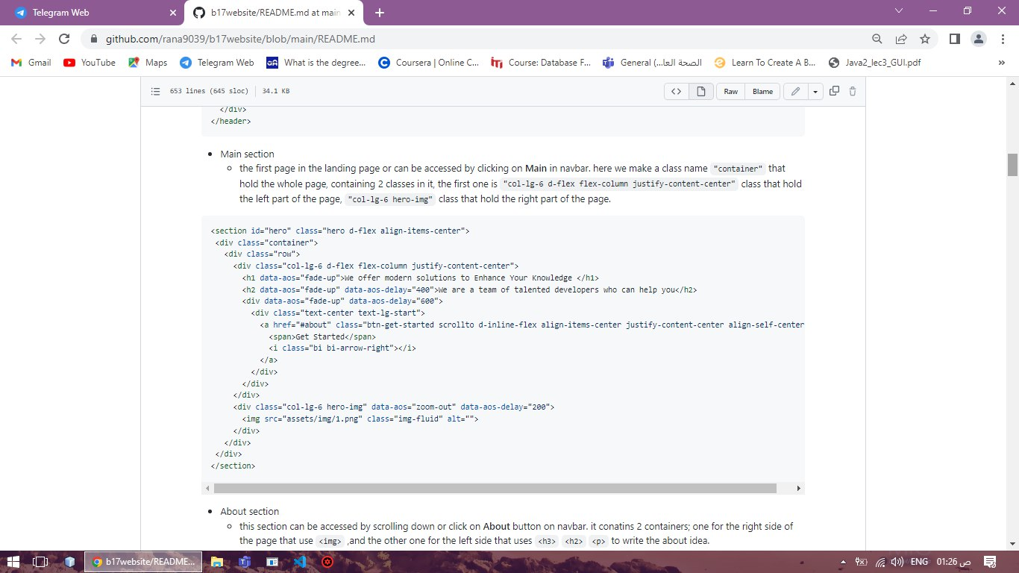

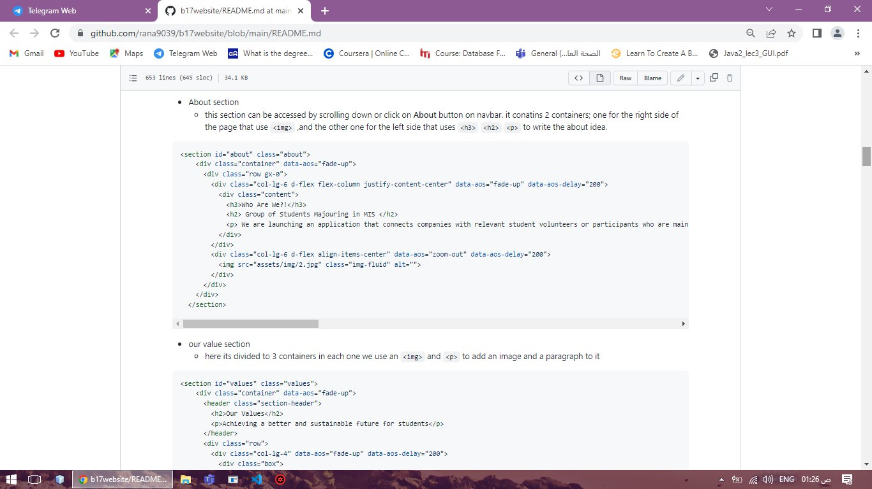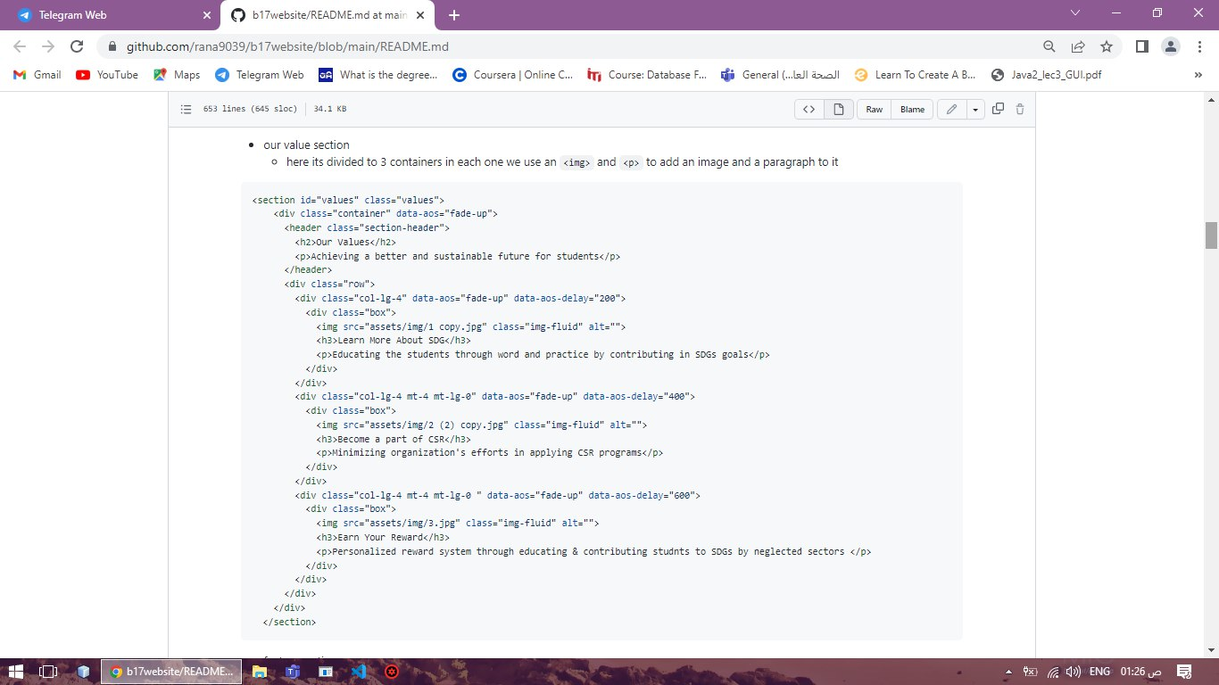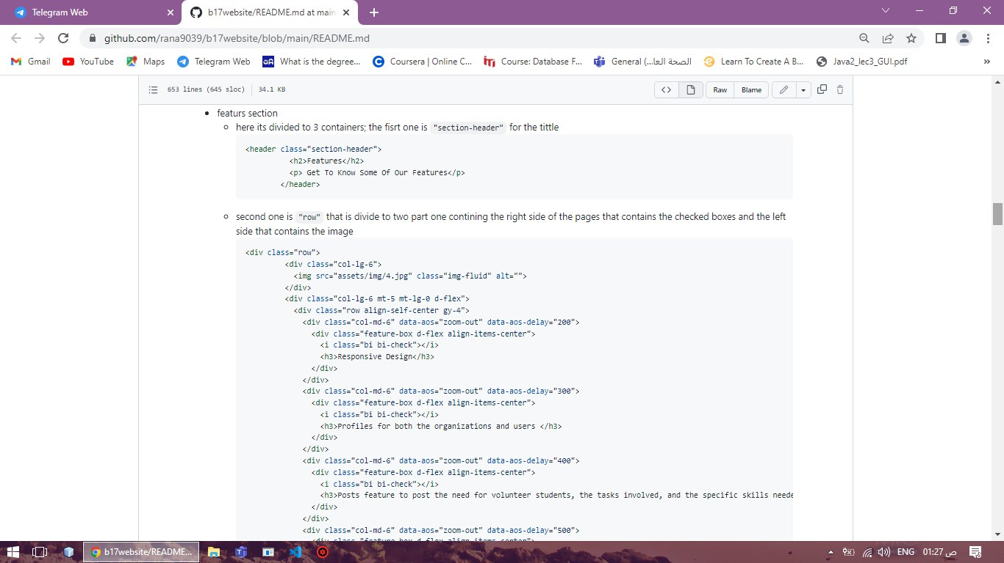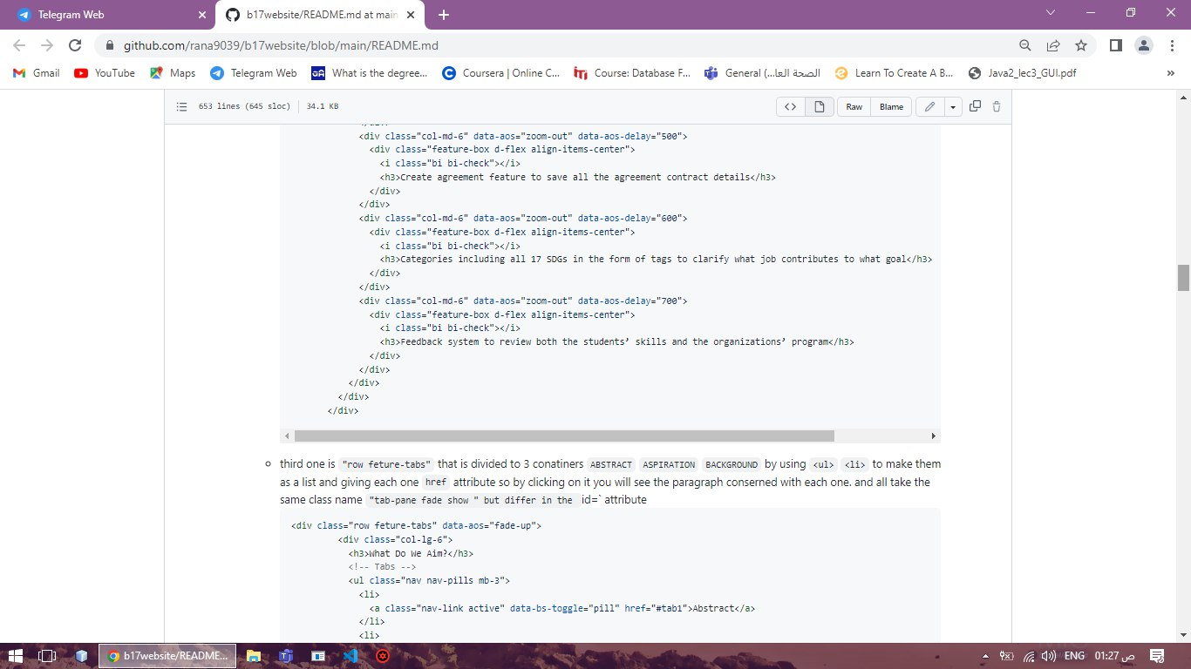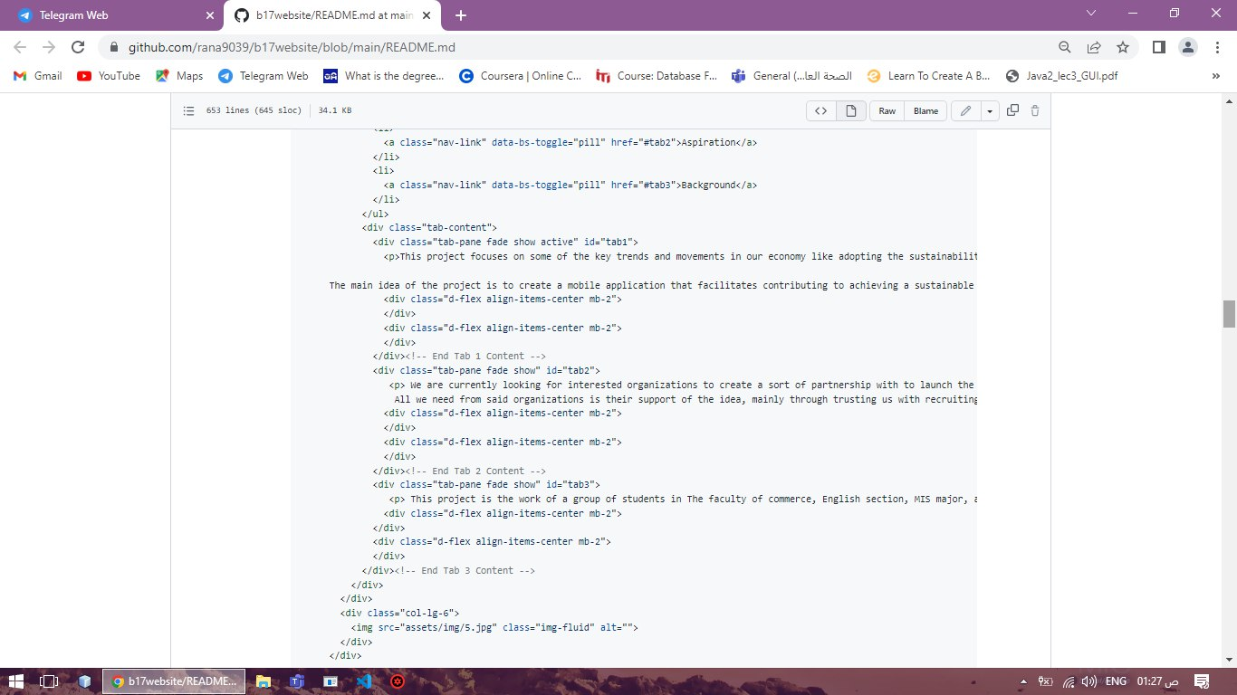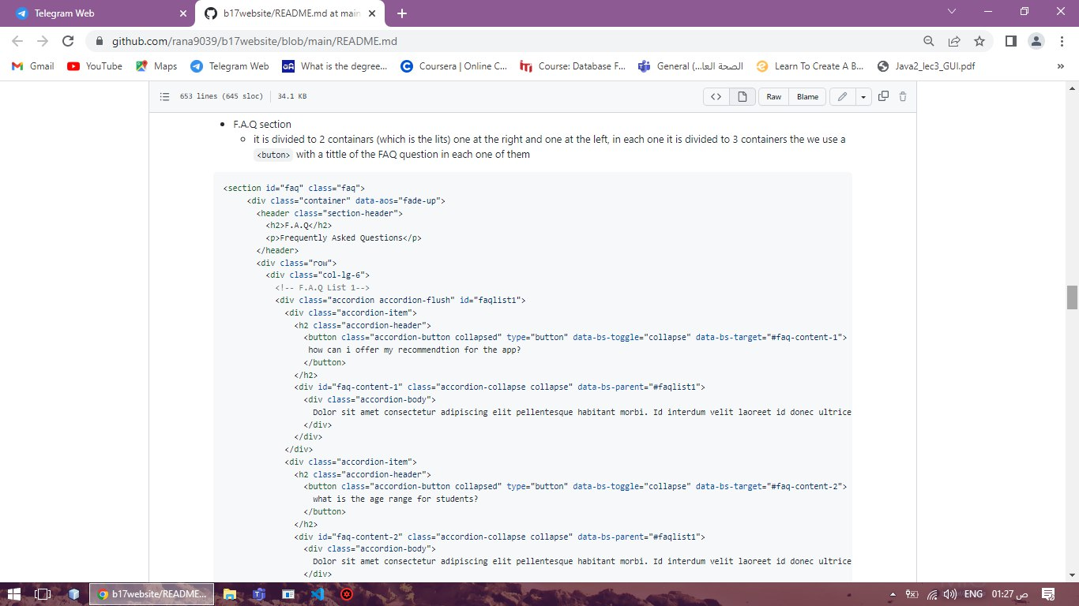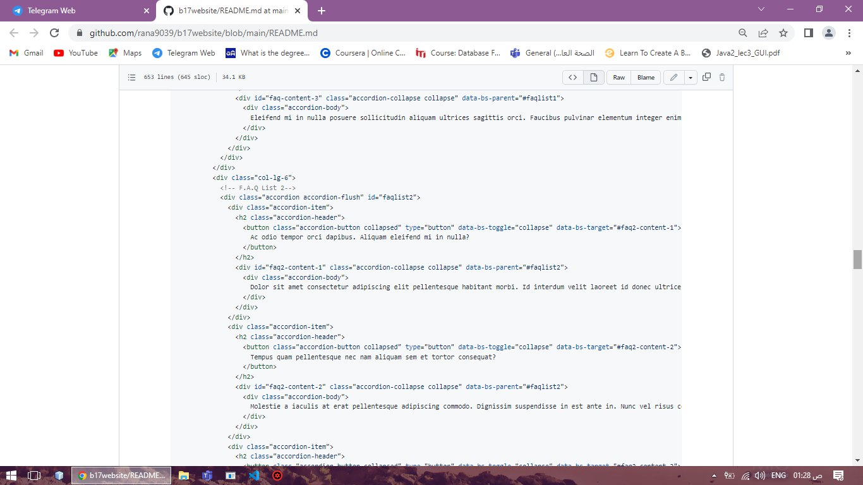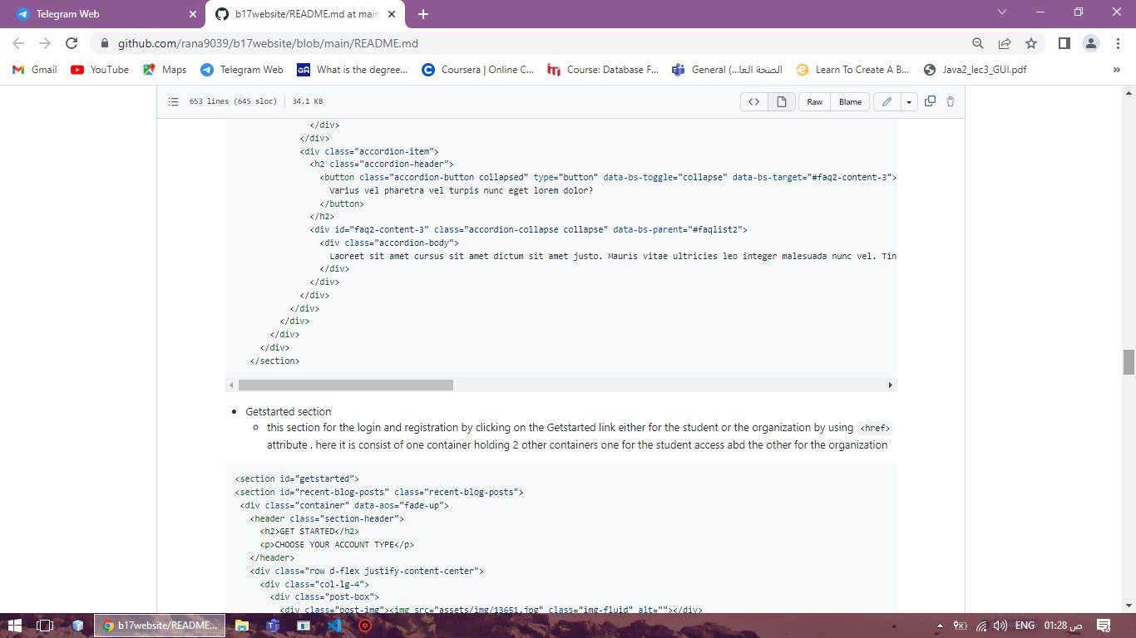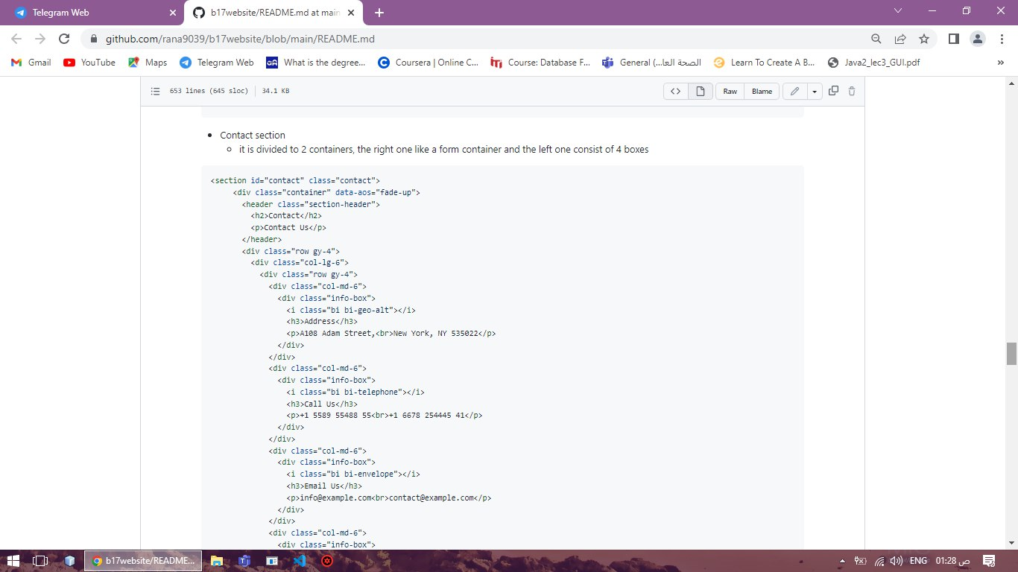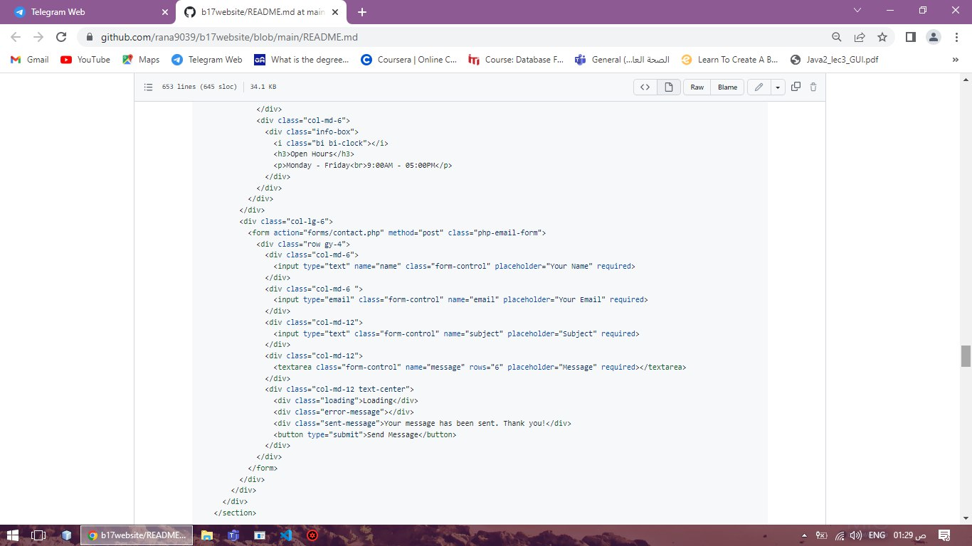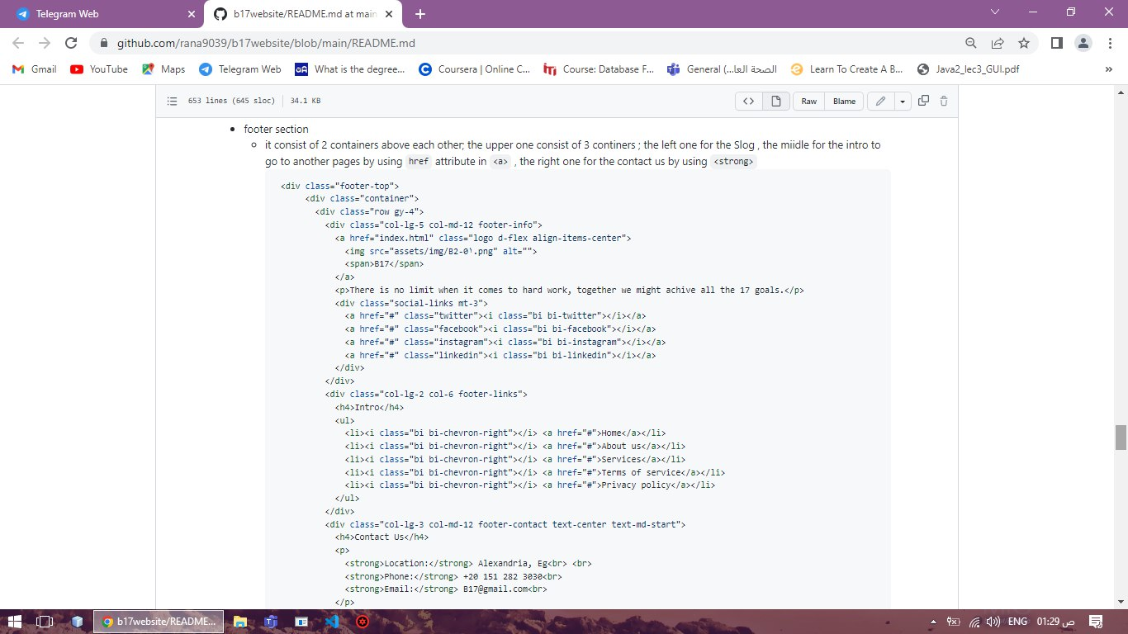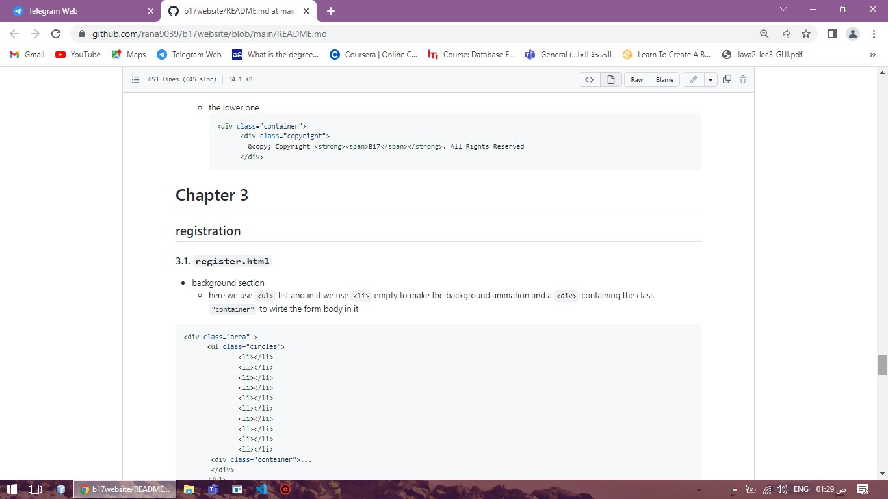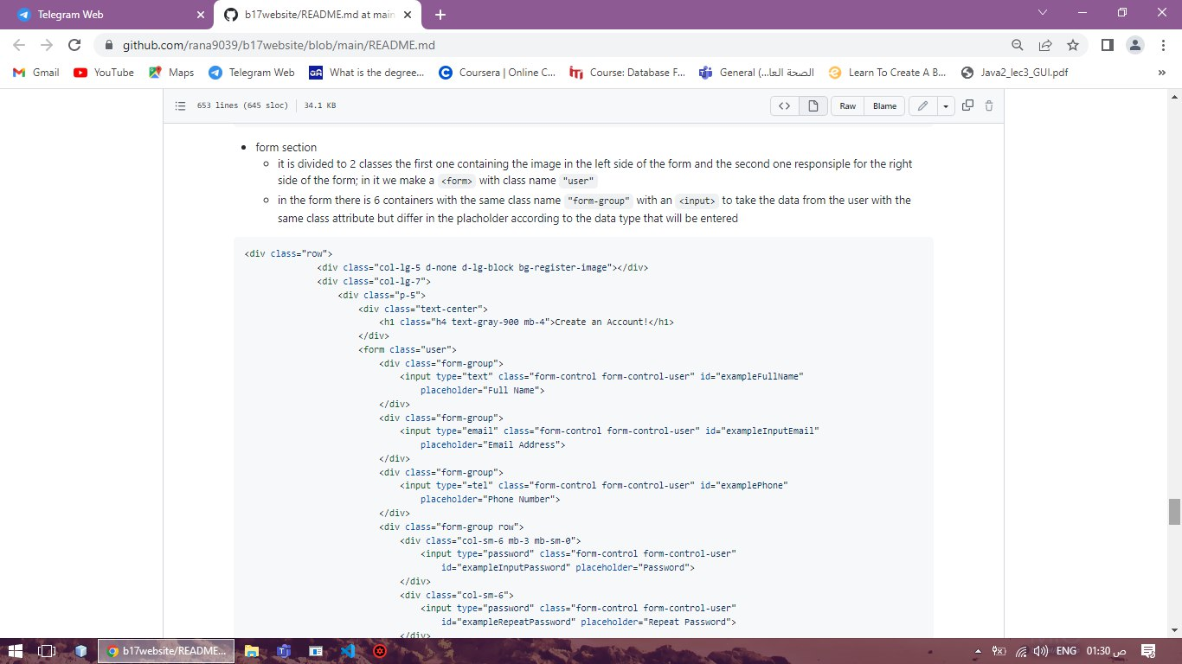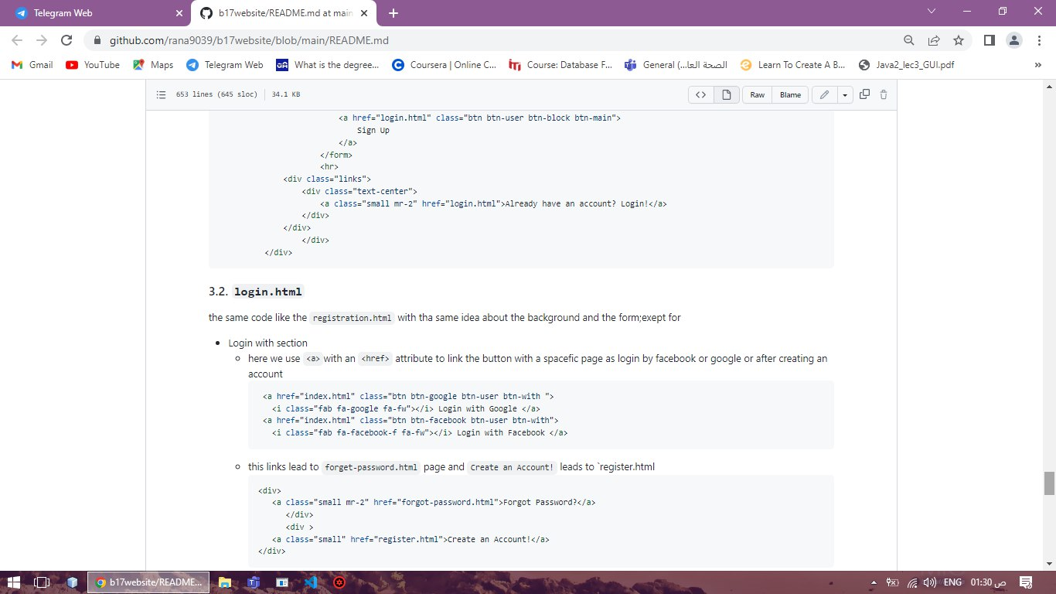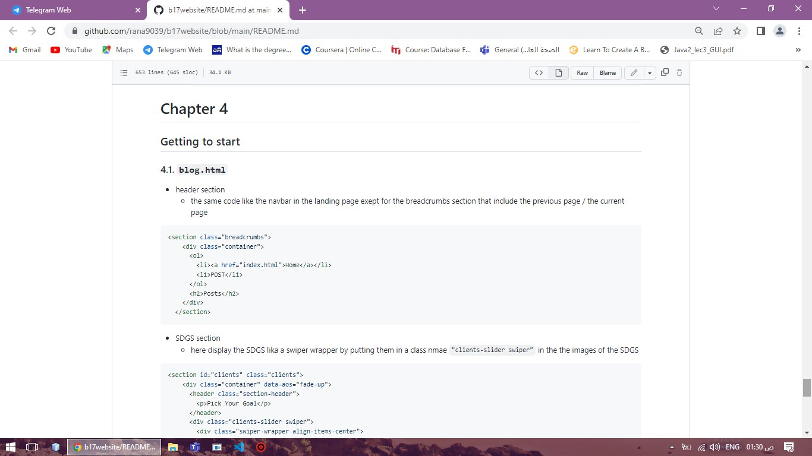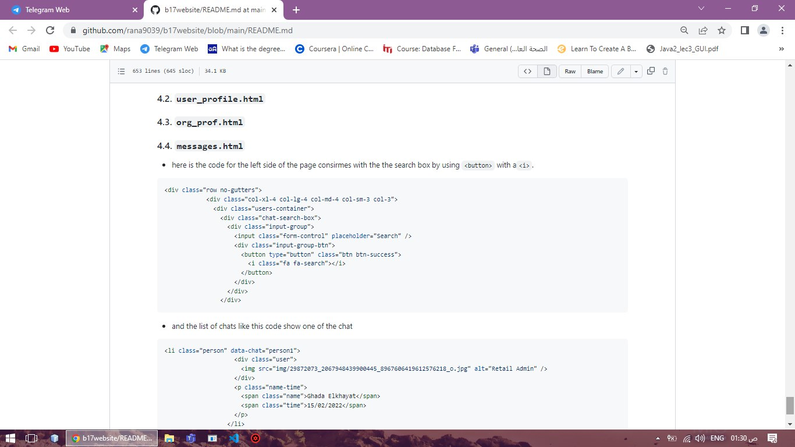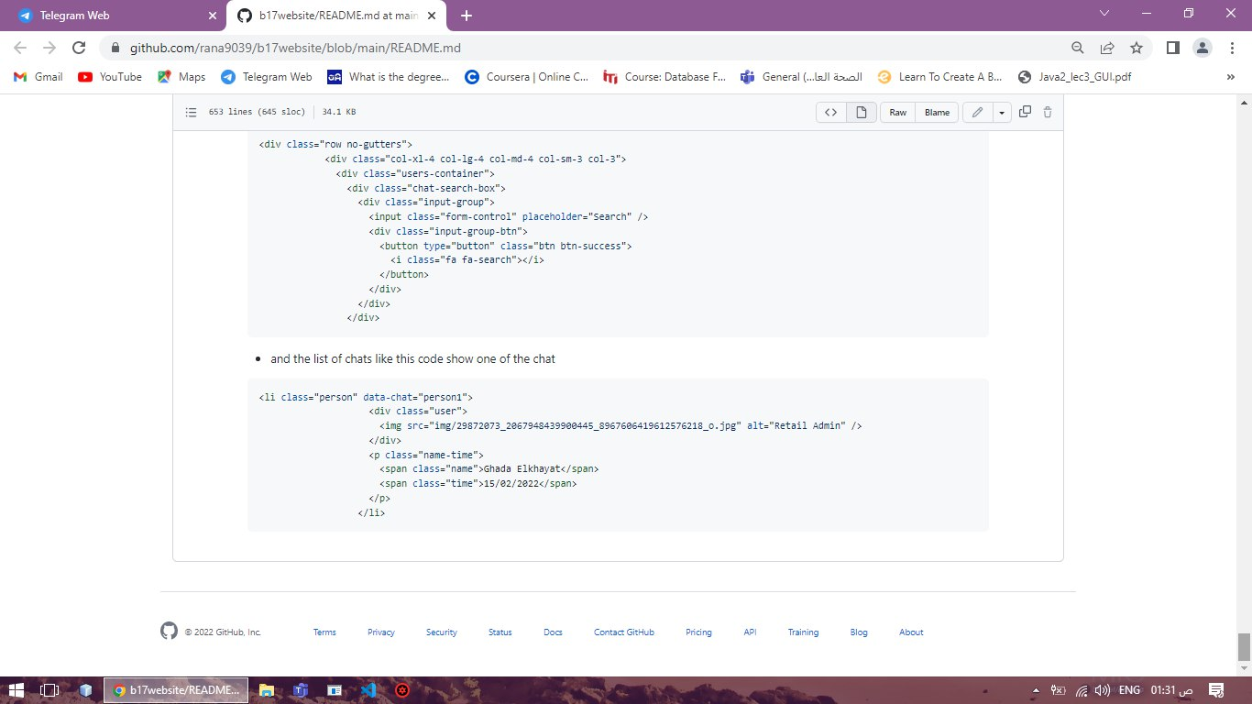

# **Appendix B:**

You can find a link to all the project work including the source code, explanation video, CVs, and all for[*here*](https://drive.google.com/drive/folders/1-1YSY4p7qQuUSZ6tWtvoj-QPJlKu6CiW?usp=sharing) *(https://drive.google.com/drive/folders/1-1YSY4p7qQuUSZ6tWtvoj-QPJlKu6CiW?usp=sharing)*

## **References:**

1. [*Application code documentation*](https://github.com/DoaaSherif1/CodeDocumentation/blob/main/README.md)
2. [*Website code documentation*](https://github.com/rana9039/b17website/blob/main/README.md#chapter-1)
3. Student behavior articles
4. [*[PDF] Extracurricular Activities and Their Effect on the Student's Grade Point Average: Statistical Study. | Semantic Scholar*](https://www.semanticscholar.org/paper/Extracurricular-Activities-and-Their-Effect-on-the-Bakoban-Aljarallah/33f494f2be39aa424d4fa41de90d6b4280a5d1bf)
5. [*(PDF) Research-Based on Big Data Analysis on The Influence of Extracurricular Activities on the Character Education of High School Students in China and Indonesia (researchgate.net)*](https://www.researchgate.net/publication/358666792_Research-Based_on_Big_Data_Analysis_on_The_Influence_of_Extracurricular_Activities_on_the_Character_Education_of_High_School_Students_in_China_and_Indonesia)
6. [*article_144076_7685ec791a3fc6a827df325e36882650.pdf (ekb.eg)*](https://ejcm.journals.ekb.eg/article_144076_7685ec791a3fc6a827df325e36882650.pdf)
7. Survey

https://forms.gle/pHo9t3KuTJVGkirX6

1. System analysis approach

[*Systems Analysis and Design (Kendall).pdf (google.com)*](https://docs.google.com/viewer?a=v&pid=sites&srcid=ZGVmYXVsdGRvbWFpbnxpdDIzc2FkfGd4OjJmODlhMjNkNTQwOThjOWY)